FIT FOXES
GIVING THANKS and DOING PLANKS

Sunday | Monday | Tuesday | Wednesday | Thursday | Friday | Saturday
 |  |  |  |  | 1  I am thankful for: | 2  I am thankful for:
3  I am thankful for: | 4  I am thankful for: | 5  I am thankful for: | 6  I am thankful for: | 7  I am thankful for: | 8  I am thankful for: | 9  I am thankful for:
10  I am thankful for: | 11  I am thankful for: | 12  I am thankful for: | 13  I am thankful for: | 14  I am thankful for: | 15  I am thankful for: | 16  I am thankful for:
17  I am thankful for: | 18  I am thankful for: | 19  I am thankful for: | 20  I am thankful for: | 21  I am thankful for: | 22  I am thankful for: | 23  I am thankful for:
24  I am thankful for: | 25  I am thankful for: | 26  I am thankful for: | 27  I am thankful for: | 28  I am thankful for: | 29  I am thankful for: | 30  I am thankful for:

Student: _________________________________ Total Days Completed: _________

Teacher: ________________________________ Parent Signature: ____________________________________

GIVING THANKS and DOING PLANKS

PLANK EXERCISES – Choose 1 Timed Plank Exercise and 3 Counted Plank Exercises each day from the list of 10 plank variations below!

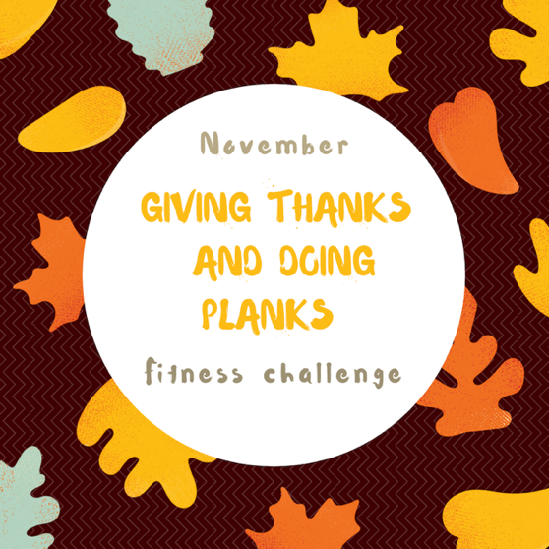
TIMED PLANK
EXERCISES - Hold for at least 20 seconds.
Increase time each day for your personal best.
- High Plank (on hands)
- Low Plank (on elbows)

LEVELS
Level 1-Complete 1 round of planks
Level 2-Complete 2 rounds of planks
Level 3-Complete 3 rounds of planks

GIVING THANKS
Think of someone or something you’re thankful for and write it on the calendar each day.

COUNTED PLANK EXERCISES
- Plank Shoulder Touches – 10 repetitions each shoulder
- Up-Down Plank –
- 10 repetitions
- Arm Raise – 5 repetitions each arm
- Plank Jacks – 10 repetitions
- Knee-to-Elbow Plank – 5 repetitions each leg
- Toe Tap Plank – 10 repetitions each side
- Plank Leg Raise – 10 repetitions each leg
- Knee Tap Plank (Low) – 10 repetitions each knee

