Weather Study Guide 4.6
• Temperature is the measure of the amount of thermal energy in the atmosphere.
• Air pressure is due to the weight of the air and is determined by several factors including the temperature of the air.
• A front is the boundary between air masses of different temperature and humidity.
• Cirrus, stratus, cumulus, and cumulo-nimbus clouds are associated with certain weather
conditions.
• Cumulus clouds are fluffy and white with flat bottoms. They usually indicate fair weather. However, when they get larger and darker on the bottom, they become cumulo-nimbus clouds. Cumulo-nimbus clouds may produce thunderstorms.
• Stratus clouds are smooth, gray clouds that cover the whole sky (block out direct sunlight). Light rain and drizzle are usually associated with stratus clouds.
• Cirrus clouds are feathery clouds. They are associated with fair weather. Cirrus clouds often indicate that rain or snow will fall within several hours.
• Extreme atmospheric conditions create various kinds of storms such as thunderstorms, hurricanes, and tornadoes.
• Different atmospheric conditions create different types of precipitation.
• Meteorologists gather data by using a variety of instruments.
• Meteorologists use data to predict weather patterns.
• A barometer measures air pressure.
• An anemometer measures wind speed.
• A rain gauge measures the amount of precipitation.
• A thermometer measures the temperature of the air.
Weather Vocabulary
Science Vocabulary
air mass -- a large body of air which has about the same temperature and humidity throughout
air pressure -- the weight of air pushing on everything around it; determined by several factors including the temperature of the air
anemometer -- a tool that measures wind speed
barometer -- a tool that measures air pressure
cirrus clouds-- feathery clouds associated with fair weather
cold front -- the leading edge of a cold air mass that pushes up lighter warm air (Clouds may develop, and the sudden rising of warm air may lead to showers or thunderstorms.)
condensation -- the change of matter from a gas (water vapor) to a liquid state
cumulonimbus clouds-- tall, dense, puffy clouds associated with heavy rain and thunderstorms (often very large and dark at the bottom)
cumulus clouds-- fluffy, white clouds with flat bottoms (When they get larger and darker at the bottom, they produce thunderstorms.)
evaporation -- the change of matter from a liquid to a gas (water vapor) state
forecast -- a prediction about the weather made by a meteorologist
front -- the boundary between air masses of different temperature and humidity
high pressure -- Cold air is heavier than warm air. Its matter is more closely packed together and it pushes down harder on the earth’s surface; therefore, a cold air mass is called a high-pressure area. (Since cold air holds less water vapor, it also tends to be drier air. If you are outside, feeling pleasantly dry and cool, chances are you are in a high-pressure system.)
humidity -- the amount of water vapor in the air
hurricane -- a huge, slowly-spinning tropical storm that forms over water and has winds of at least 119km/h (74mph)
low pressure -- Warm air is lighter than an equal volume of cold air; warm air is lighter and tends to rise from the Earth’s surface. (Because it is rising, warm air presses down on the Earth’s surface with less force. If you are outside and the weather is cloudy and windy, you are most likely in a low-pressure area.)
meteorologist -- a scientist who gathers weather data by using a variety of instruments
rain gauge -- a tool used to measure precipitation
precipitation -- a form of water which forms and falls from the Earth’s atmosphere (rain, sleet, hail, snow)
stratus clouds-- smooth, gray clouds that cover the whole sky usually associated with light rain and drizzle (These clouds block out direct sunlight.)
temperature -- the measure of the amount of heat energy in the atmosphere
thermometer -- a tool that measures the temperature of the air
thunderstorm -- a weather condition usually having strong gusts of wind and heavy rain (Thunderstorms can be accompanied by lightning, hail, strong winds, heavy rains, and even tornadoes.)
tornado -- a small, destructive, whirling, fast-moving storm that forms over land
warm front -- the leading edge of a lighter, warm air mass that is lifted over cold air (As it rises, steady precipitation develops.)
water cycle -- the movement of water through the environment (evaporation, condensation, and precipitation)
wind -- the movement of air from low to high-pressure areas
thermal energy -- the kind of energy that is related to and/or caused by heat

Weather Tools
Rain Gauge
Anemometer
Barometer
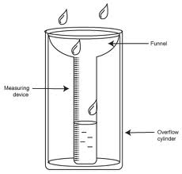
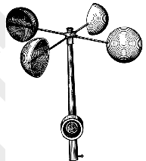
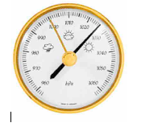

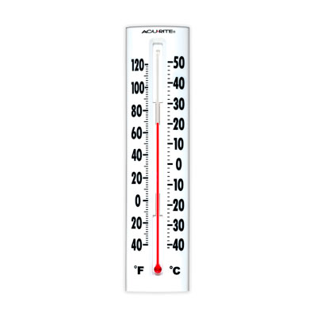
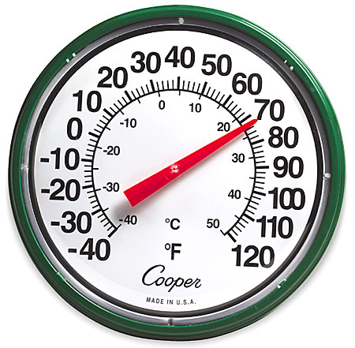
Thermometer

Cloud Types

Big Idea Questions
Cumulus: Cumulus
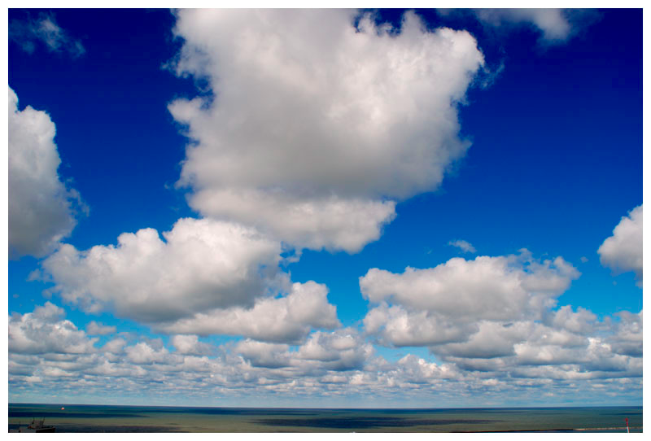
• Fluffy and white with flat bottoms
• Usually indicate fair weather

Cirrus: Cirrus
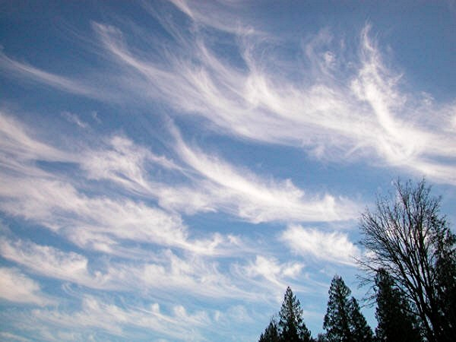
• Thin, feathery clouds high in the
sky
• Associated with fair weather
• Often indicate that rain or snow
will fall within several hours

Stratus: Stratus
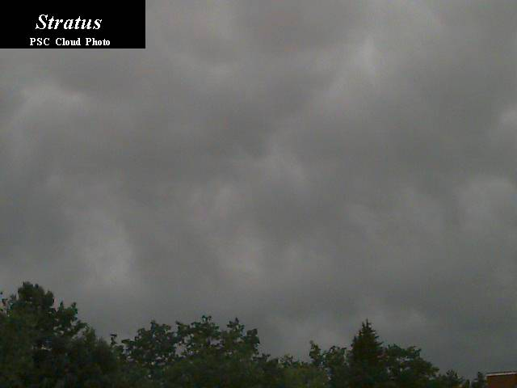
• Smooth, gray clouds that cover the
whole sky (block out direct
sunlight)
• Usually associated with light rain
and drizzle

Cumulonimbus: Cumulonimbus
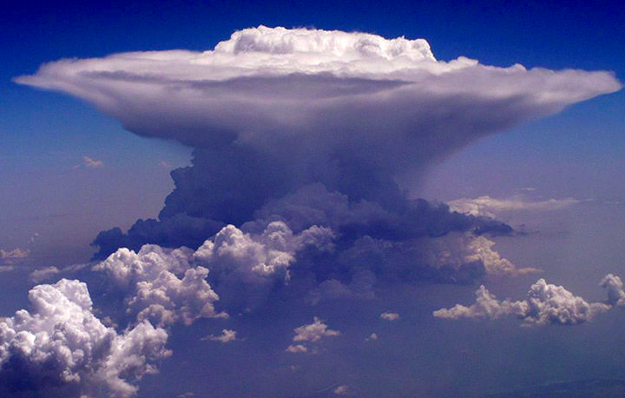
• Look like a gray blanket or puffs of
smoke
• Made up of piles of cumulus clouds
• Usually produce thunderstorms

Storms

Storm Type | Associated Weather Conditions | When Storms Occur
Thunderstorm  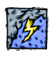 | Heavy rain, strong wind, flashes of lightning, rolls of thunder. | When a warm, moist air mass near the ground is covered by a mass of cold air. Severe thunderstorms have winds of 58 mph or greater.
Hurricane (tropical storm over the Atlantic Ocean)  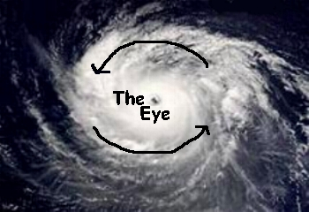 | Heavy rain, strong whirling  winds, high tides, and huge  waves. Hurricanes are formed over water. | When a warm low-pressure  weather system is surrounded by cooler air. Winds exceed 75 mph.
Tornado (funnel-shaped cloud)  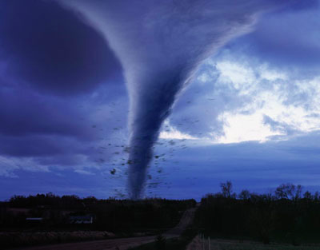 | Strong whirling winds in a  funnel-shaped cloud. Tornadoes are formed over land. | When a warm, moist air mass near the ground is covered by a mass of cold air and creates a strong, rotating column of air that  reaches from a cumulonimbus cloud on to the ground.

Big Idea Questions

• How could you use a thermometer to compare air temperatures over a certain period of time? Explain the steps you would take to gather this data.
• You notice a big change in the air pressure from one day to the next day. Which weather tool would you examine to see this drop in air pressure? What do you think will happen with the weather in that area?
• A warm front is moving over the Richmond area. How will this warm front look on a weather map?
• Describe the following cloud types: cirrus, stratus, cumulus, and cumulonimbus. What type of weather would you expect to see with each type of cloud?
• How are rain, snow, sleet, and hail alike? How are they different?
• While reading a thermometer every two hours, you notice the temperature is falling throughout the day. What might be causing this?
• What type of weather could you expect to see with a high pressure air mass? low pressure air mass?
• When does a warm air mass form a warm front?
• When does a cold air mass form a cold front?
• Name the tools meteorologists use to predict weather. What purpose does each tool serve?
• How could you use these tools to make weather predictions over time?
• Think about: (1) a hurricane; (2) a thunderstorm; (3) a tornado. What would you probably observe outside if this type of storm happened in our area? (Include observations about temperature, wind, and precipitation.) What would the barometer probably read? What might an anemometer read?
• How would a weather map of Richmond look if a blizzard were heading our way? What symbols would you expect to see?
• What kind of air mass is most likely to form over the Gulf of Mexico? Explain your answer.
• If you were a meteorologist for the Richmond area and heavy rain was reported in the area, what readings might your weather tools show as you are about to give your report on TV? (Include readings for a barometer, thermometer, anemometer, and rain gauge.)

