Sound Project…due April 10th
Choose one of the projects below to show your knowledge of what you have learned during our unit on SOUND. You may use any resource that is available to you to complete the project you choose.

Caught on Video!
Make a video demonstrating the following vocabulary words: vibration, resonance, volume, pitch, sonar, morse code, animal sounds, musical instruments. Be sure your video includes clear definitions of each as well as creative visuals to show what the words mean. This video should not exceed 5 minutes.

Sound Bingo!
Record sounds to go with four bingo boards that you create. Each board that you make should have nine sounds each. The cards should be printed, contain color and visuals, along with directions on how to play. Be ready to play your game with the class!

Create an instrument!
Make a homemade musical instrument that will produce at least 3 different notes. Your instrument should be neatly painted or decorated and show the time and effort you put into it. This should NOT be made from a kit. Be sure to have your name on the instrument and be ready to demonstrate how it works for your class. (Please note: hitting random items with a stick to mimic a drum will not be accepted!)
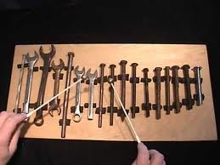
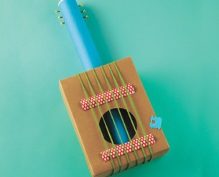

Grading Rubric (100 total points)

20 Timeliness: My project was turned in on time
20 Quality: My project showed high quality through colorful visuals

Instrument
20 Produced at least 3 different notes
20 Neatly painted or decorated
20 Name on instrument

Bingo
20 Four cards printed with 9 sound boxes each
20 Neat graphics; colorful
20 Sound clips clear and recognizable

Video
30 all eight vocabulary words were defined
30 video contained appropriate visuals to help define the words
