Resources Study Guide 4.9
• Virginia is rich in a wide variety of natural resources, including forests, arable (farmable) land, coal, sand and aggregates (rocks), wildlife and aquatic organisms, clean water and air, and beautiful scenery.
• A watershed is an area over which surface water (and the materials it carries) flows to a single collection place. The Chesapeake Bay watershed covers approximately half of Virginia’s land area. The other two major watershed systems are the Gulf of Mexico and the North Carolina Sounds.
• Virginia’s water resources include groundwater, lakes, reservoirs, rivers, bays, and the Atlantic Ocean.
• Virginia has a great variety of plant and animal resources.
• Natural and cultivated forests are a widespread resource in Virginia.
• Virginia’s soil and land support a great variety of life, provide space for many economic activities, and offer a variety of recreational opportunities.
Resources Vocabulary
Science Vocabulary
agriculture -- economic activities that are supported by growing crops and raising livestock arable land -- an area that can support the growing of many crops due to the rich nutrients and minerals in the soil
bay -- a part of the ocean that extends into the land (The Chesapeake Bay is located on the east coast of Virginia.)
climate -- the weather you can typically expect during certain times of the year
coal -- a black, rock-like mineral (one of Virginia’s most important natural resources)
cultivated forest -- a large group of trees in a certain area maintained and, sometimes, planted by people
erosion -- the moving and carrying away of the Earth’s sediment
glacier -- a large mass of ice and snow that is a cause of some types of erosion
groundwater -- water contained under the ground's surface, in the cracks of sand, soil, and gravel (Groundwater is a common source of water for drinking and irrigation.)
lake -- a body of water entirely or nearly surrounded by land usually made of fresh water
human-made resources -- materials, useful or necessary for life, that are made by people using natural resources (cars, home, clothing)
mineral -- a naturally occurring substance that has been formed due to the Earth’s natural changes
natural resources -- materials that are supplied by nature that are useful or necessary for life (minerals, land, timber, soil)
ore- a natural occurring mineral that contains a metal (This mineral is mined and worked.)
reservoir -- a man-made or natural collection of water used for power, drinking, or watering crops
river -- a natural stream that flows into a lake, bay, or ocean
soil -- a renewable resource made from weathered rock, plant, and animal materials
watershed -- an area over which surface water and the materials it carries flow to a single collection place
watershed address -- Your watershed address shows the connections between all the rivers downstream of a particular location. Knowing your watershed address is helpful in terms of understanding what is upstream and downstream, which can be an important consideration in terms of preventing pollution or preparing for potential
flash floods.

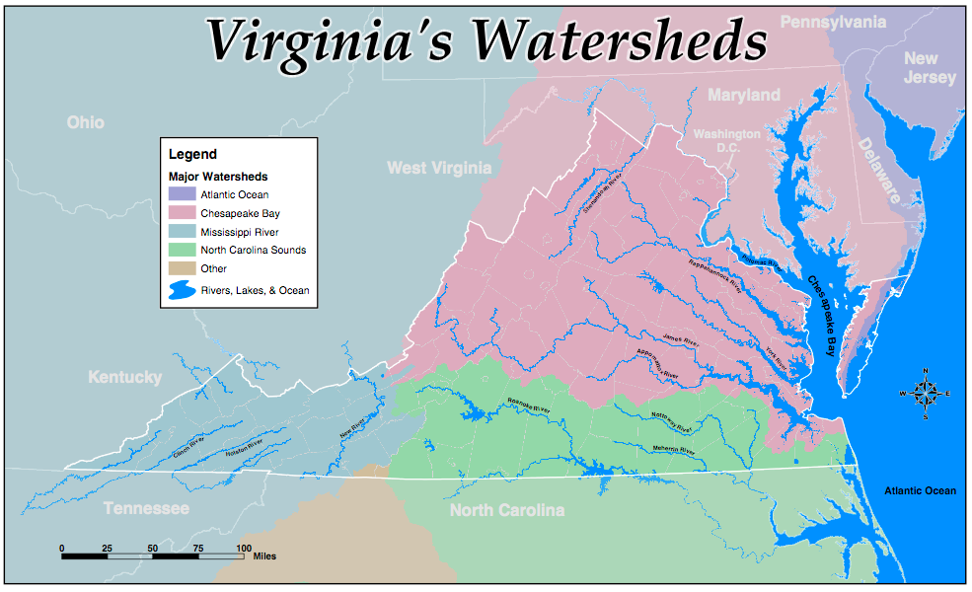

Big Idea Questions

• Resources can be natural or man-made. Explain the difference between these two kinds of resources.
• Give some examples of natural resources found in the state of Virginia.
• Virginia has rivers, lakes, and bays among its bodies of water. Describe some characteristics of each type of water feature. Give an example of each one that is located in Virginia.
• How do people and watersheds relate to each other?
• What does it mean if someone asks you to name your watershed address? What is your watershed address?
• What do you think “We all live downstream” means?
• Name some important mineral resources found in Virginia, and tell why they are important to our state.
• Why are Virginia’s forests, soil, and land important in our state?

