Light Study Guide 5.3

Light is a form of energy that has properties of both a wave and a particle. The particles are called photons and they move in straight lines.

Light waves
Unlike sound, light waves travel in STRAIGHT paths called RAYS. A set of parallel rays is called a BEAM.

Light does not need a media to travel through.
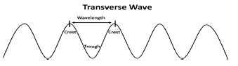
Wavelength is measured between any two corresponding points on successive waves. It is usually measured from crest to crest, or trough to trough.
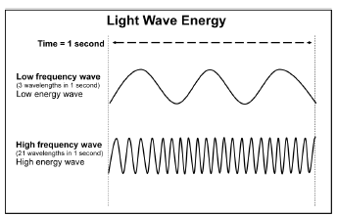
Light waves are waves of energy that are characterized by their wavelengths and frequency. Frequency is the number of waves passing a given point every second. The greater the frequency, the greater the amount of energy. High frequency light has high energy; low frequency light has low energy.

Sunlight consists of the entire electromagnet spectrum. The only difference between the various types of electromagnetic radiation is the amount of energy.

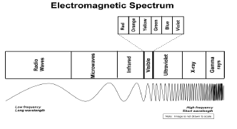

Gamma rays have the most energy (higher frequency).
Radio ways have the least energy (lower frequency).

Colors - ROYGBIV
We see visible light as the colors of the rainbow. Each color has a different wavelength. Red has the longest wavelength and violet has the shortest. The colors in order from the longest wavelength to the shortest are: Red, Orange, Yellow, Green, Blue, Indigo, Violet.

Black and white are not spectral colors. Black is when a material absorbs all the visible light and no light is reflected back. Black is a total absence of reflected light. White is a reflection of all visible light together.
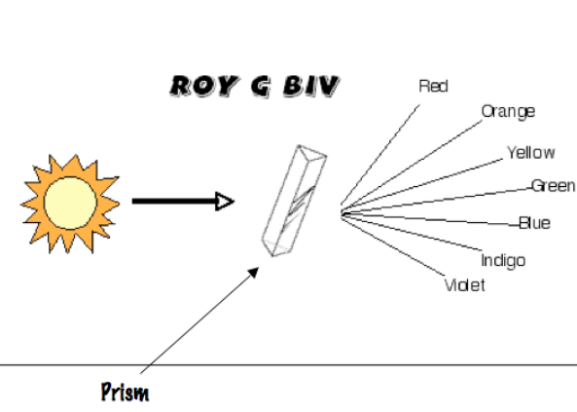

Reflection, Refraction, Transmission, Absorption
Light travels in straight paths until it hits an object. The wave that strikes a surface is called the incident wave. The wave that bounces back is called the reflected wave.

- Reflection – light bounces off an object. If the surface the light wave encounters is smooth and polished, like a mirror, the reflected wave will be bounce back at the same angle.

- Refraction – light waves are bent as a result of a change in the velocity moving from one medium to another. For example, light moving from air into water. (The frequency doesn’t change.)

The amount of refraction depends on density of the material it is entering; the wavelength of the light wave; and the angle at which the incident wave enters the new medium.
Some examples of refraction:
- A spoon appears to bend when it is immersed in a cup of water.
- Shadows on the bottom of a pool are caused because air and water have different densities.
- A glass prism disperses white light into its individual colors. As visible light exits the prism, it is refracted and separated into a display of colors.

- Transmitted – light passes through the object (transmission)
  - Transparent - light easily passes through these materials. Examples include clear glass, clear plastic food wrap, clean water, air
  - Translucent – light partially passes through these materials. Examples include wax paper, frosted glass, thin fabrics, some plastics, and thin paper.
  - Opaque – light cannot pass through opaque material. Examples include metal, wood, brick, aluminum foil.

- Absorbed – light can be absorbed as heat

Vocabulary
Concave lens- a lens that is curved inward; bends light outward
Convex lens – a lens that is curved outward; bends light inward
Crest – the top of one wavelength
Electromagnetic spectrum – the full range of electromagnetic waves from longest to shortest (includes radio waves, microwaves, infrared waves, visible light, ultraviolet, light, x-rays, and gamma rays)
Infrared light – invisible light felt as heat
Laser – a concentrated beam of light, made of just one type of light
Light – a form of energy that travels in straight lines from its source in waves
Light waves – characterized by their wavelengths (red has the longest, violet has the shortest)
Opaque – allowing no light to pass through an object (shadows may be cast by opaque objects)
Photon – a particle of light that moves in a straight line
Prism – refracts visible light so that the rays are bent and separated into the colors of the spectrum
Reflected – light that bounces off an object or surface (such as a mirror)
Refracted – light that is bent as its path is changed (such as when light passes through different objects like a lens or water)
ROYGBV – the colors of white light in order from longest to shortest (red, orange, yellow, green, blue, violet
Translucent – allowing some light to pass through an object ( the image will be distorted)
Transmitted – light passed through an object
Transparent – allowing most light to pass through an object
Transverse waves – movement of light in waves
Trough – the bottom of one wavelength
Ultraviolet light – invisible light to humans (causes sunburns and suntans)
Visible spectrum – light that appears white because of different wavelengths traveling together (the light people can see)
Wavelength – the distance between one crest to another crest or one trough to the next trough

Neat fact: Did you know it takes light less than 8.5 minutes to travel 93 million miles to reach the Earth?!

