Energy, Force, and Motion Study Guide 4.2

• The position of an object can be described by locating it relative to another object or to the background.
• Tracing and measuring an object’s position over time can describe its motion.
• Speed describes how fast an object is moving.
• Energy may exist in two states: kinetic or potential.
• Kinetic energy is the energy of motion.
• A force is any push or pull that causes an object to move, stop, or change speed or direction.
• The greater the force, the greater the change in motion will be. The more massive an object, the less effect a given force will have on the object.
• Friction is the resistance to motion created by two objects moving against each other. Friction creates heat.
• Unless acted on by a force, objects in motion tend to stay in motion and objects at rest remain at rest.

Science Vocabulary
energy -- the ability to do work
force -- any push or pull that causes an object to move, stop, or change speed or direction
friction -- the resistance to motion created by two objects moving against each other; a force that works against motion
gravity -- an unseen force that pulls two objects toward each other
inertia -- the tendency for objects to resist motion (Unless acted on by a force, objects in motion tend to stay in motion, and objects at rest remain at rest.)
kinetic energy -- the energy of motion
motion -- a change in an object’s position (described by the object’s direction and speed)
potential energy – stored energy
speed -- the measure of motion, how fast an object is moving
work -- when a force moves an object

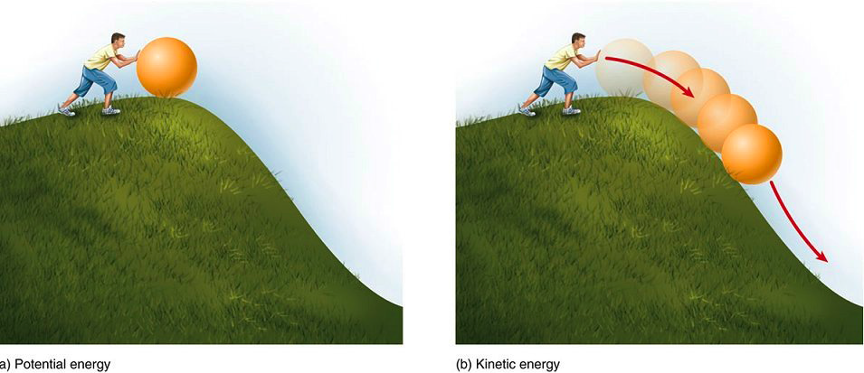

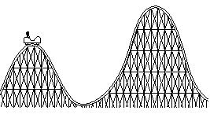
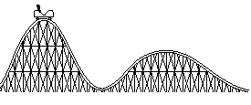

This rollercoaster does not have enough kinetic
energy to carry itself over the second hill
because the second hill is taller than the first.
This rollercoaster has enough kinetic energy to carry
itself over the second hill because the first hill is larger
than the second.

Big Idea Questions
• How can you tell the direction and speed of an object?
• What would you expect to see on a chart over time if a runner’s practice times are improving? What would this mean about the speed she has been running?
• Think about the following motions: up, down, forward, backward. Give an example of an object that generally moves in each direction. (example: A rocket usually moves upward.)
• How does the weight of items inside a wagon affect the force needed to move the wagon? How can you design an investigation to prove you are correct?
• Why does a large jet need a long runway before it can take flight?
• If you are riding a bike and a friend comes and pushes you from behind, what will happen to your motion?
• What happens to the motion of an object if equal but opposite forces are acting on it? (example: tug-of war contest with equal numbers of students on both sides)
• Name some objects that have kinetic energy.
• What does friction do to the motion of an object?
• Do you think there would be more friction on a smooth road or a rough road? Explain your answer.
• Discuss how you would design an investigation to discover how friction affects moving objects. Be sure to include all the components of the scientific process.

