Electricity and Magnetism Study Guide 4.3

• A continuous flow of negative charges (electrons) creates an electric current. The pathway taken by an electric current is a circuit.
Closed circuits allow the movement of electrical energy. Open circuits prevent the movement of electrical energy.
• Electrical energy moves through materials that are conductors (metals). Insulators (rubber, plastic, wood) do not conduct electricity well.
• Among conducting materials, the rate at which energy flows depends on the material’s resistance.
• In a series circuit, there is only one pathway for the current, but in a parallel circuit there are two or more pathways for it.
• Rubbing certain materials together creates static electricity.
• Lightning is the discharge of static electricity in the atmosphere.
• Electrical energy can be transformed into light or motion, and can produce thermal energy.
• Certain iron-bearing metals attract other such metals (also nickel and cobalt).
• Lines of force extend from the poles of a magnet in an arched pattern defining the area over which magnetic force is exerted.
• An electric current creates a magnetic field, and a moving magnetic field creates an electric current.
• A current flowing through a wire creates a magnetic field. Wrapping a wire around certain iron-bearing metals (iron nail) and creating a closed circuit is an example of a simple electromagnet.
• Benjamin Franklin, Michael Faraday, and Thomas Edison made important discoveries about electricity.

Science Vocabulary
attract -- to move together
circuit -- the pathway taken by an electric current
closed circuit -- a pathway which permits the flow of electricity
conductor -- a substance that lets an electric charge pass through it (metals)
current -- a continuous flow of negative charges (electrons)
dry cell -- an energy source with chemicals stored in paste form so they will not spill (battery)
electromagnet -- a magnet made by passing an electric current through a wire wrapped around an iron rod
electrons -- negative charges that flow through a wire or circuit to create electricity
insulator -- a substance that does not conduct electricity very well (rubber, plastic, wood)
lightning -- the discharge of static electricity in the atmosphere
magnetic field -- the area around the poles of a magnet that extends out in an arched pattern where the magnetic force is strong
mechanical energy -- the energy an object has because of its motion or position (fans, mixers, etc.)
open circuit -- a pathway which prevents the flow of electricity
parallel circuit -- a circuit which allows a current to flow along more than one path
permanent magnet -- a magnet that retains its magnetic properties in the absence of an inducing field or current
radiant energy -- energy traveling in electromagnetic waves such as solar energy that is produced from the sun (lamp)
repel -- to move in the opposite direction; to push away by a force
series circuit -- a circuit which allows only one path for the flow of electricity
static electricity -- electricity caused when certain materials rub against each other to create an electrical

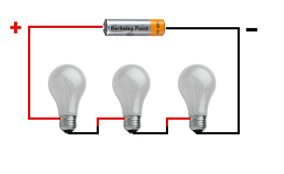
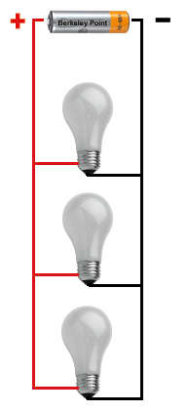
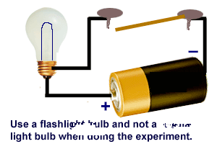
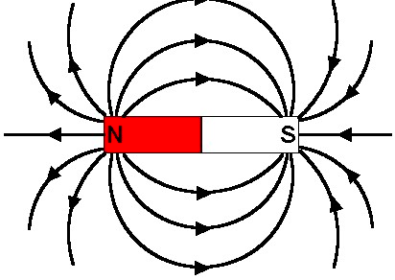
Series Circuit
Parallel Circuit
Open Circuit
Magnetic Field

Historical Contributions

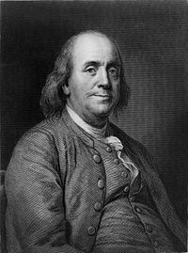

Benjamin Franklin
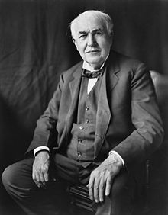
Benjamin Franklin was a respected statesman and scientist. His scientific experiments proved that lightning is a form of electricity. Franklin also helped develop the lightning rod, a device used to protect buildings from damage during electric storms.

Thomas Edison
Thomas Edison invented the incandescent light and the phonograph. He made improvements to the telephone, typewriter, electric generator, and electrically powered train. He designed the world’s first electric power
stations, thereby making electric power available to millions.
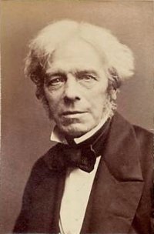

Michael Faraday
Michael Faraday was a British physicist and chemist who discovered the principle of electromagnetic induction in 1831. He found that moving a magnet through a coil of copper wires caused an electric current to flow in the wire (induction). The electric generator and electric motor are based on this principle.
Big Idea Questions
• Look around the classroom. Find three conductors and three insulators of electricity.
• Why are both conductors and insulators important when studying electricity?
• What is the difference between an open and a closed electric circuit?
• What kind of circuit would you have if you pressed the lever on a toaster oven, and it started to work? Explain your answer.
• Describe what you would need to do to make a small light bulb work if you only had the bulb, a battery, and some electrical wire. What type of circuit would this be?
• What do you know about the symbols (-) and (+) on a dry cell battery? If an object needed more than one battery to operate, how would you need to insert the batteries to make it work?
• Give an example of when you have experienced static electricity with your body.
• Discuss what you could do to use static electricity to attract or repel different materials.
• Give an example of static electricity found in nature.
• Explain the difference between a series circuit and a parallel circuit.
• What other types of energy can be produced from electrical energy? Give two examples from your house that transform electrical energy to another form of energy, and name the energy produced. (example: hairdryer-heat)
• How are electricity and magnetism related?
• Describe how the magnetic field of a magnet would look. Where would you see the strongest pull?
• How are permanent magnets and electromagnets alike? How are the different? When does an electromagnet lose its magnetism?
• If you wanted to lift a heavy pickup truck in the air and move it to another location, would you rather use a permanent magnet or an electromagnet? Explain your choice.
• What do Ben Franklin, Michael Faraday, and Thomas Edison have in common? Explain a contribution each person made in regard to understanding electricity.

