Presumed Knowledge: IBDP Chemistry Y2
Topic 1 -Stoichiometric Relationships
1.1: Particle Theory and chemical change
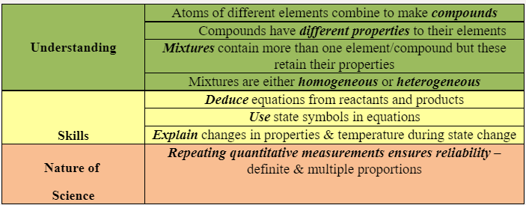
- Which statement describes all homogeneous mixtures?
  - Any sample has the same ratio of the components
  - The components are covalently bonded together
  - The components cannot be easily separated
  - The mixture needs a specific ratio of components to form
- Phosphoric acid, H3PO4, can undergo stepwise neutralization, forming amphiprotic species.
  - Formulate an equation for the reaction of one mole of phosphoric acid with one mole of sodium hydroxide.
  - Formulate two equations to show the amphiprotic nature of H₂PO₄⁻.
  - Calculate the concentration of H₃PO₄ if 25.00 cm³ is completely neutralised by the addition of 28.40 cm³ of 0.5000 mol dm⁻³ NaOH.
  - Outline the reason that sodium hydroxide is considered a Brønsted–Lowry base.
1.2: The mole concept
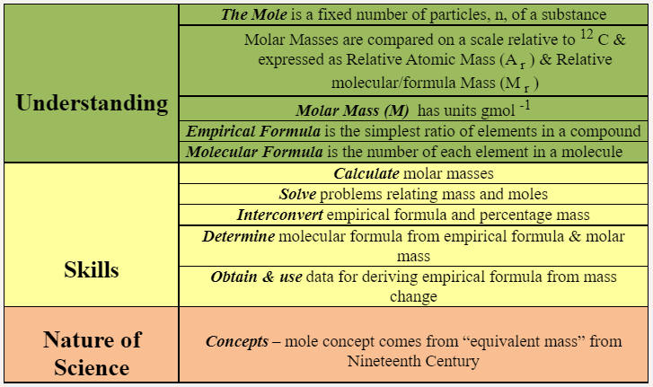
- What is the number of hydrogen atoms in 2.00 moles of Ca(HCO₃)₂?
  - 2.00
  - 4.00
  - 1.20*10²⁴
  - 2.41*10²⁴
- 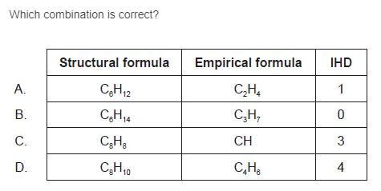
- What is the number of carbon atoms in 12g of ethanoic acid, Mr=60?
  - 0.20
  - 2.0
  - 1.2*10²³
  - 2.4*10²³
- How many moles of magnesium hydroxide are produced with 0.50 mol of ammonia?
Mg₃N₂ (s) + 6H₂O (l) → 3Mg(OH)₂ (aq) + 2NH₃ (aq)
  - 0.25
  - 0.33
  - 0.75
  - 1.5
1.3: Reacting masses and volumes
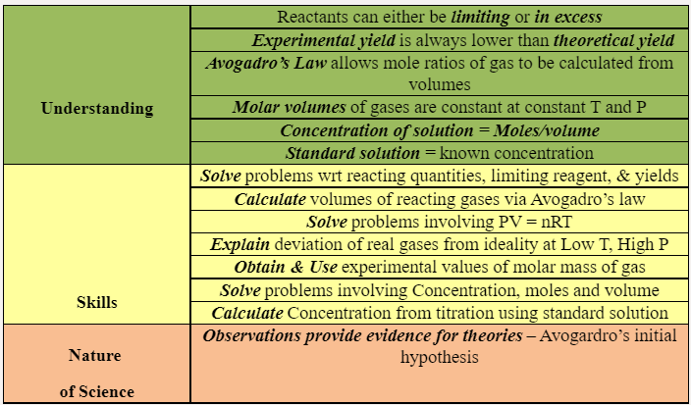
- The two containers shown are connected by a valve. What is the total pressure after the valve is opened and the two gas samples are allowed to mix at constant temperature?
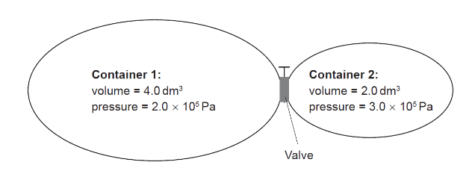
  - 1.5*10⁵ Pa
  - 2.3*10⁵ Pa
  - 2.5*10⁵ Pa
  - 5.0*10⁵ Pa
- 0.20 mol of magnesium is mixed with 0.10 mol of hydrochloric acid. Calculate the maximum yield of hydrogen gas in mols.
Topic 5 – Energetics
5.1: Measuring energy change
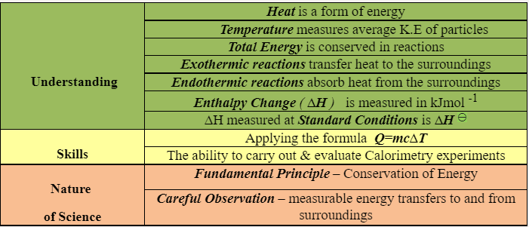
- Which statement describes an endothermic reaction?
  - The bonds broken are stronger than the bonds formed.
  - The enthalpy of the reactants is higher than the enthalpy of the products.
  - The temperature of the surroundings increases
  - The products are more stable than the reactants
- What is the enthalpy change, in J, when 5 g of water is heated from 10°C to 18°C? Specific heat capacity of water: 4.18 kJ kg⁻¹ K⁻¹
  - 5 × 4.18 × 8
  - 5 × 10⁻³ × 4.18 × 8
  - 5 × 4.18 × (273 + 8)
  - 5 × 10⁻³ × 4.18 × (273 + 8)
- Alkanes undergo combustion and substitution.
  - Determine the molar enthalpy of combustion of an alkane if 8.75 × 10⁻⁴ moles are burned, raising the temperature of 20.0 g of water by 57.3 °C.
- When equal masses of X and Y absorb the same amount of energy, their temperatures rise by 5 °C and 10 °C respectively. Which is correct?
  - The specific heat capacity of X is twice that of Y.
  - The specific heat capacity of X is half that of Y.
  - The specific heat capacity of X is one fifth that of Y.
  - The specific heat capacity of X is the same as Y.
- Which is correct when Ba(OH)2 reacts with NH4Cl?
Ba(OH)₂ (s) + 2NH₄Cl (s) → BaCl₂ (aq) + 2NH₃ (g) + 2H₂O (l) ΔH^{Θ} = +164 kJ mol⁻¹
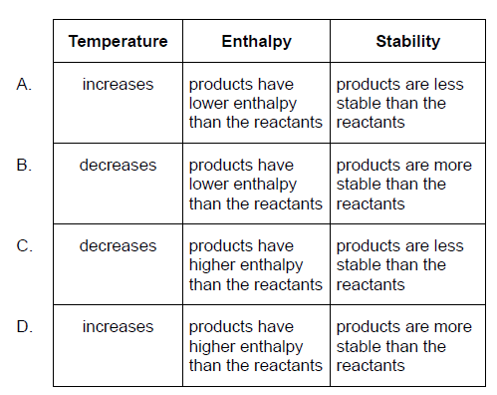
5.2: Hess’s Law
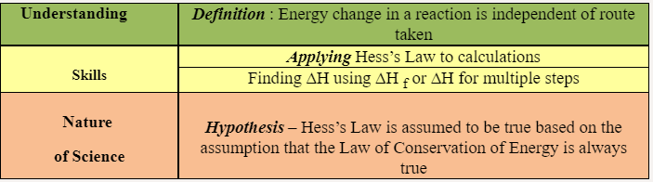
- Which equation represents the standard enthalpy of formation of lithium oxide?
  - 4Li (s) + O₂ (g) → 2Li₂O (s)
  - 2Li (s) + 1/2O₂ (g) → Li₂O (s)
  - Li (s) + 1/4O₂ (g) → 1/2Li₂O (s)
  - Li (g) + 1/4O₂ (g) → 1/2Li₂O (g)
- What is the enthalpy change of the reaction, in kJ?
2C (graphite) + O₂ (g) → 2CO (g)
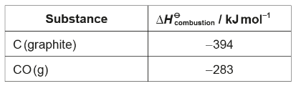
  - −394 – 283
  - 2(−394) + 2(−283)
  - −394 + 283
  - 2(−394) + 2(283)
- Consider the following equations.
2Al (s) + 3/2O₂ (g) → Al₂O₃ (s) ΔH^{Ɵ} = −1670 kJ
Mn (s) + O₂ (g) → MnO₂ (s) ΔH^{Ɵ} = −520 kJ
What is the standard enthalpy change, in kJ, of the reaction below?
4Al (s) + 3MnO₂ (s) → 2Al₂O₃ (s) + 3Mn (s)
  - −1670 + 520
  - 3/2(−1670) + 3(520)
  - 2(−1670) + 3(−520)
  - 2(−1670) + 3(520)
- Which expression gives the enthalpy change, ΔH, for the thermal decomposition of calcium carbonate?
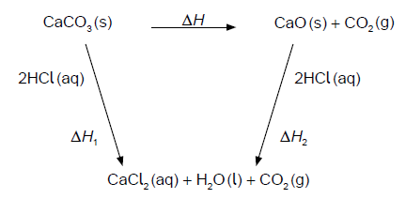
  - ΔH = ΔH₁ − ΔH₂
  - ΔH = 2ΔH₁ − ΔH₂
  - ΔH = ΔH₁ − 2ΔH₂
  - ΔH = ΔH₁ + ΔH₂
5.3: Bond Enthalpy
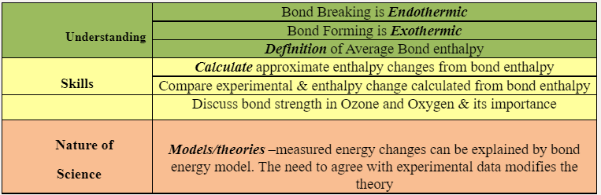
- Which combustion reaction releases the least energy per mole of C₃H₈?
Approximate bond enthalpy / kJ mol⁻¹
O=O 500
C=O 800
C≡O 1000
  - C₃H₈ (g) + 5O₂ (g) → 3CO₂ (g) + 4H₂O (g)
  - C₃H₈ (g) + 9/2O₂ (g) → 2CO₂ (g) + CO (g) + 4H₂O (g)
  - C₃H₈ (g) + 4O₂ (g) → CO₂ (g) + 2CO (g) + 4H₂O (g)
  - C₃H₈ (g) + 7/2O₂ (g) → 3CO (g) + 4H₂O (g)
- Which is the enthalpy change of reaction, ΔH?
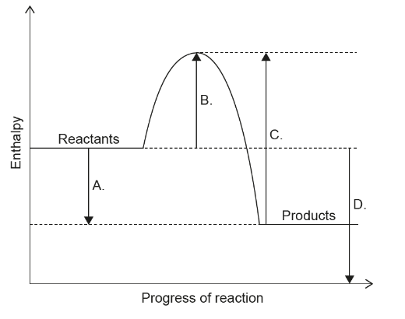
Topic 6 – Kinetics
6.1: Collision theory and rates of reaction
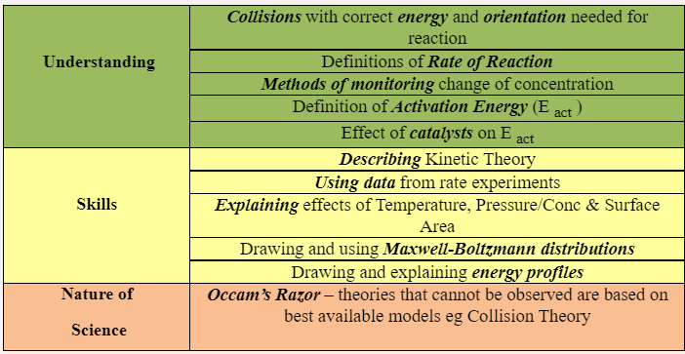
- Which combination has the greatest rate of reaction at room temperature?
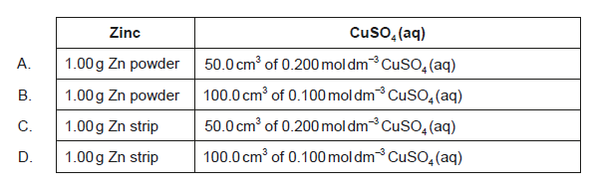
- The graph shows the Maxwell–Boltzmann energy distribution curve for a given gas at a certain temperature.
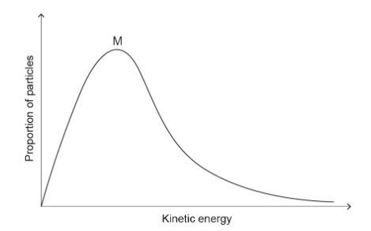
How would the curve change if the temperature of the gas decreases while the other conditions remain constant?
  - The maximum would be lower and to the left of M.
  - The maximum would be lower and to the right of M.
  - The maximum would be higher and to the left of M.
  - The maximum would be higher and to the right of M.
- Which arrow shows the activation energy of the uncatalysed forward reaction for this equilibrium?
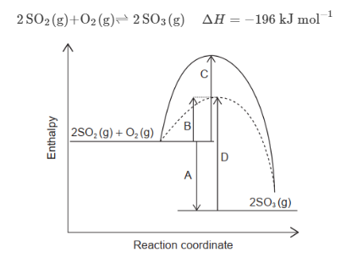
- The dotted line represents the volume of carbon dioxide evolved when excess calcium carbonate is added to hydrochloric acid. Which graph represents the production of carbon dioxide when excess calcium carbonate is added to the same volume of hydrochloric acid of double concentration?
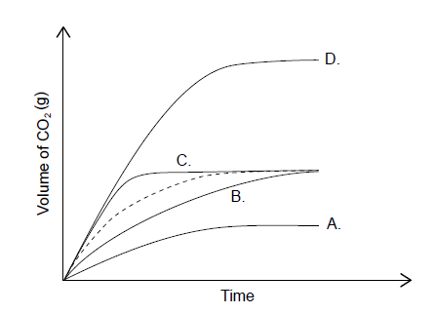
- The same amount of two gases, X and Y, are in two identical containers at the same temperature. What is the difference between the gases?
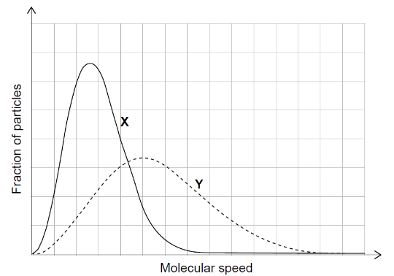
  - X has the higher molar mass.
  - Y has the higher molar mass.
  - X has the higher average kinetic energy.
  - Y has the higher average kinetic energy.
Topic 7 – Equilibrium
7.1: Equilibrium
Understanding | Dynamic Equilibrium : forward & backward rates are equal
 | How to write K _{c} expression for any equilibrium
 | The meaning of K _{c} wrt the balance of equilibrium
 | K _{c} is temperature dependent
 | Meaning of Reaction Quoitient
 | K _{c} unaffected by catalysts
Skills | Characteristics of Dynamic Equilibrium
 | Deducing K _{c} from equation
 | Applying Le Chatelier’s Principle
Nature of Science | Obtaining evidence for theories – Isotopic labelling
 | Common language – Equilibrium has multiple meanings in different fields

- The equilibrium 2H₂ (g) + N₂ (g) ⇌⇌ N₂H₄ (g) has an equilibrium constant, K, at 150 °C. What is the equilibrium constant at 150 °C, for the reverse reaction?
N₂H₄ (g) ⇌⇌ 2H₂ (g) + N₂ (g)
  - K
  - K⁻¹
  - -K
  - 2K
- What effect does a catalyst have on the position of equilibrium and the value of the equilibrium constant, K_{c}, for an exothermic reaction?
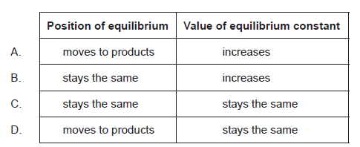
- What is correct when temperature increases in this reaction at equilibrium?
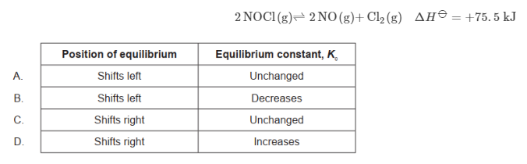
- What effect does increasing both pressure and temperature have on the equilibrium constant, K_{c}?
N₂ (g) + 3H₂ (g) ⇌⇌ 2NH₃ (g) ΔH = −45.9 kJ
  - Decreases
  - Increases
  - Remains constant
  - Cannot be predicted as effects are opposite
Topic 8 – Acids and Bases
8.1: Theories of acids and bases
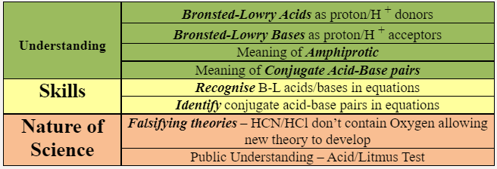
- What is the conjugate acid of HS⁻?
  - H₂S
  - S²⁻
  - H₂SO₃
  - H₂SO₄
- Which cannot act as a Brønsted–Lowry base?
  - HPO₄²⁻
  - H₂O
  - CH₄
  - NH₃
8.2: Properties of acids and bases
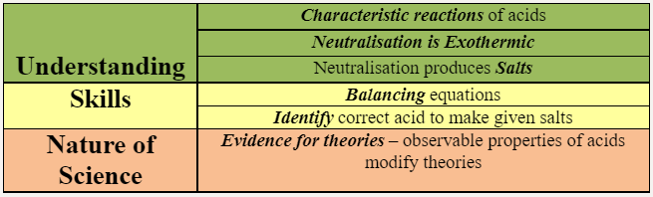
- Write a balanced equation for the reaction between sulfuric acid and sodium bicarbonate.

- Butanoic acid, CH₃CH₂CH₂COOH, is a weak acid and ethylamine, CH₃CH₂NH₂, is a weak base.

  - State the equation for the reaction of each substance with water.
    - Butanoic acid:
    - Ethylamine:
  - State the formula of the salt formed when butanoic acid reacts with ethylamine.
8.3: The pH scale
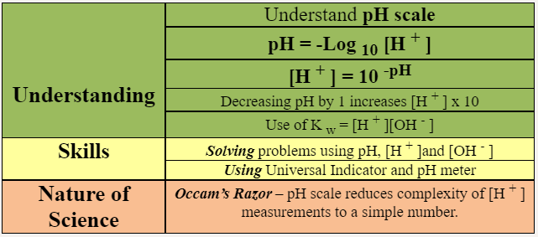
- Which solution has a pH of 9?
  - 1.0 × 10⁻⁹ mol dm⁻³ HCl (aq)
  - 1.0 × 10⁻⁵ mol dm⁻³ KOH (aq)
  - 1.0 × 10⁻⁹ mol dm⁻³ KOH (aq)
  - 1.0 × 10⁻⁵ mol dm⁻³ HCl (aq)
- What is the pH of 0.001 mol dm⁻³ NaOH (aq)?
  - 1
  - 3
  - 11
  - 13
- What will happen if the pressure is increased in the following reaction mixture at equilibrium?
CO₂ (g) + H₂O (l) ⇌⇌ H⁺ (aq) + HCO₃⁻ (aq)
  - The equilibrium will shift to the right and pH will decrease.
  - The equilibrium will shift to the right and pH will increase.
  - The equilibrium will shift to the left and pH will increase.
  - The equilibrium will shift to the left and pH will decrease.
- 10.0 cm³ of an aqueous solution of sodium hydroxide of pH = 10 is mixed with 990.0 cm³ of distilled water. What is the pH of the resulting solution?
  - 8
  - 9
  - 11
  - 12
8.4: Strong and weak acids and bases
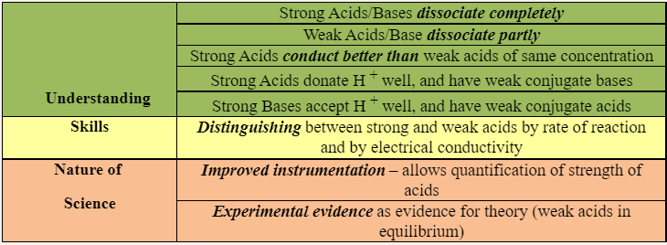
- Which of these acids has the weakest conjugate base?
  - HCl
  - CH₃COOH
  - NH₄Cl
  - C₆H₅COOH
- What is the order of increasing pH for the following solutions of the same concentration?
  - HCl (aq) < NH₃ (aq) < NaOH (aq) < CH₃COOH (aq)
  - CH₃COOH (aq) < HCl (aq) < NH₃ (aq) < NaOH (aq)
  - HCl (aq) < CH₃COOH (aq) < NH₃ (aq) < NaOH (aq)
  - NaOH (aq) < NH₃ (aq) < CH₃COOH (aq) < HCl (aq)
- Which statement is correct?
  - A strong acid is a good proton donor and has a strong conjugate base.
  - A weak acid is a poor proton acceptor and has a strong conjugate base.
  - A strong acid is a good proton donor and has a weak conjugate base.
  - A strong base is a good proton donor and has a weak conjugate acid.
Topic 9 – Redox processes
9.1: Oxidation and reduction
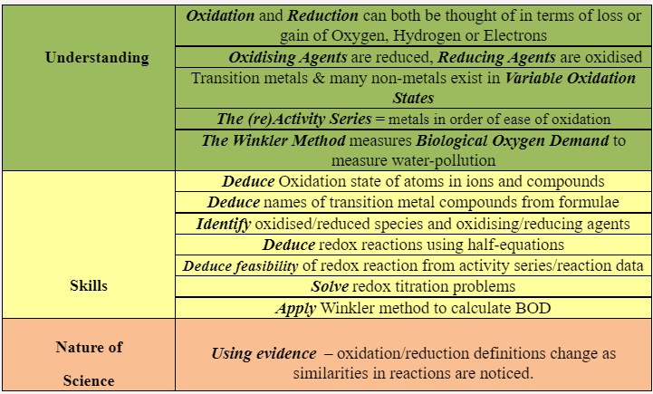
- What is the change in the oxidation state of oxygen?
2Fe²⁺ (aq) + H₂O₂ (aq) + 2H⁺ (aq) → 2H₂O (l) + 2Fe³⁺ (aq)
  - +1
  - 0
  - -1
  - -2
- What is correct for this redox reaction?
MnO₂ (s) + 2I⁻ (aq) + 4H⁺ (aq) → Mn²⁺ (aq) + I₂ (aq) + 2H₂O (l)
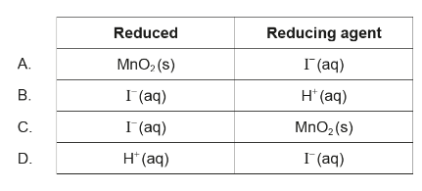
- What is the oxidation state of oxygen in H₂O₂?
  - -2
  - -1
  - +1
  - +2
- What are the oxidation states of oxygen?
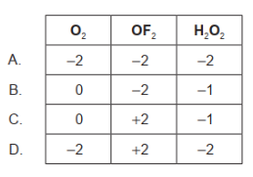
9.2: Electrochemical cells
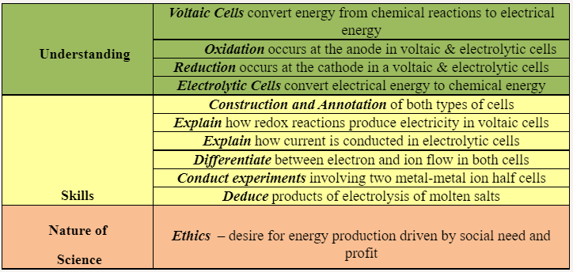
- Which statement is correct about the electrolysis of molten lead(II) bromide, PbBr₂?
  - Br⁻ ions accept electrons at the cathode (negative electrode).
  - Pb²⁺ ions accept electrons at the anode (positive electrode).
  - Br⁻ ions lose electrons at the anode (positive electrode).
  - Pb²⁺ ions lose electrons at the cathode (negative electrode).
- What is correct in an electrolytic cell?
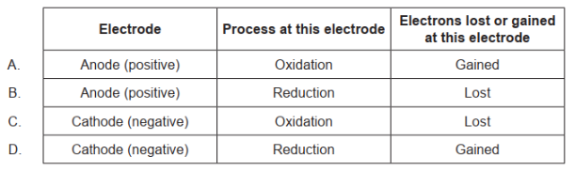
- Consider the following electrochemical cell. What happens to the ions in the salt bridge when a current flows?
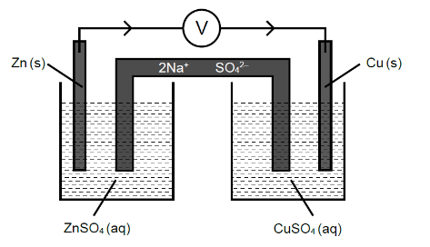
  - Na⁺ ions flow to the zinc half-cell and SO₄²⁻ ions flow to the copper half-cell.
  - Na⁺ ions flow to the copper half-cell and SO₄²⁻ ions flow to the zinc half-cell.
  - Na⁺ and SO₄²⁻ ions flow to the copper half-cell.
  - Na⁺ and SO₄²⁻ ions flow to the zinc half-cell.
- The following reaction occurs in a voltaic (galvanic) cell.
Mg (s) + 2Ag⁺ (aq) → Mg²⁺ (aq) + 2Ag (s)
Which reaction takes place at each electrode?
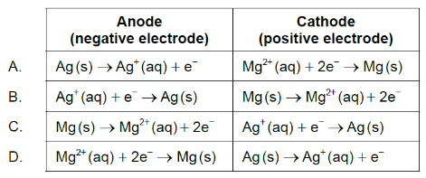
- Which describes the flow of electrons in a voltaic cell?
  - From the cathode (positive electrode) to the anode (negative electrode) through the external circuit
  - From the anode (negative electrode) to the cathode (positive electrode) through the external circuit
  - From the oxidizing agent to the reducing agent through the salt bridge
  - From the reducing agent to the oxidizing agent through the salt bridge
Topic 10 – Organic chemistry
10.1 – Fundamentals of organic chemistry
Understanding | An Homologous Series is a family of compounds with the same general formula & functional group with successive members differing by -CH ₂ -
 | Structural Formulae can be represented in full or condensed
 | Structural Isomers share molecular formula but arrange atoms differently
 | Functional Group = the reactive part of a compound
 | Saturated compounds only have single bonds
 | Unsaturated compounds have at least one double or treble bond
 | Benzene is an unsaturated, aromatic hydrocarbon
Skills | Explain trends in boiling pts in homologous series
 | Understand empirical, molecular & structural formulae
 | Identify homologous series from structure
 | Identify functional groups
 | Construct real or virtual 3-D models
 | Apply IUPAC rules to straight chain and branched molecules
 | Identify primary, secondary & tertiary halogenoalkanes, alcohols and amines
 | Discuss structure of benzene and the evidence for it
Nature  of Science | Serendipity – discovery of PTFE and superglue
 | Ethics – drugs & pesticides have harmful as well as beneficial effects

- Which pair of compounds are structural isomers?
  - Propane and propene
  - Propanal and propanone
  - Propan-1-ol and propanal
  - Propyl propanoate and propanoic acid
- What is the general formula of alkynes?
  - C_{n}H_{2n+2}
  - C_{n}H_{2n}
  - C_{n}H_{2n−2}
  - C_{n}H_{n}
- What is the name of this compound, applying IUPAC rules?
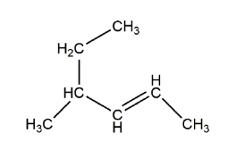
  - 4-methylhex-2-ene
  - 4-ethylpent-2-ene
  - 2-ethylpent-3-ene
  - 3-methylhex-4-ene
10.2: Functional group chemistry
Understanding | Alkanes – unreactive except radical substitution
 | Alkenes – addition reactions. Test= Bromine water
 | Alcohols – nucleophilic substitution & oxidation
 | Halogenoalkanes – nucleophilic substitution
 | Nucleophile – lone pair donor
 | Addition Polymers – from monomers
 | Benzene – electrophilic substitution
Skills | Write equations for combustion of Alkanes
 | Explain mechanism for radical substitution
 | Write equations for Alkene reactions with i)Hydrogen ii)Halogens iii)water
 | Polymerisation of Alkenes, monomer à repeat unit
 | Write equations for Combustion of Alcohols
 | Write equations for oxidation of primary & secondary Alcohols
 | Conditions for isolating Aldehydes & Carboxylic acids
 | Write equations for condensation of alcohols and carboxylic acids to form esters
 | Write equations for substitution of Halogenoalkanes with NaOH
Nature  of Science | Use of Data – key organic chemical reactions applied to produce new molecules

- What is formed in a propagation step of the substitution reaction between bromine and ethane?
  - CH₃CH₂•
  - CH₃CH₂CH₂CH₃
  - H•
  - Br⁻
- Which molecule will decolorize bromine water in the dark?
  - Cyclohexane
  - Hexane
  - Hex-1-ene
  - Hexan-1-ol
- Which mechanism does benzene most readily undergo?
  - Nucleophilic substitution
  - Electrophilic substitution
  - Electrophilic addition
  - Free radical substitution
- What type of reaction occurs when C₆H₁₃Br becomes C₆H₁₃OH?
  - Nucleophilic substitution
  - Electrophilic substitution
  - Radical substitution
  - Addition
- Methane reacts with chlorine in sunlight. Which type of reaction occurs?
CH₄ (g) + Cl₂ (g) → CH₃Cl (g) + HCl (g)
  - Free-radical substitution
  - Electrophilic substitution
  - Nucleophilic substitution
  - Electrophilic addition
- What is the product of the reaction between hex-3-ene and steam?
  - Hexan-1-ol
  - Hexan-2-ol
  - Hexan-3-ol
  - Hexan-4-ol
Topic 11 – Measurement and data processing
11.1: Uncertainties and errors in measurement and results
Understanding | Qualitative data includes all non-numerical information
 | Quantitative data comes from measurement, and are associated with error
 | Propagation of random errors in data processing shows impact of uncertainty on final result
 | Experimental design leads to systematic error
 | Repeat trial and measurement will reduce random error but not systematic error
Skills | Differentiate between random and systematic error
 | Record uncertainty as +/- to appropriate precision
 | Discuss ways to reduce uncertainty in experiments
 | Propagation of uncertainty in processed data (incl. % uncertainty)
 | Discuss systematic error and reduction
 | Estimate whether a source of error is major or minor
 | Calculate % error as compared to established result
 | Differentiate between accuracy and precision

- The enthalpy of combustion of a fuel was determined using the calorimeter shown. The final result was lower than the literature value.
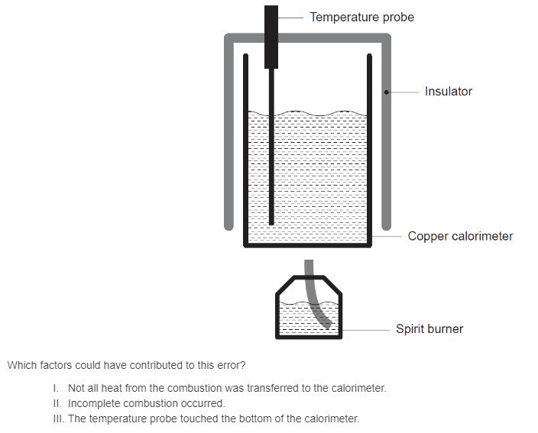
  - I and II only
  - I and III only
  - II and III only
  - I, II, and III
- Burette readings for a titration are shown. What is the mean titre?
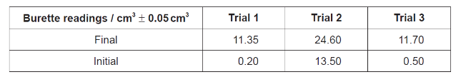
  - 11.1 cm³ ± 0.1 cm³
  - 11.15 cm³ ± 0.05 cm³
  - 11.2 cm³ ± 0.05 cm³
  - 11.2 cm³ ± 0.1 cm³
11.3: Spectroscopy
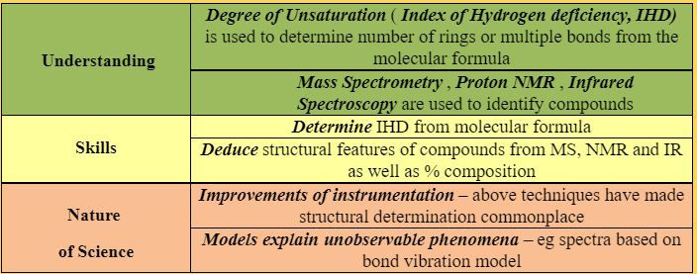
- Consider the mass spectrum of an element:
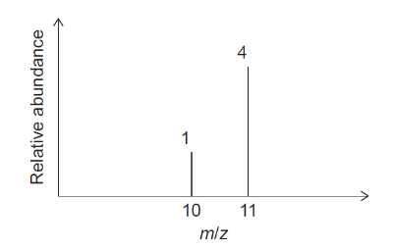
What is the relative atomic mass of this element?
  - 10.2
  - 10.5
  - 10.8
  - 10.9
- Determine the index of hydrogen deficiency (IHD) of paracetamol.
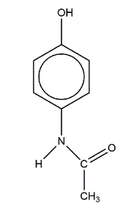
  - 3
  - 4
  - 5
  - 6
- Which is correct for the spectra of organic compounds?
  - Mass spectroscopy provides information about bond vibrations.
  - ¹H NMR spectroscopy provides the values of carbon–hydrogen bond lengths.
  - Infrared spectroscopy provides the number of hydrogen atoms.
  - Mass spectroscopy provides information about the structure.

