Presumed Knowledge for Psychology SL 2018-2019
Gregory P. Lyndaker

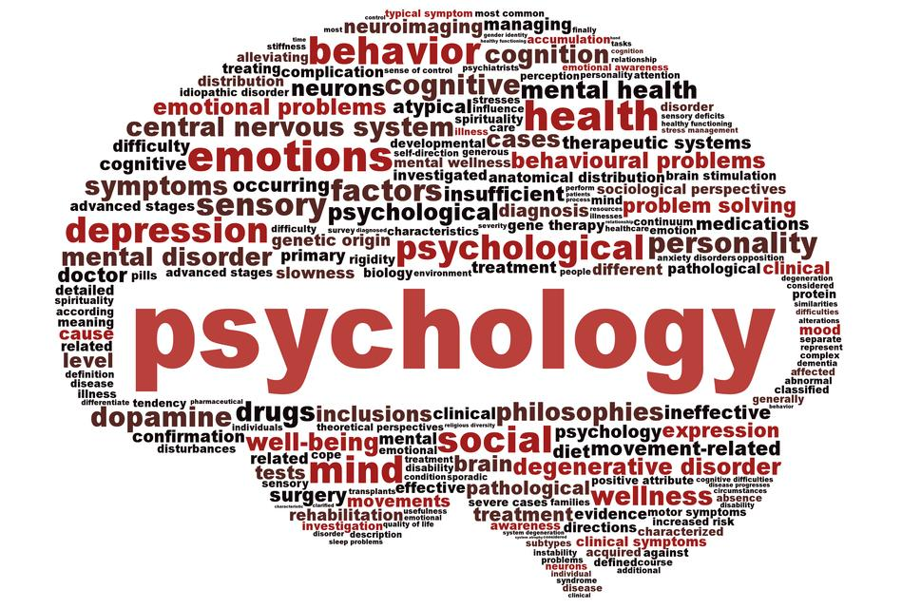
Psychology at the SL level will include many new and unfamiliar terms. The following is not intended to be a complete list but includes concepts that you are expected to know as you begin the course. We will expand on these basic concepts throughout the year.
Terms/Concepts to be familiar with
Scientific Method
Types of Research Methods (Experiments, Case Study, Observation, Interviews, Correlational Studies)
Biological Impacts on Behaviors (Hormones, Brain Parts, Nervous System)
Cognition (Thinking, Memory, Problem Solving)
Social Impact on Behavior (Conformity)
Cultural Impacts on Behavior (Individualism, Collectivism)
How to organize an essay including introduction, body, conclusion.
How to address IB command terms
How to contribute to class discussion by sharing personal examples and respectfully listening to others’ examples.
How to meet deadlines
How to follow instructions
How to keep track of all assignments
How to use Schoology
How to upload documents to Schoology, Google and Turnitin.com

