IB MYP Chemistry Presumed Knowledge
Students are expected to remember and be proficient in all basic Math and Algebra skills. Students should review Physical Science concepts learned in middle school, in order to be familiar with basic scientific concepts.
Review of Scientific Method
Fill in the blank using the following words: Scientific Method, Hypothesis, Observation, Experiment, Quantitative Data, Qualitative Data, Conclusion, Theory and Scientific Law
Term | Definition
 | educated guess about the outcome of an experiment
 | using your 5 senses to develop a testable question
 | a set of controlled, repeatable trials that test the hypothesis by gathering data
 | judgment based on data about the question/hypothesis
 | It is a systematic approach used in scientific study
 | relationship that has never been disproved/refuted
 | idea supported by many experiments

Review of Experimental Design
Fill in the blank using the following words: Title, independent variable, dependent variable, levels of IV, number of trials, hypothesis, control and constant
Term | Definition
 | things that CANNOT change in the experiment
 | the variable YOU change or manipulate
 | how many times you’re going to repeat your experiment
 | one of the levels that is the standard of comparison
 | the variable that responds to the changes you made the different species you’re going to test
 | The Effect of... (the independent variable) …on…(the dependent variable)
 | If…then…because… statement

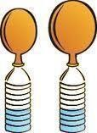
Practice Problem #1
Patty carries out an experiment by setting up five plastic bottles. To each plastic bottle, she adds 10 milliliters of vinegar. She then measures out the following amounts of baking soda: 1.0 g, 2.0 g, 3.0 g, 4.0 g, 5.0 g. She pours each amount of baking soda into a different balloon and fastens the balloons over the openings of each of the plastic bottles. To initiate each reaction, she pours the baking soda out of the balloon and into the bottle. As the reactions proceed, carbon dioxide is released and fills the balloons. A picture of the setup is shown here.

Once each balloon stops inflating, Patty uses a string to measure the circumference of the balloon around the widest part, and then Patty measures the length of the string that stretched around the balloon. Patty records her data in the table below.

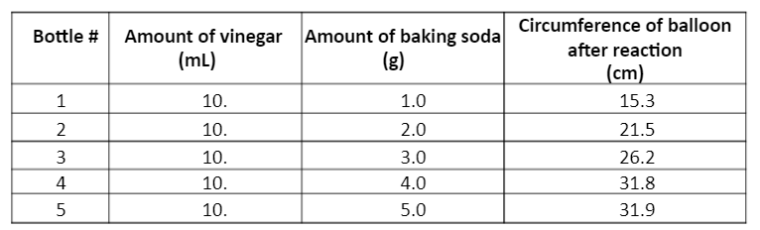
Based on the experiment, answer the following questions
- What is the independent and dependent variables?
- What are 3 constants?
- Is there a control? Why or why not?
- What would be Patty’s hypothesis?
- Graph the data below. Make sure to label your axes and to include title!

Title:
x-axis:
y-axis:
Into to Unit and Conversions
SI Units – international system of measurement used by scientists. Allows scientists all over the world to communicate using one language
SI Base Units Common Conversion Factors
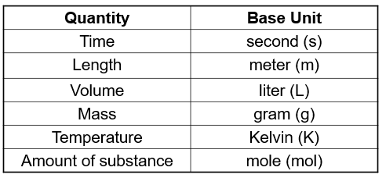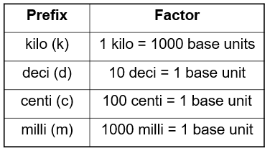
Practice Problem #2
- How many inches are there in 3.5 feet? ___
- How many milliliters (mL) in 1 L? ___
- How cm in 125 mm? ___
- If a dog is 200 g, how much does the weigh in kg? ___
- How tall is Ms. Nguyen in feet if she is 61 inches tall? ___
- Explain the strategy you are using to answer the questions above.

