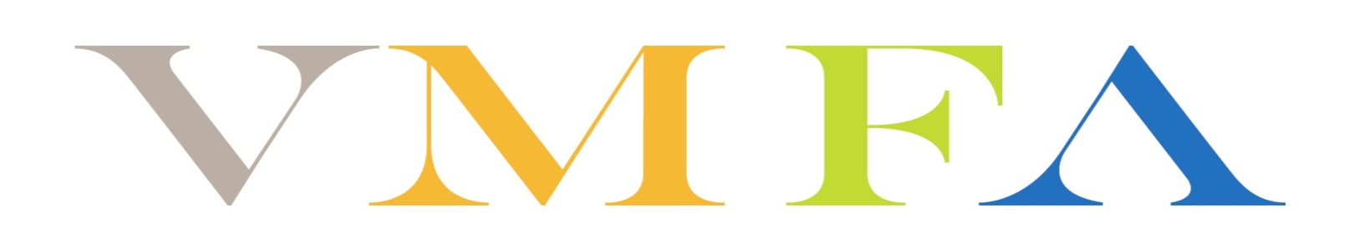

Upcoming Family Day Events
Fall 2017-Winter 2018

Family Day Events - Volunteers greet and welcome visitors; hand out schedules and point visitors in the direction of activities; assist children with art projects and other hands-on activities; usher visitors into and out of performances; manage lines; aid staff, artists, and performers with setting up, managing, and cleaning up performance and work space areas and equipment; and help with other event-specific tasks. Volunteers for these events should enjoy working with a diverse, multigenerational audience.

Sat., Sept. 16 Celebrate the Art of Latin America: Caribbean!
- Volunteer Timeframe: 10:00 a.m.-3:30 p.m.
- Volunteer Orientation: Fri., Sept. 8, from 10:00-11:00 a.m. or 6:00-7:00 p.m.

Sat., Oct. 14 Celebrate Native American Art!
- Volunteer Timeframe: 10:00 a.m.-3:30 p.m.
- Volunteer Orientation: Fri., Oct. 6, from 10:00-11:00 a.m. or 6:00-7:00 p.m.

Sat., Feb. 10 ChinaFest: Year of the Earth Dog!
- Volunteer Timeframe 9:00 a.m.-5:00 p.m.
- Volunteer Orientation Fri., Jan. 26, from 10:00-11:00 a.m. or 6:00-7:00 p.m.

*****************************************************************************************

To assist with these opportunities or to learn about others, please contact Kim Frola, Program Manager for Volunteers and Community Service, at kim.frola@vmfa.museum or at 804-340-1461. Volunteers must be signed up in advance of the event or assignment. Thank you for your interest and ongoing support of VMFA!

