IB Math Sequencing
Math course recommendation after IBDP
- IBDP Math SL: Applications & Interpretation AP Statistics. AB Calculus, and/or AP Computer Science A
- IBDP Math SL: Analysis & Approaches AP Statistics, BC Calculus, and/or AP Computer Science A

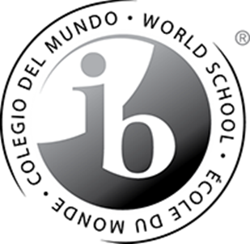
IBDP Math Options

Math SL: Applications and Interpretation  IB3198XA | Math SL: Analysis and Approaches  IB3197XA
- developing mathematics for describing our world and solving practical problems  - harnessing the power of technology alongside exploring mathematical models  - mathematics seen in a practical context | - developing mathematics to become fluent in the construction of mathematical arguments  - develop strong skills in mathematical thinking  - exploring real and abstract applications of these ideas, with and without technology
Topics Covered and Suggested Teaching Hours:  Number and Algebra 16 hours  Functions 31 hours  Geometry and Trigonometry 18 hours  Statistics and Probability 36 hours  Calculus 19 hours  Internal Assessment: Mathematical Exploration 30 Hours | Topics Covered and Suggested Teaching Hours:  Number and Algebra 19 hours  Functions 21 hours  Geometry and Trigonometry 25 hours  Statistics and Probability 27 hours  Calculus 28 hours  Internal Assessment: Mathematical Exploration 30 Hours
Total Teaching Hours for Math Standard Level (SL): 150 hours

