IB DP Biology
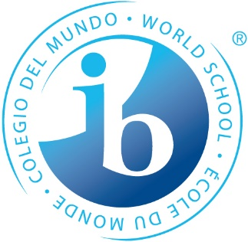
CORE TOPICS | HOURS
Topic 1: Cell biology | 15
Topic 2: Molecular biology | 21
Topic 3: Genetics | 15
Topic 4: Ecology | 12
Topic 5: Evolution & biodiversity | 12
Topic 6: Human physiology | 20
95
TOTAL

ADDITIONAL HIGHER LEVEL | HOURS
Topic 7: Nucleic acids | 9
Topic 8: Metabolism, cell respiration & photosynthesis | 14
Topic 9: Plant biology | 13
Topic 10: Genetics & evolution | 8
Topic 11: Animal physiology | 16
60
TOTAL

OPTIONS | HOURS
A: Neurobiology & behavior
B: Biotechnology & bioinformatics
C: Ecology & conservation
D: Human physiology
SL=15
HL=25
TOTAL

Practical Scheme of Work | HOURS
Practical Activities | 20 SL  40 HL
Internal Assessment (individual investigation) | 10
Group IV | 10

IA—a student designed investigation that demonstrates the application of knowledge and skills
Group IV—collaborative and interdisciplinary activity to investigate a science topic

IB DP Chemistry
CORE TOPICS | HOURS
Topic 1: Stoichiometric relationships | 13.5
Topic 2: Atomic structure | 6
Topic 3: Periodicity | 6
Topic 4: Chemical bonding and structure | 13.5
Topic 5: Energetics/thermochemistry | 9
Topic 6: Chemical kinetics | 7
Topic 7: Equilibrium | 4.5
Topic 8: Acids and bases | 6.5
Topic 9: Redox processes | 8
Topic 10: Organic chemistry | 11
Topic 11: Measurement and data processing | 10
95
TOTAL

ADDITIONAL HIGHER LEVEL | HOURS
Topic 12: Atomic structure | 2
Topic 13: The periodic table—the transition metals | 4
Topic 14: Chemical bonding and structure | 7
Topic 15: Energetics/thermochemistry | 7
Topic 16: Chemical kinetics | 6
Topic 17: Equilibrium | 4
Topic 18: Acids and bases | 10
Topic 19: Redox processes | 6
Topic 20: Organic chemistry | 12
Topic 21: Measurement and analysis | 2
60
TOTAL

OPTIONS | HOURS
A: Materials
B: Biochemistry
C: Energy
D: Medicinal chemistry
SL=15
HL=25
TOTAL

Practical Scheme of Work | HOURS
Practical Activities | 20 SL  40 HL
Internal Assessment (individual investigation) | 10
Group IV | 10

