HELP US DESIGN OUR BUDDY BENCH!

What is a Buddy Bench? A student who has no one to play with sits on the bench, which signals to other students to invite that student to play.
Use the diagram below to show us what our Buddy Bench should look like.
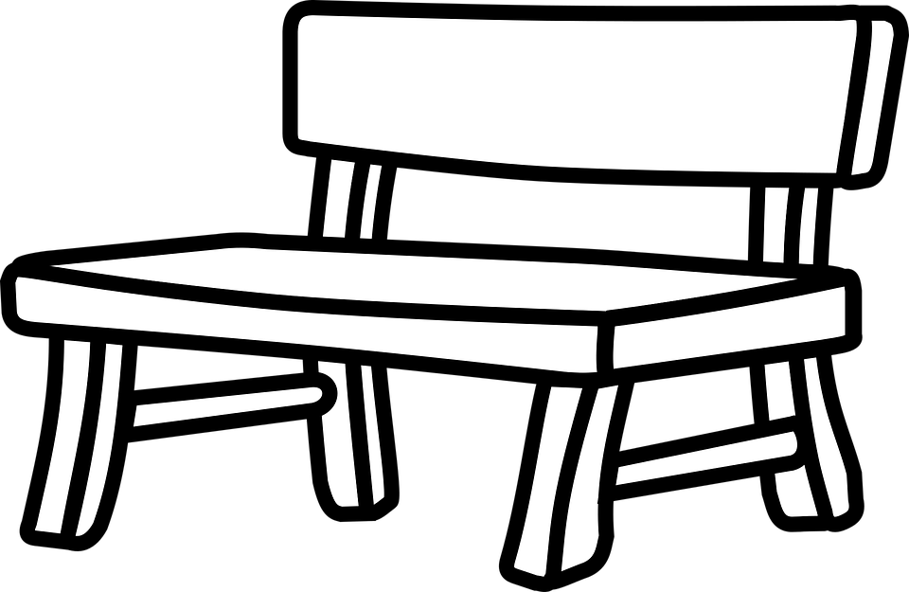

Artist name: __________________

Hand in this completed form to your teacher by May 31st. Winners will be announced at our talent show on June 4th!
Questions? Contact Ms. Bushey at blbushey@henrico.k12.va.us or 261-5060
CALLING ALL ARTISTS!
Is your talent art?
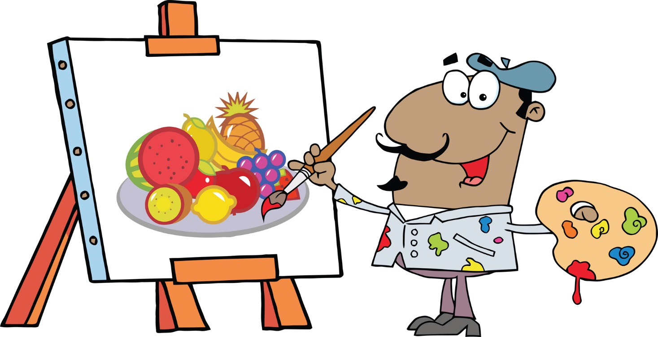

Submit your finished piece to Ms. Bushey by May 31 to have it showcased at our 2018-2019 Talent Show!

The show is on June 4 at 6pm.

Questions? Contact Ms. Bushey at blbushey@henrico.k12.va.us or 261-5060

