UNDER WHAT CONDITIONS DO YOU STUDY BEST?

According to studies the best way to study is to simulate the environment in which you test. However, some people argue that their study time is more efficient in an environment where they are most comfortable. Your study environment should be a balance between comfort and efficiency. To determine your best study conditions, check the box beside the term in each section that best defines you.

Sound
- Silence
- Background music
- Low noise
- Noise

Light
- Bright
- Medium
- Low
- Dark, just the computer

Location
- Sitting at a desk or table
- Relaxing on a bed or floor

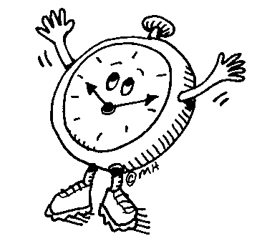 | Time  - In the early morning  - Afternoon  - Evening  - Late at night
Movement
- Being still
- Taking frequent breaks
- Moving around

MY OPTIMUM STUDY CONDITIONS ARE…
Sound | Light | Location | Time | Movement
Focus on Time Management and Organization

Time management and organization are the foundations for every kind of work that you do. There are always good reasons for “putting things off.” Making a commitment to setting up a schedule to accomplish your tasks requires persistence and perseverance. Understanding your personal issues with time management and organization is the first step to solving the problems. The end result will be successful habits.

- Intend to accomplish your goal in a reasonable amount of time.
- Be realistic in eliminating excuses; reward yourself for positive.
- Break up long-term assignments into reasonable units.
- Set priorities carefully in order to save time.
- Keep organized.
- Make daily “to-do” lists.
- Make realistic schedules and follow them.
- Use quality study time – not quantity study time.
- Make time to warm up your mind and review your knowledge.
- Always ask yourself if that was the best use of your time.

STUDY HABITS INVENTORY

 | Hardly Ever | Sometimes | Most Always
1. Do you intend to study, concentrate and learn?
2. Do you follow a daily written schedule?
3. Do you have a regular place to work and study?
4. Is it well-equipped, well-lighted and comfortable?
5. Do you keep track of homework assignments in a book?
6. Do you keep a long-term schedule or calendar of tests, projects
and reports?
7. Do you plan weekly reviews?
8. Do you take effective class notes?
9. Do you keep a notebook for every subject?
10. Are you organized?
11. Do you have a note-taking system?
12. Do you edit your notes?
13. Do you compile study sheets for tests?
14. Do you know how you learn best?
15. Do you study with friends?
16. Do you listen well in class?
17. Do you know what distracts you?
18. Do you look up new words?
19. Do you keep track of new words you learned?
20. Do you use the glossary?
21. Do you have a study system for textbooks?
22. Do you outline reading assignments?
23. Do you skim assignments before reading them?
24. Do you read tables, charts and graphs?
25. Do you have a private shorthand system for taking notes?
26. Do you organize papers before you write?
27. Do you write a first draft?
28. Do you proofread for spelling and punctuation errors?
29. Do you study effectively?
30. Do you learn in school?
31. Do you get enough sleep?
32. Do you exercise regularly?
33. Do you study at the same time each day?
34. Do you make good use of your mind?
35. Do you try to improve your study habits?
36. Do you space your study periods over several days?
37. Do you keep up-to-date with your studies?
38. Do you review often?
ELIMINATING EXCUSES

Do you make excuses when it’s time to study or do homework? Eliminate those excuses by practicing positive talking. When you are thinking about excuses, use some of the questions below to change the excuse into action!

Excuse | “I’m here and that’s enough.”
Ask yourself | “Since I’m not putting out any effort, should I expect anything in  return?”
Excuse | “I just don’t have the time.”
Ask yourself | “Is studying really a priority? How many things do I find to do that  don’t have to be done, at least right now?”
Excuse | “Well, I’ll start tomorrow.”
Ask yourself | “How many times have I said that? Is that a convenient excuse? What will I say tomorrow?”
Excuse | “I can’t!”
Ask yourself | “How many ways/methods have I tried? How many times have I  tried? Have I tried to get help?”
Excuse | “I don’t need to study.”
Ask yourself | “Why do I think this? What is my grade in the class?”
Excuse | “I’m just too tired.”
Ask yourself | “Would I be this tired if I had the choice to do something else? How  much sleep did I get last night?”
Excuse | “It’s boring.”
Ask yourself | “What do I expect to get out of this information? How have I tried to  relate the information to my life? Do I really need the information?”
Excuse | “It’s just too much for me, so why start now?”
Ask yourself | “Is there anything I can realistically accomplish now? Why am I in  this mess? When should I have started the assignment?”

Now, tell yourself “I WILL…. AND I CAN!”
TOOLS FOR STUDY

When you are ready to study make sure that you have an area with all of the tools that you need already collected. Remember that your computer is an excellent resource but you must also have supplies that are not technology-based. The following are the tools recommended for study areas:

Reference
- Dictionary
- Thesaurus
- English handbook or grammar book
- Atlas
- Almanac

Utensils
- room light and desk lamp
- pens
- pencils/erasers
- colored pencils/crayons
- colored highlighters
- ruler
- compass
- scissors
- stapler
- paper clips
- tape
- calculator
- timer

Paper
- large monthly calendar
- notebooks
- scratch tablets/paper
- index cards (3 X 5, 4 X 6)
- colored typing paper

Other
- bulletin board
- tissues/hand sanitizer

ORGANIZING YOUR ASSIGNMENTS

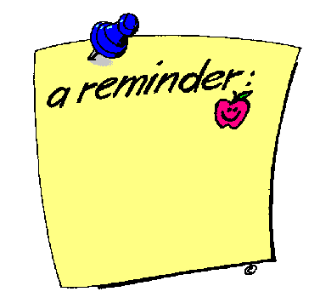 | Assignment Sheets  - Purchase an assignment notebook that you use for assignments only  - Use one assignment sheet for each class  - Take the assignment sheet/notebook with you to every class  - Write each assignment, include estimated time and due date
3 X 5 index cards
- Use one 3 X 5 index card for each assignment
- Write the specific assignment
- Note the estimated time required to complete the assignment
- Note the date the assignment is due
- Keep these cards in a packet and refer to them often

Accordion File
- Purchase a portfolio with enough pockets to have one for each class
- Use one pocket for each class assignment; label each pocket
- Put an assignment sheet in each pocket
- Write the assignment for each day on the assignment sheet for each class
- Add assignment sheets as necessary when the original sheet is full

Agenda Book
- Purchase your own or use the FMS Agenda book
- Write the specific assignment for each class in the areas provided
- Use the monthly calendar to monitor assessments for each class

Google Calendar
- Create a calendar using Google Calendar for your FMS classes
- Color code each class with a different color
- Place your daily assignments for each class on the calendar
4. Use the calendar to place long-term assignments and assessments

Stickys (not recommended by teachers)
1. Create a sticky specifically for your homework
2. Label each class on the sticky
3. Write the assignment for each class on the sticky including time required and date due
4. Place assessments on the sticky with the due dates and study dates
5. Mark completed assignments on the sticky
6. DO NOT erase stickys until the assignment has been turned in

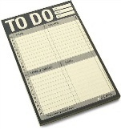 | Daily “To-do” list  - Use index cards of any size.  - Write what you want to do and must accomplish each day on an index card.  - Assign a priority number for each of the items on the card.  - Cross off each item as you complete the task. This action will give you a sense of accomplishment.  - Keep the index card with you throughout the day and refer to it often.

Helpful Hints:
- Post a note to yourself reminding you to take your assignment notebook sheet home from school.
- Be sure you understand the full assignment before leaving class. If you have questions, ask the teacher.
- Know where to find information from each teacher

ASSIGNMENT SHEET

Student Name WEEK OF

SUBJECT
THIS WEEK | ASSIGNMENT | DUE DATE | ESTIMATED TIME | MATERIALS NEEDED | DONE
LATER
EXAMS | MATERIAL TESTED | DATE | TYPE OF TEST | SPECIAL NOTES

How to Use a To-Do List

Points to consider when creating a “To-do” List:  - Prepare each evening for the next day  - Keep this list with you  - Be realistic—there are only 24 hours in a day  - Cross off items as you do them  - Add new items whenever you think of them  - Use a coding system to set priorities  - Ask yourself these questions when priorities:  - Use a notebook and index cards  - Put items left over from today’s list on tomorrow’s list  - Realistically estimate the amount of time needed to complete each task—then add one more  - Give yourself a reward for completing every task on your “to-do” list | 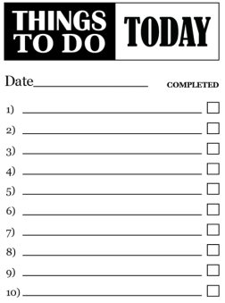

Date: ____________________________________

Top Priorities
- ________________________________________________________________________
- ________________________________________________________________________
- ________________________________________________________________________

Homework
Subject | Assignment | Due Date

Things to bring home today | Things to bring to school tomorrow
- ______________________________  - ______________________________  - ______________________________  - ______________________________  - ______________________________ | - ___________________________  - ___________________________  - ___________________________  - ___________________________  - ___________________________

Notes

SCHEDULES: THE BACKBONE OF GOOD STUDY HABITS

- Analyze how you currently use your time.
  - Carefully consider
    - When and where do you study?
    - How often do you study?
    - How much time do you waste and how much time do you spend wisely?
    - What is the quality of your study time?
    - What “excuses” do you use regularly?
    - What are your priorities?
- Learn how to make a schedule
  - Consider priorities in this order:
    - In-class time
    - Work hours
    - Meals
    - Sleep
    - Classes outside of school
    - Family activities
    - Study block time
    - Recreation time
  - Using a schedule
    - Consider these hints before you begin
      - Don’t’ schedule every hour of the day
      - Leave room for the unexpected
      - Leaver room for change, but only make a change for a good reason
    - Write legibly
    - Be realistic
- Post Schedules/Assignments/Lists:
  - Keep a calendar:
    - In a notebook
    - Inside your locker door
    - On a bulletin board or wall in your room
  - Post time schedules of home activities
    - On the refrigerator door
    - On a family bulletin board
    - Include the following:
      - Study blocks for all family members
      - Family activities
      - Special events
  - Make and post daily “to-do” lists.
- Hints for successful schedules:
  - Try using your schedule for a wee before making changes.
  - Become familiar with your schedule and make the schedule a habit
  - Post it so that you will see it several times each day
  - Carry it with you for easy reference
  - Remember to be flexible and to change something only if there is good reason
SETTING PRIORITIES

Things I Want to Do | Things I Should Do

PRIORITIES
1.
2.
3.
4.
5.
6.
7.
8.
9.
10.

MONTHLY ASSIGNMENT SCHEDULE

Looking for a monthly assignment calendar? Try purchasing an extra yearly calendar during the winter holidays when calendars are inexpensive. Choose a fun calendar that will hold students interest during the school year. Place the calendar in the study area, study box, or study bag in your home. Have students make long term plans in this monthly planner. Projects should be broken into smaller assignments with firm deadlines so students are not overwhelmed by one large project. Remember to add any family events or trips that may impact the planning schedule. Try using a different color for each class or subject area.

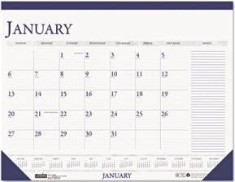
Need a larger space? Try using the large desk planners sold at most office supply stores. The desk calendars have large spaces that are easy to read and have larger boxes for multiple assignments. Projects should still be broken into smaller assignments. Remember to add any family events or trips that may impact the planning schedule. Try using a different color for each class or subject area.

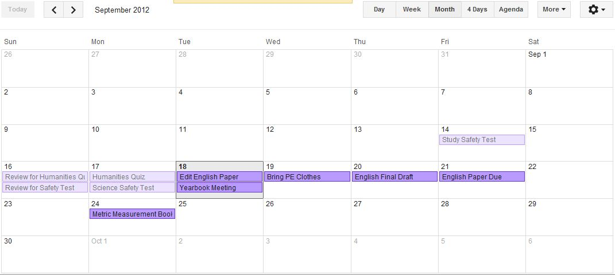
Are you more comfortable with technology than with paper calendars? Try using an online calendar like the Google Calendar below. Students can still use the same planning methods including breaking down large assignments and color coding classes. Make sure that the calendar can be accessed from multiple digital locations (lap top, PC, phone, etc.).

DAILY SCHEDULE

BEFORE YOU LEAVE SCHOOL CHECKLIST

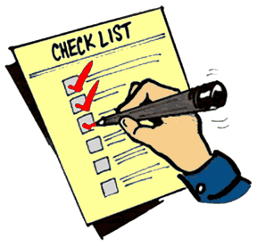

Assignment sheet is complete for each class/subject

Understand all assignments and due dates

Gather all necessary books, notebooks, materials and supplies

Stop by the library/media center if necessary

Talk to or see any necessary person

Review “to-do” list

CAUSES OF POOR CONCENTRATION

CONCENTRATION is the ability to control your attention. Some things prevent you from focusing your attention. Make sure that you prevent the causes of poor concentration below.

- Distracting noises
- Your body “condition”
- Boredom
- Daydreaming
- Hunger
- Worry
- Dislike of subject
- Wrong “time” of day
- TV
- Overwhelming
- Feeling about the task or assignment
- Lack of commitment
- Constant interruptions
- Poor attention span
- Indecision to study
- Lack of sleep
- Poor diet

GOOD HABITS FOR CONCENTRATION

- Intend to study and learn
- Become interested in the subject
  - Look for points of view
  - Question and dare to disagree
  - Predict outcomes
  - See connections/relations within the information
- Know yourself
  - Take advantage of your learning style and modality
  - Use your positive aspects
- Set clear and realistic goals
  - Know what you are supposed to learn
  - Concentrate on the focus of material/information
  - Briefly outline tasks to be completed
- Exclude distractions
  - Keep a “distractions list” and continually try to reduce it
- Use a timer to remind you that a certain amount of time has passed
  - Intend to concentrate and accomplish a certain amount of learning in a specific amount of time
- Eliminate daydreaming from study time!
  - Make a tic/check mark on a piece of paper each time you catch yourself daydreaming
  - Continually try to reduce the number of tic marks from one study block to the next
- Vary your routine within the study block.
  - Change subjects if you become bored
  - Take a 5-10 minute break for every 30-45 minute period of concentration
  - Allow 15-20 minutes for your brain to refocus before beginning new material
- Summarize more often
  - Talk to yourself as if you’re teaching someone the information
  - Talk to someone who is interested in the subject
- Reward yourself for focused, sustained concentration
  - Start with reasonable expectations and short blocks of concentration
  - Continually attempt to lengthen the duration of study blocks
  - Be positive!
  - Tell yourself, “That’s a job well-done!”
BEFORE YOU BEGIN TO STUDY

Setting Priorities
- Consider the following:
- After-school activities and club meetings
- Lessons and homework
- Friends and family
- Plan to space blocks of study time over several days on long-range assignments
- Helps you retain new knowledge and make learning more permanent
- Gives you time to think about and change written assignments
- Realistically plan your time
- One regular block of time each day is best for making studying a habit
- Estimate completion time of assignments
- Do not try to study if you are:
- Hungry or tired
- To cold/hot or sick
- Too comfortable/uncomfortable
- Worried or upset or distracted

Know Yourself
- Know when you study best:
- Are you a morning or night person?
- When are you most productive, awake and alert?
- Do you let everybody know that you should not be disturbed?
- Have you formed a habit of studying the same time each day?
- Know where you study best:
- Consider distractions (TV, Talking, Windows, Music, Particular objects on a
desk/table, People walking by)
- Know why you are studying:
- Why do you need this knowledge/information?
- How is it relevant to you and what you want to do with it?
- Know your learning style:
- Left/right brain dominance
- Visual auditory kinesthetic learning modalities
- Do you study best alone or with others?

Select a special study place
- Environment
- Comfortable, but not too comfortable
- Ventilated and quiet
- Away from things that distract you
- Well-lighted
- Use the same place as often as possible
- make it a habit
- keep study tools on hand
READY… SET… STUDY!

- Gather all materials needed
- Set your mind to study
  - Intend to have focused, effective study time
  - Set realistic goals/purposes to be met during the study session
    - Strive for quality as well as quantity
    - Try to make short and intermediate goals within the time block
  - Become actively involved
    - Continually ask yourself questions about the material
    - Remind yourself to review material often
- Set priorities for assignments
  - Create a “to-do” list for each study block and assign a priority for each assignment to be completed
  - Map out a time line
    - Work backwards from due dates
    - Consider the following
      - Length of assignment
      - Difficulty of book to be read
      - Number of questions to be answered
      - Presentation mode: handwriting or typing
  - Set intermediate goals by a certain date
    - Short-range “chunks” of work are easier to focus upon and handle.
    - Congratulate yourself for completing each intermediate goal
  - Divide time among subjects
    - Study the hardest thing first, when your mind is fresh.
    - Leave routine and less difficult tasks for last
      - Recopying papers
      - Alphabetizing
      - Organizing reports
      - Creating the table of contents
    - Allow time blocks to be spaced over several hours or days
      - This allows material to be “soaked into the subconscious”
      - Reflective time is necessary
      - This is much better for proofreading material
- Warm up your brain
  - Take 1-5 minutes to warm up your mind.
  - Be sure to understand the assignment/requirements for the subject
    - Ask yourself:
      - What to I already know about this?
      - What am I trying to learn from this material?
      - What am I to know by the end of this study block?
  - Review familiar material first
    - Titles/subtitles
    - Boldface type/italics
    - Vocabulary words
    - Review questions
    - Class notes/teacher handouts
  - Apply knowledge of how you learn to warm up and study
    - Use available materials during the study block to make the best use of your learning style
      - Write things
        - Vocabulary words
        - Lists
        - Definitions
        - Diagrams/charts
      - Make a tape of things to remember/memorize
      - Write important information on 3 X 5 cards and post the cards in your room.
    - Learn new study skills that work for you
- Take a break
  - Take a 5-10 minute break for every 30-35 minute study period
    - Do something physical
      - Get something to eat
      - Walk
      - Call a friend
  - Take a short break when switching subjects/topics

I’M DONE—NOW WHAT?

When you finish an assignment:

Review
- Briefly review a summary activity.
  - Skim/scan texts, notes and handouts
  - Talk to yourself
  - Recreate mind maps or other graphic organizers
  - In your mind, try to explain it to someone else
- Talk about it with a friend/classmate/parent.
- Review again within 24 hours.

Overlearn
- Form a study group
- Keep a running list of vocabulary words
- Reread the assignment and your homework to be sure you have completed what was expected.
- Make up test questions about what you have learned.
- Repeat the review steps.

Evaluate
- Is your homework in the correct format, is it organized, and is it easy to read?
- Is this your best effort?
- Did you learn what you set out to learn?
- Do you really know the information for which you will be held responsible?
- Is there a way you can improve?
- Can you relate the material to show that you know it?

TARGET THE PROBLEMS and PRESCRIBE SOLUTIONS

For every problem there is a solution. It just may be that the process of finding the right solution is a bit frustrating at times. Be persistent and confident. Don’t forget to seek help is you need it.

List Classes Here | List problems with studying for each class here | List solutions and study strategies for each class here | Results | Rewards

List Classes Here | List problems with studying for each class here | List solutions and study strategies for each class here | Results | Rewards
GREAT STUDY TIPS

Do you need more tips for studying? Check out the study tips below:

- Allow time for information to “soak in.”
- Too many new ideas at one time are confusing.
- The human brain can successfully process 6-7 ideas during one time period and maintain good retention of the information if enough repetition is used.
- It is less tiring to “spread out” study periods than to “cram.”
- Pace yourself
- Be organized.
- Use the tasks/assignments that do not require great amounts of concentration alternately with more difficult tasks.
- Be sure your study activities are in tune with your intentions.
- Being with the most difficult tasks—and “get it done” so that it won’t hang over your head!
- Make studying a habit!
- Build on your learning strengths.
- Seriously consider the effects of procrastination and how well you can do without them.
- Examine your priorities and how you can make changes to make your life easier and more successful.
- Become aware of your time management patterns and change them gradually to better meet your needs.
- Learn to use spare moments: standing in line, waiting for someone or something, etc.
- Make sure you understand the assignment.
- Break large assignments into smaller, organized parts.
- Set reasonable time limits for yourself.
- Give yourself enough time to do a good job. Go for quality!
- Try new ways to problem solve.
- Always predict the amount of effort and the time required to complete a task.
- Don’t spread yourself too thin. Consider your commitments and the priority of each.
- Really enjoy your “free time.”
- Have a positive attitude about learning.
- It’s OK to dislike the assignment or task, but to it anyway!
- Good grades most often are lost due to lack of organization rather than a lack of information.
- Concentration is the biggest problem when studying.
- Review information just before you go to bed.
- Prop reading material at a 45 degree angle and your eyes will be less tired.
- Seek help if you don’t understand something or if you are having problems.
- Get to know someone in every class you have. You can borrow or trade books, study together, and ask each other questions about assignments.

STEPS TO EASIER LEARNING

STUDY

LEARNER

OVERLEARN

HIGHER TEST SCORES AND GRADES

MORE SELF-CONFIDENCE

… THE EASIER LEARNING BECOMES!

