**Cruisin’ Through Math**

**j0215326**

Strengthening the Foundation

with

Theme-based SOL Review Programs

**Cruise Directors: Clara Hauth-Pflugrath,**

**Linda Gillen & Patricia Freeman**

**Fairfax County Public Schools**

**Franklin Middle School, Chantilly, VA**

March 9, 2013

Welcome to our workshop on *end of year reviews for Math SOLs,* or as we call it*,* “Taking the ‘testiness’ out of State Standards-Based High-Stakes Testing”. We are looking forward to an engaging and productive session. Our goal is to share instructional strategies, hands-on activities and planning tools to help make your review sessions appropriate and successful for all learners.

We would like to take this opportunity to thank the following individuals for their unwavering support and guidance during this educational endeavor. Our Franklin family actively demonstrates the collaborative spirit of a true professional learning community. We extend our gratitude to David Van Vleet, Noel Klimenko, Sharon Eisenburg, Turnell Sims, Asma Junco, Bryan Holland, Patti Bowers, Patricia Freeman, Steven Klarevas, Karen Serroka, Jeannine Domedion, Allison Bivens, Deborah Tucceri, Jennifer Baker, Theresa Duesterhaus, Missy Elles, Josette Kearney, Peggy Richards, Joan Carboni, LaDuska Adriance, Lauren Pflugrath and our families.

Clara Hauth-Pflugrath Linda Gillen

[Clara.Hauth@fcps.edu](mailto:Clara.Hauth@fcps.edu) [Linda.Gillen@fcps.edu](mailto:Linda.Gillen@fcps.edu)

Patti Freeman

[Patricia.Freeman@fcps.edu](mailto:Patricia.Freeman@fcps.edu)

Please note that the following may include information obtained via the internet. Site sources are listed at the end of the sections. Materials are presented as available sites for information use only and are not guaranteed to be accurate and up-to-date. Some materials may be copywrited and are intended for informational and instructional purposes only. These materials are not available for public distribution without the authorization of source consent.

Cruisin’ Thru Math

Preparing for High-Stakes Assessments

Thank you for joining us in our annual high-stakes testing preparation. As middle school general and special education math teachers, we spend the year engaging, teaching and preparing students through the curriculum within the NCTM strand framework. We enjoyed the journey but felt that students, parents and teachers were overly stressed and tired of rote style testing reviews. Three years ago the eighth grade team gathered and in the middle of a winter storm decided that we all needed to take a new look at our preparation and the math cruise idea for review was launched. Since then, we have embarked on cruising the Caribbean with our students several times continually reviewing and enhancing the program based on the needs of our students.

Our cruise is organized around the five strands of the Virginia Standard of Learning blueprint which incorporates the NCTM standards. We focused on each strand for about one week. Each Monday the students entered their classrooms to the sounds of tropical music and we embarked on a new island math topic and adventure.

Teachers shared island information using the internet, slide shows, and classroom technology to engage students in warm-up activities based on the strand of the week. After reviewing the warm up, we used an activity or game to check homework. Each night the homework was to do several problems from, various workbooks, teacher created items or released end-of-year tests. In the course of five weeks, the students practiced test taking strategies and reviewed for the cumulative test. After the homework, we would engage the students in their “life boats” or “diving teams” with a short review lesson and then the students practiced a particular skill with their team.

To monitor and enhance student accountability, we gave them each a passport. Each completed homework assignment earned them a stamp. We gave strand quizzes during the cruise, one each week. The students had to earn a 75% or better to receive another stamp on their passport. An after school session was offered to those earning below 75%. A completed passport was the student’s admission ticket to a party after the Standards of Learning test at the end of the year.

The students were also given a “cruise journal.” This was a folder with each destination, the passport and workspace for them to work the problems of the day. Each child also received a workbook(s) from that was used to assign our daily problems.

This review involved several weeks of preparation time, but once the cruise was in place, each day was another opportunity to engage all students in the discovery of mathematics. Our results, the data from the high-stakes testing have been encouraging. Students are invested in learning and have done very well on subsequent tests. Engaging students, energizing teachers and creating a less stressful atmosphere has become our vision for all of our classes. We hope that today, you can start to create and plan an excursion of your own for the students in your classrooms. Thank you again for joining us!

**Table of Contents**

Welcome to the Franklin Cruise 2013

Collaboration

Developing your cruise

How to use the cruise itinerary map & passport

VA Grade 6,7, 8 SOL Test Blueprint

Resources available for practice questions

**Cruise Destinations** **Concepts**

Miami Muster Drill

Embarking on our journey Discussion/Passports

Formula Sheet

Homework Packets

Cruise Journal

**Bahamas Number Sense**

Bahamas Deep Sea Fishing

**Cayman Islands Computation & Estimation**

Cayman Scuba Dive Activity

**Aruba Measurement & Geometry**

Aruba Jeep Safari Adventure

**Jamaica Probability & Statistics**

Jamaica Captain’s Table Activity

**Cancun Patterns Functions & Algebra**

Mayan Ruins Treasure Hunt

**Miami Welcome Home!**

Test Taking Strategies

Fiesta

**Additional Info Homework Packet**

Letter Cards

**Cruise Planning Guide Notes:**



**Cruise Planning Guide Notes:**



**NCTM**

[**Principles and Standards for School Mathematics**](http://www.nctm.org/standards/) **(Standards 2000 Project) comes from the** [**National Council of Teachers of Mathematics**](http://www.nctm.org/)**.**

|  |  |
| --- | --- |
| |  | | --- | | **NUMBER AND OPERATIONS** | |

* Understand numbers, ways of representing numbers, relationships among numbers, and number systems
* Understand meanings of operations and how they relate to one another
* Compute fluently and make reasonable estimates

|  |  |
| --- | --- |
| |  | | --- | | **ALGEBRA** | |

* Understand patterns, relations, and functions
* Represent and analyze mathematical situations and structures using algebraic symbols
* Use mathematical models to represent and understand quantitative relationships
* Analyze change in various contexts

|  |  |
| --- | --- |
| |  | | --- | | **GEOMETRY** | |

* Analyze characteristics and properties of two- and three-dimensional geometric shapes and develop mathematical arguments about geometric relationships
* Specify locations and describe spatial relationships using coordinate geometry and other representational systems
* Apply transformations and use symmetry to analyze mathematical situations
* Use visualization, spatial reasoning, and geometric modeling to solve problems

|  |  |
| --- | --- |
| |  | | --- | | **MEASUREMENT** | |

* Understand measurable attributes of objects and the units, systems, and processes of measurement
* Apply appropriate techniques, tools, and formulas to determine measurements

|  |  |
| --- | --- |
| |  | | --- | | **DATA ANALYSIS AND PROBABILITY** | |

* Formulate questions that can be addressed with data and collect, organize, and display relevant data to answer
* Select and use appropriate statistical methods to analyze data
* Apply transformations and use symmetry to analyze mathematical situations
* Develop and evaluate inferences and predictions that are based on data
* Understand and apply basic concepts of probability

Where we started – disaggregating the data:

Example of year end assessment information with Virginia State SOL’s used to create the format of the cruise.

**Grade 8 Mathematics Test**

**Blueprint Summary Table**

**Reporting Categories Number of Items Grade 8 SOL**



Number and Number Sense 14 8.1a,b

8.2

Computation and Estimation 8.3a,b

8.4

8.5a,b

Measurement and Geometry 14 8.6a

8.7a,b

8.8a,b

8.9

8.10a,b

8.11



Probability and Statistics 22 8.12

8.13a,b

Patterns, Functions, and Algebra 8.14

8.15a,b,c

8.16

8.17

SOL Excluded from This Test 8.6b

Total Number of Operational Items 50

Field Test Items\* 10

Total Number of Items 60

\*These field test items will *not* be used to compute students’ scores on the test.

Virginia SOL

| **ISLAND** |  | **Eighth Grade Virginia SOLs** |
| --- | --- | --- |
| **Bahamas**  **7**  **questions** | **MTH**  **8.1** | The student will  a) simplify numerical expressions involving positive exponents, using rational numbers, order of operations, and properties of operations with real numbers; and  b) compare and order decimals, fractions, percents, and numbers written in scientific notation. |
|  | **MTH**  **8.2** | The student will describe orally and in writing the relationships between the subsets of the real number system. |
|  | **MTH**  **8.3** | The student will  a) solve practical problems involving rational numbers, percents, ratios, and proportions; and  b) determine the percent increase or decrease for a given situation. |
| **Caymans**  **7**  **questions** | **MTH**  **8.4** | The student will apply the order of operations to evaluate algebraic expressions for given replacement values of the variables. |
|  | **MTH**  **8.5** | The student will  a) determine whether a given number is a perfect square; and  b) find the two consecutive whole numbers between which a square root lies. |
|  | **MTH**  **8.6** | The student will  a) verify by measuring and describe the relationships among vertical angles, adjacent angles, supplementary angles, and complementary angles; and  b) measure angles of less than 360°. |
|  | **MTH**  **8.7** | The student will  a) investigate and solve practical problems involving volume and surface area of prisms, cylinders, cones, and pyramids; and  b) describe how changing one measured attribute of a figure affects the volume and surface area. |
| **Aruba**  **12**  **questions** | **MTH**  **8.8** | The student will  a) apply transformations to plane figures; and  b) identify applications of transformations. |
|  | **MTH**  **8.9** | The student will construct a three-dimensional model, given the top or bottom, side, and front views. |
|  | **MTH**  **8.10** | The student will  a) verify the Pythagorean Theorem; and  b) apply the Pythagorean Theorem. |
|  | **MTH**  **8.11** | The student will solve practical area and perimeter problems involving composite plane figures. |
| **Jamaica**  **8**  **questions** | **MTH**  **8.12** | The student will determine the probability of independent and dependent events with and without replacement. |
|  | **MTH**  **8.13** | The student will  a) make comparisons, predictions, and inferences, using information displayed in graphs; and  b) construct and analyze scatterplots. |
|  | **MTH**  **8.14** | The student will make connections between any two representations (tables, graphs, words, and rules) of a given relationship. |
|  | **MTH**  **8.15** | The student will  a) solve multistep linear equations in one variable with the variable on one and two sides of the equation;  b) solve two-step linear inequalities and graph the results on a number line; and  c) identify properties of operations used to solve an equation. |
| **Cancun**  **16**  **questions** | **MTH**  **8.16** | The student will graph a linear equation in two variables. |
|  | **MTH**  **8.17** | The student will identify the domain, range, independent variable, or dependent variable in a given situation. |

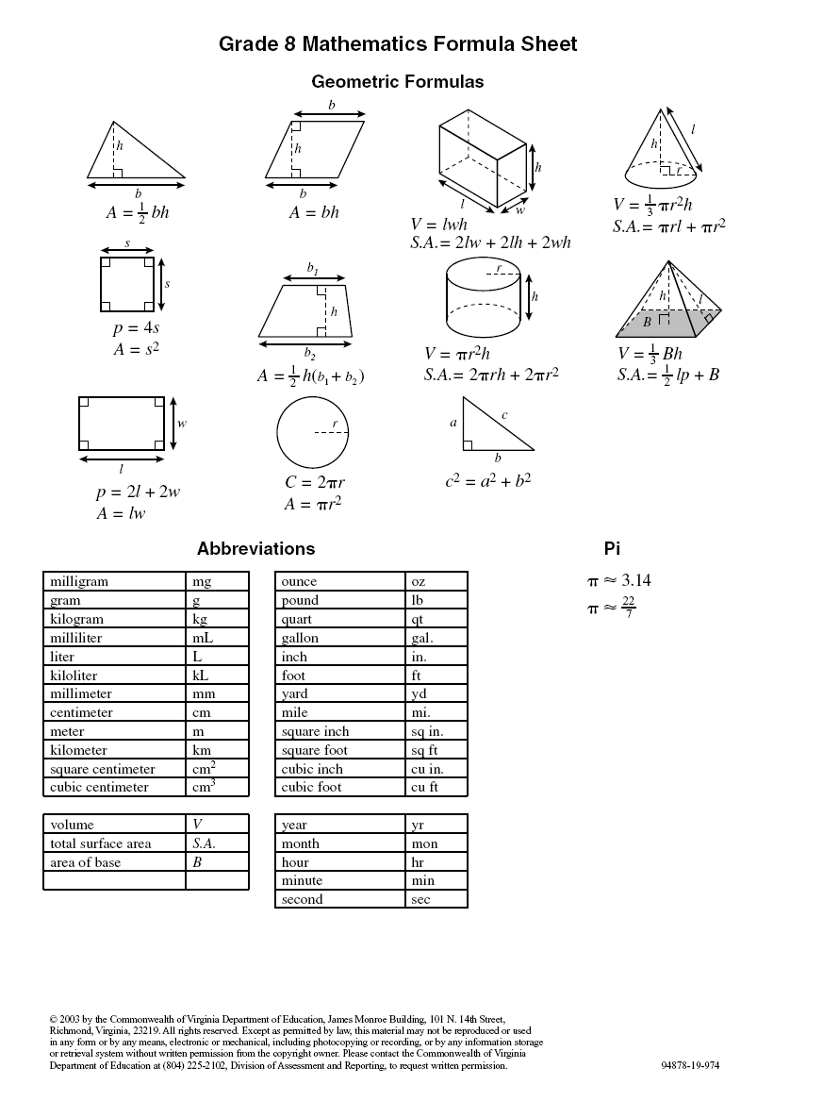

j0215326March 2013

Dear Math 8 Students and Parents!

Well, we’ve done it – we made it through 10 units, 18 objectives and 33 weeks of eighth grade math!

It’s been a fun and busy year. Our next step – SOL prep! The 8th grade team embarks on a 5 week review with a theme of Cruisin’ Through Math. Each week the students will be focusing on a new strand of the mathematics standards. This review will enhance their understanding of each concept we have learned this past year. We travel on our cruise through the Caribbean, stopping at spots of interest which we incorporate into our review!

It is a great 5 weeks and we look forward to working with the students as they journey to the end of their eighth grade year and the SOL test, which is on the computer this year and scheduled for the week of May 28, 2013.

Each student will be given a Cruise Guide which is a folder for their journal and homework problems. This folder should be written in daily and used for warm up activities, homework assignments and questions regarding each unit. Students will also be given a book called Measuring Up, which is a paperback workbook, to be used only for reference materials and assignments and is not to be written in by the student.

Parents, thank you for your support of the review and activities. Please continue to encourage your student through homework completion, test preparations and review activities available on Blackboard through the Math 8 external site links.

We look forward to a great review unit and the culmination of a successful SOL preparation course.

Bon Voyage!

Name:\_\_\_\_\_\_\_\_\_\_\_\_\_\_\_\_\_\_\_\_\_\_\_



Period: \_\_\_\_

Cruise Director(s) \_\_\_\_\_\_\_\_\_\_\_\_\_

\_\_\_\_\_\_\_\_\_\_\_\_\_\_\_\_\_\_\_\_\_\_\_\_\_\_\_\_

**Cruise Passport**

|  |  |  |  |
| --- | --- | --- | --- |
| **Week: Port of Call** | **Homework Completion** | **Classwork/Participation** | **Test – 75% pass rate** |
| **Week One: Bahamas**  **April 25-April 29** |  |  |  |
| **Week Two: Cayman Islands**  **May 2-5** |  |  |  |
| **Week Three: Aruba**  **May 9-13** |  |  |  |
| **Week Four: Jamaica**  **May 23-27** |  |  |  |
| **Week Five: Cancun**  **May 30-3** |  |  |  |
| **Customs PASS**  **Welcome Home Fiesta**  **June 3** |  |  |  |

**Total Cruise Points: \_\_\_\_\_\_\_/\_\_\_\_\_\_\_**

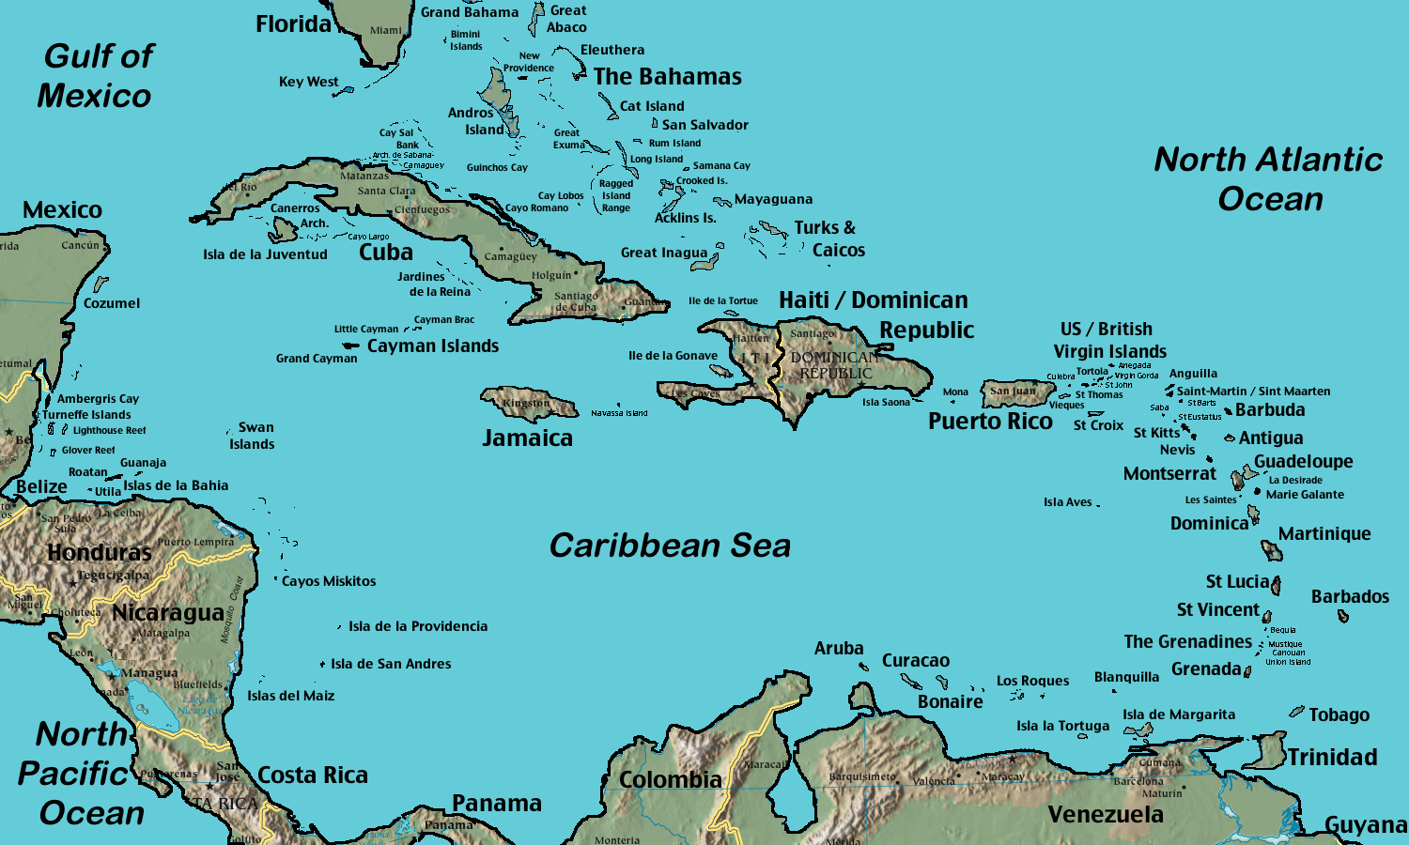

http://www.google.com/search?hl=en&q=google+maps+free+caribbean

**Disclaimer: All itineraries are subject to change without notice. If we run into bad weather we may have to stay longer. Prevailing seas may mean that we move to the next island at a faster clip. See your cruise directors daily for any additional announcements.**

Cruise Ledger

As you get started on your cruise you need to look at your finances and be prepared to keep track of your expenses. You have saved for this trip and are starting with a balance of $500. You have remembered to bring your checkbook with you so that you can take advantage of activities on the islands that you will be visiting. Have fun!!!!!

Bahamas

1. You make out a check to Bahamas’ Deep Sea Fishing Expedition in the amount of $55.
2. You forgot your suntan lotion! The cost is $5.89 plus a 5% tax. Make the check out to ABC Pharmacy.
3. Your last paycheck of $125 is deposited in your account.

Cayman Islands

1. You make out a check to Scuba Steve’s Dive Shop in the amount of $45 for your dive experience.
2. Great news! You won at bingo. Deposit $60 into your account.

Aruba

1. You are looking forward to your Jeep Safari today. Make your check out to Aruba Jeep Adventures in the amount of $50.
2. Oh Darn! You discovered that the shorts that you really wanted to wear today are ruined. You run to the ship’s gift shop to buy some. As luck would have it, they are having a 30% sale on shorts today. You but some that are originally priced at $42.50. Don’t forget that you have to pay a 6% tax. Make the check out to Franklin Cruise Line Gift Shop.

Jamaica

1. What luck! You are the one millionth customer at Coco Moe’s gift shop. You win $100. Deposit it in you bank account.
2. Feeling generous now, you decide to buy you and your friends lunch on the island. Your lunch costs $38.50. Don’t forget to add an 20% tip and 7% tax. Make the check out to Tropical Paradise Café.

Cancun

1. Treasure Hunt Day has arrived. Make a check out to Mayan Ruins Adventures in the amount of $25.
2. You buy your grandparents a gift. Your total bill is $38, but don’t forget the 5% tax.

**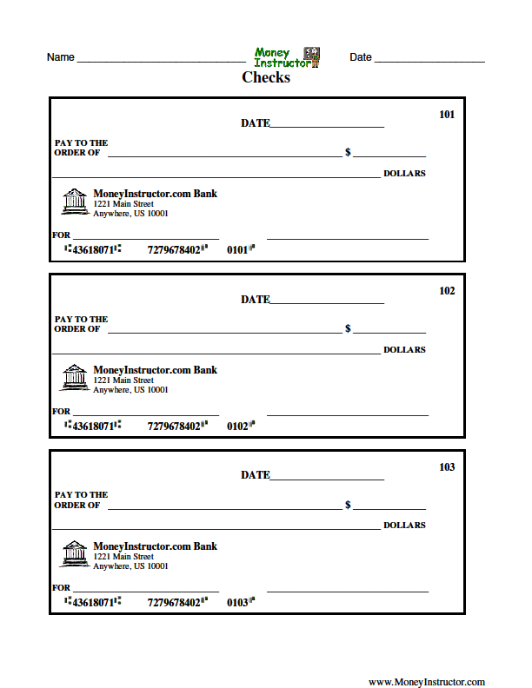**

**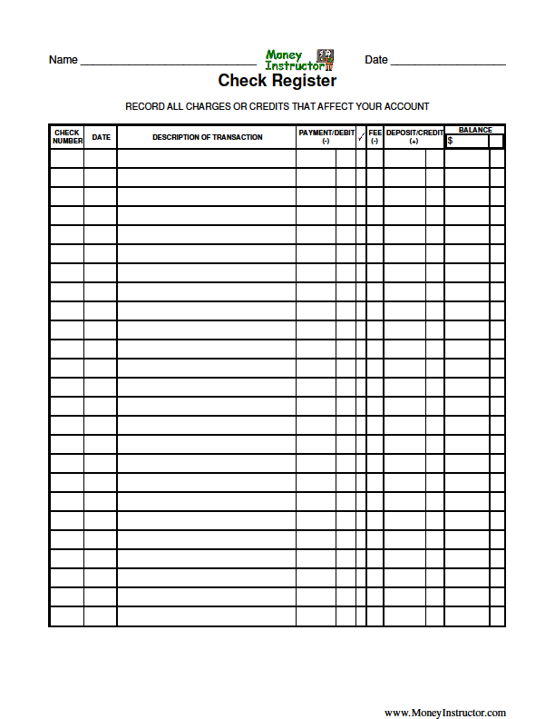**

**Cruise Journal**



**Date: Island:**

**Name: Date:**

**Work space for HW**

|  |  |
| --- | --- |
|  |  |
|  |  |
|  |  |
|  |  |

**Bahamas Deep Sea Fishing Game**

**1**

**3**

**4**

**5**

**7**

**9**

**10**

**8**

**6**

**2**

**Bahamas Deep Sea Fishing – Number Sense Review Game Instructions**

**The Bahamas game is designed to engage the students in an activity**

**related to the units for Number Sense.**

**Copy and laminate fish template – colored paper and card stock if available**

**Cut out fish and use magnets for placement on the board.**

**Create an Ocean Scene for the board.**

**Before the students come in the room, place a point value behind each fish**

**on the board that is hidden from the students (examples 100, 200, 300 etc.).**

**Tell students that this is our first excursion and that they will become**

**very good at deep sea fishing and that they will accumulate points for the fish**

**that they “catch.”**

**Have students work independently on the Bahamas Deep Sea Fishing**

**Worksheet. They must show all of their work and we suggest that they**

**use the cruise journal sheets to show their work.**

**After the students have finished the ten practice problems have them**

**get into groups to discuss their answers.**

**Divide the class into two or more teams.**

**The game begins with the teacher asking one student from team A**

**to “fish” by selecting one of the fish on the board numbered 1-10.**

**The student then answers the question that has the same number from the worksheet. If correct, the teacher takes the fish off the board and awards the designated points to that team. If incorrect, the other team has a chance to**

**“catch” that fish and earn the points. The next team chooses a fish and the game continues until all of the questions are answered.**

**Tally the points for each team and congratulate all of the students on**

**a successful fishing trip.**

**Hand out small package of goldfish to all of the students! Allow students to enjoy their “catch.”**

**Catch me if you can!**

**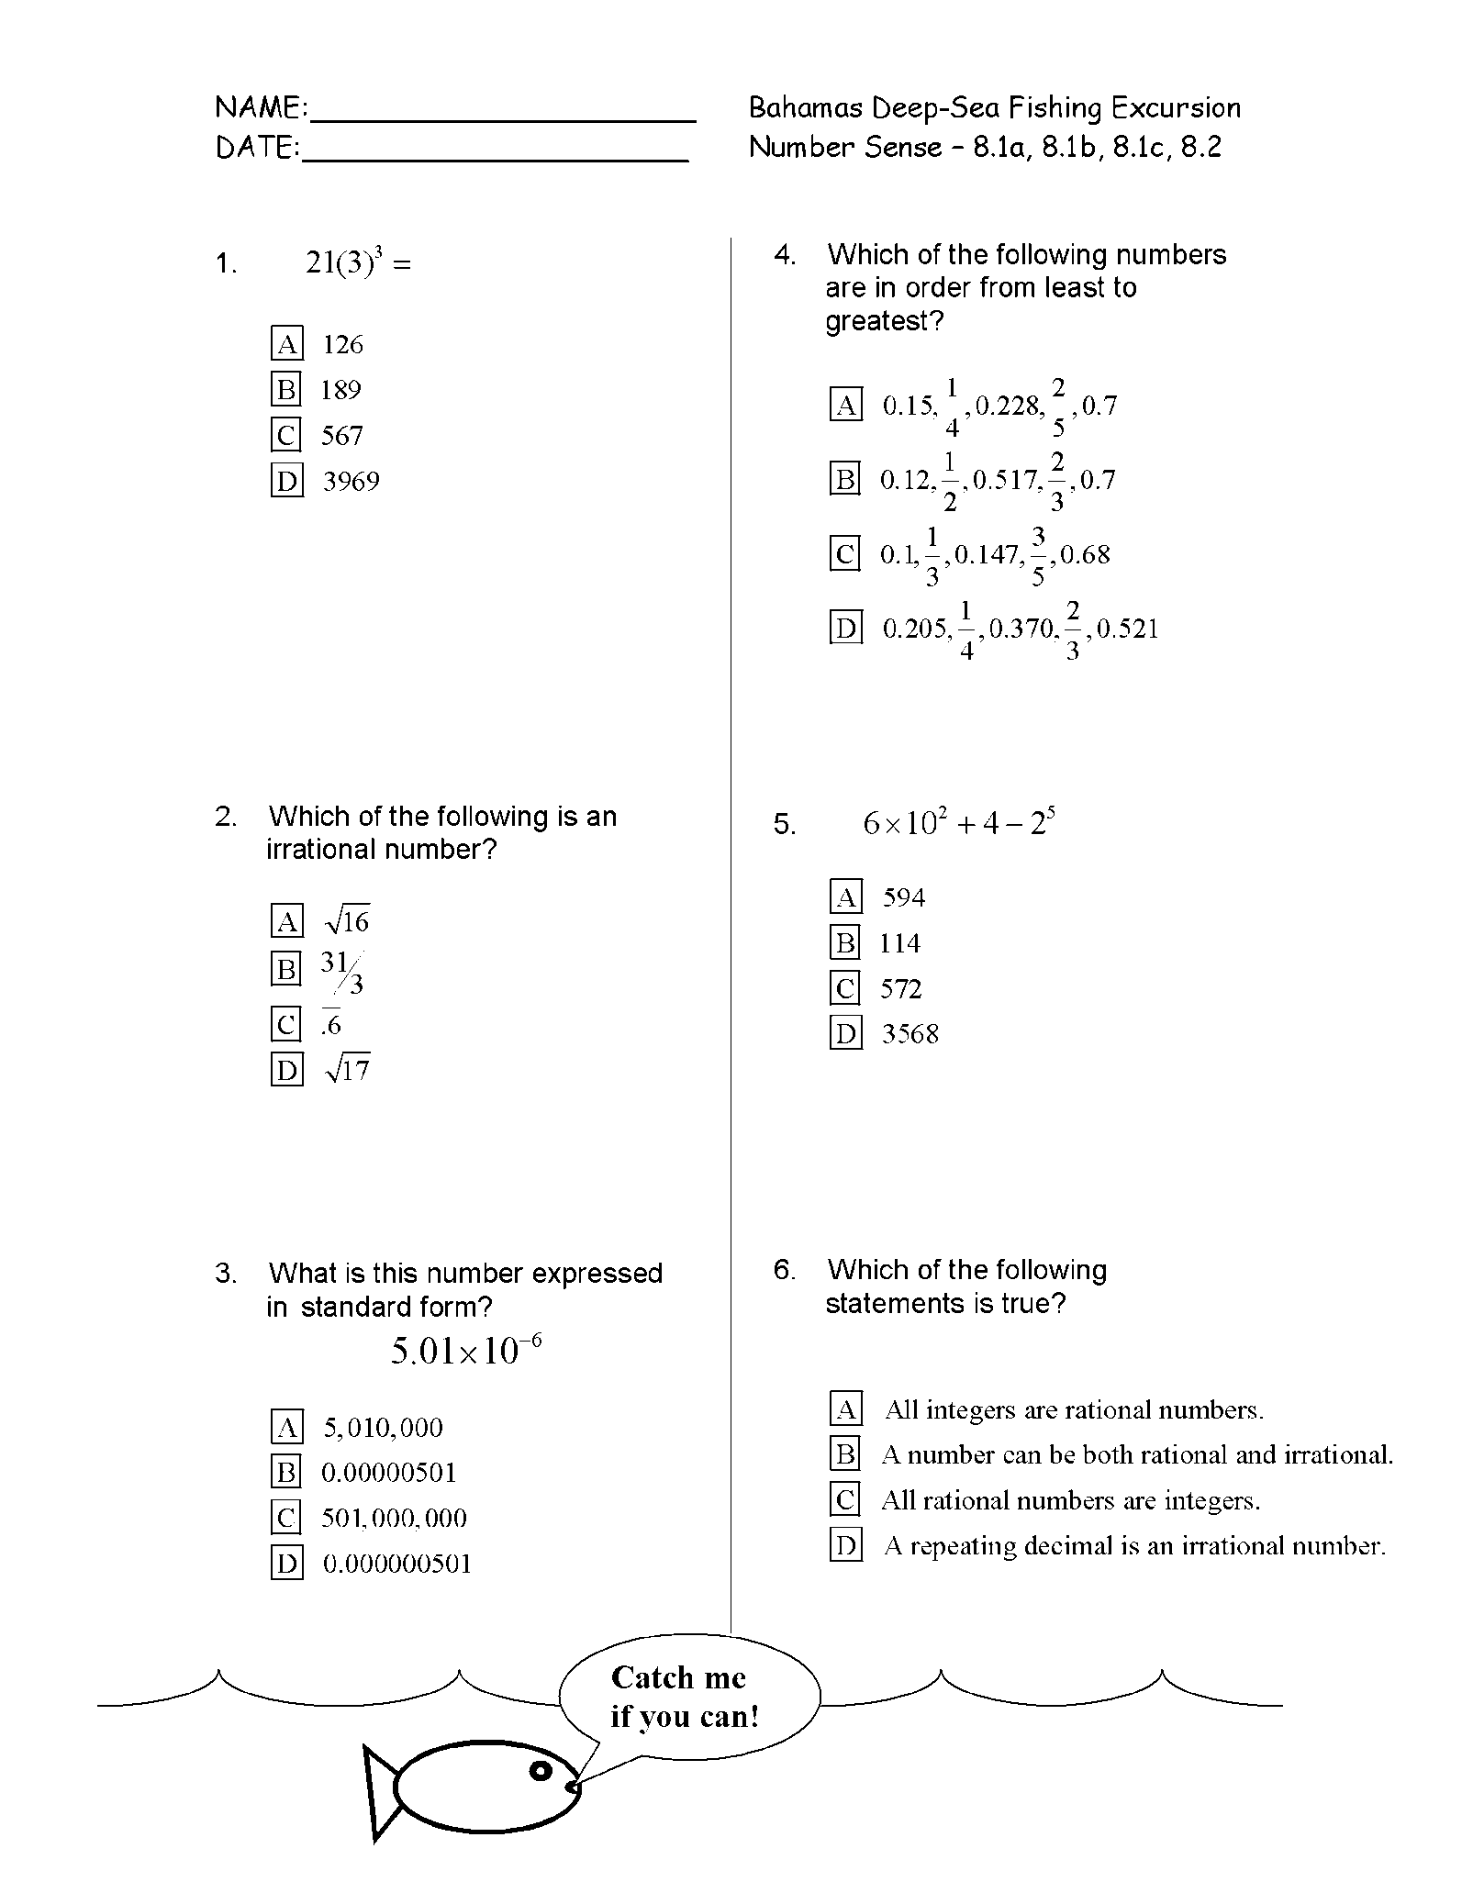**

**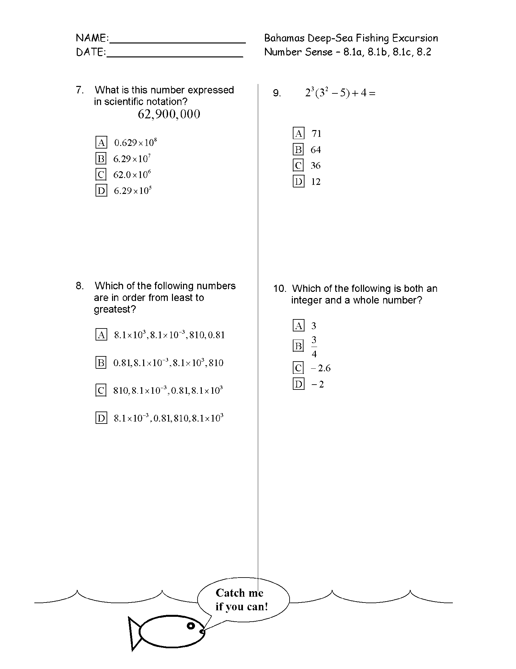**

j0288994

**Diving into Computation & Estimation with Scuba Steve!**

**This is a game is a scuba dive student activity based on review questions relating to computation and estimation.**

**Copy and laminate the Scuba Dive Activity page. One for each table**

**or group of 2 to 4 in your classroom.**

**Each student receives a worksheet of 10 problems regarding computation**

**and estimation. Students should work independently and again show all of their work, before they can participate in the dive.**

**They receive their diving certification when all of the problems are completed and all work is shown At that point the student is given his diving game piece**

**(we use the four different color centimeter cubes as game pieces).**

**After the whole class has a game piece, the actual dive begins. Each player puts his/her diver (cube) on the waves at 0 feet, or sea level.**

**Teachers will ask for responses for one question at a time. Again this is at your discretion, we often use ABCD cards or white boards with the students to get a quick look at the answers. Answers should be discussed one at a time as needed.**

**If the student has the correct answer, he/she gets to dive to the next 100 foot level on the board. If the student is not correct, they have the opportunity to re-do the problem with the class as it is discussed and then move their game piece. We dive in groups so each table wants to help their fellow divers succeed.**

**When all of the questions have been answered and discussed the students announce the dive teams that have made it to 1000ft.**

**Students are given AIRHEADS for making the dive and having enough air to make it back to the boat.**

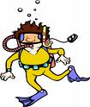

**Are you ready to dive on in!**



**Dive into math with SCUBA STEVE!**

|  |  |
| --- | --- |
| 0 | Ready, set, get your fins wet! |
| 100 feet | Wow – this is cool, I can see the bottom of the boat! |
| 200  feet | Fish swimming in schools to your left – they are checking your work! |
| 300  feet | Is that a shark behind you? |
| 400  feet | I never thought I would make it this far! |
| 500  feet | Stop here and check your air! |
| 600  feet | Can we check out the sunken ship? |
| 700  feet | That is one weird fish! |
| 800  feet | Hey, can you please turn on your headlamp? |
| 900  feet | I can see the bottom! |
| 1000  feet | Wow it is deep and dark down here! You WIN, head back to the boat! |

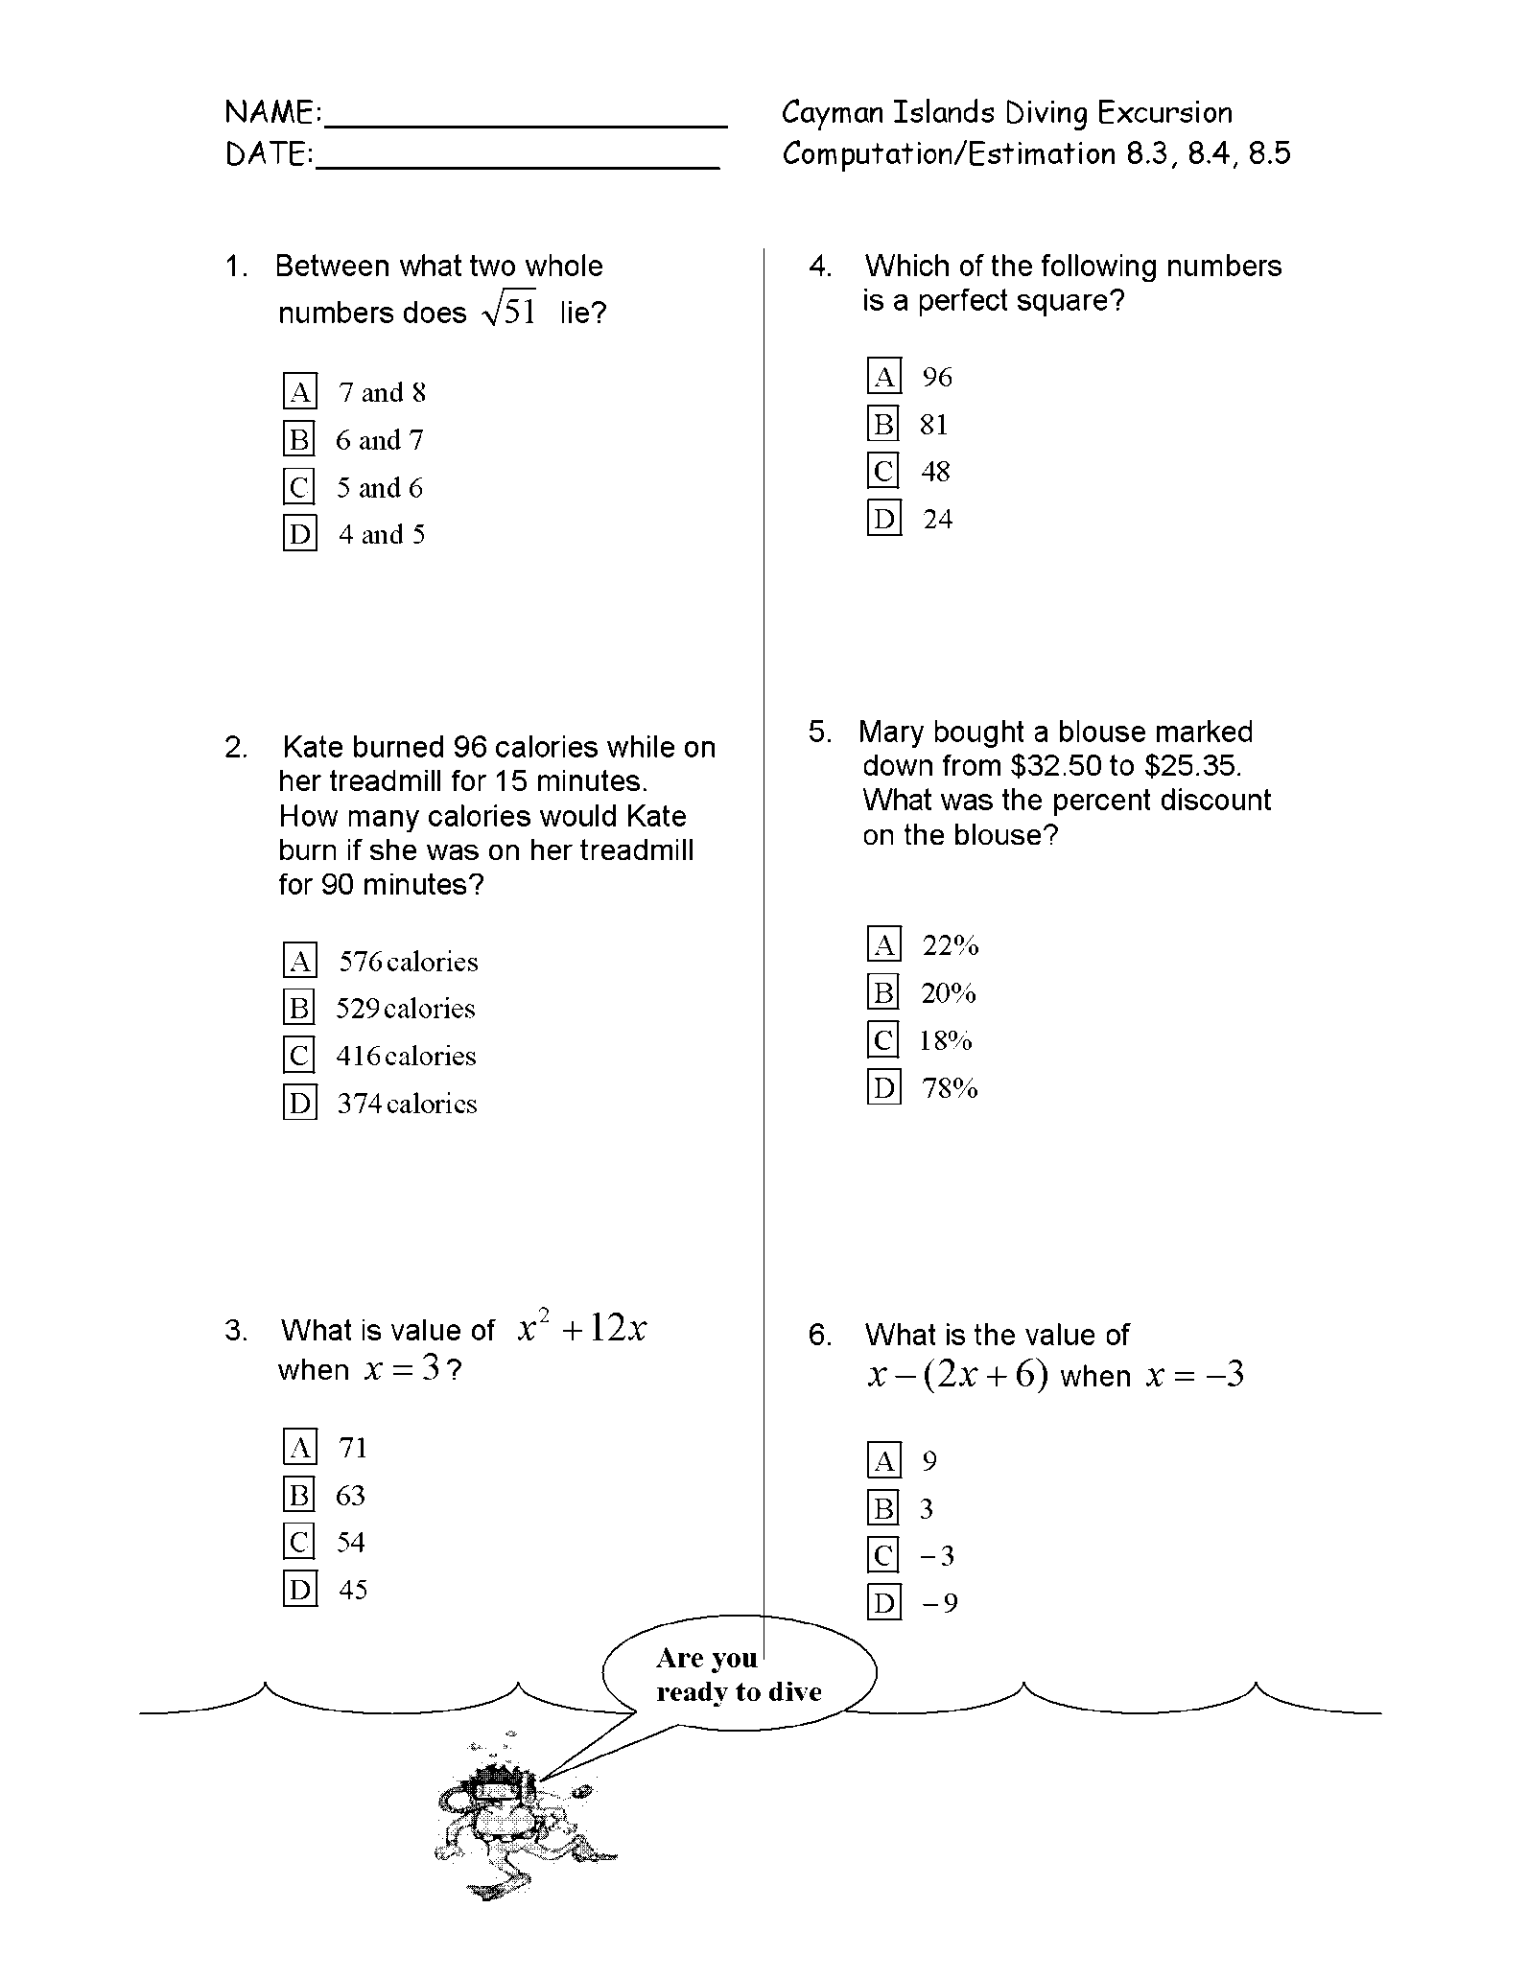

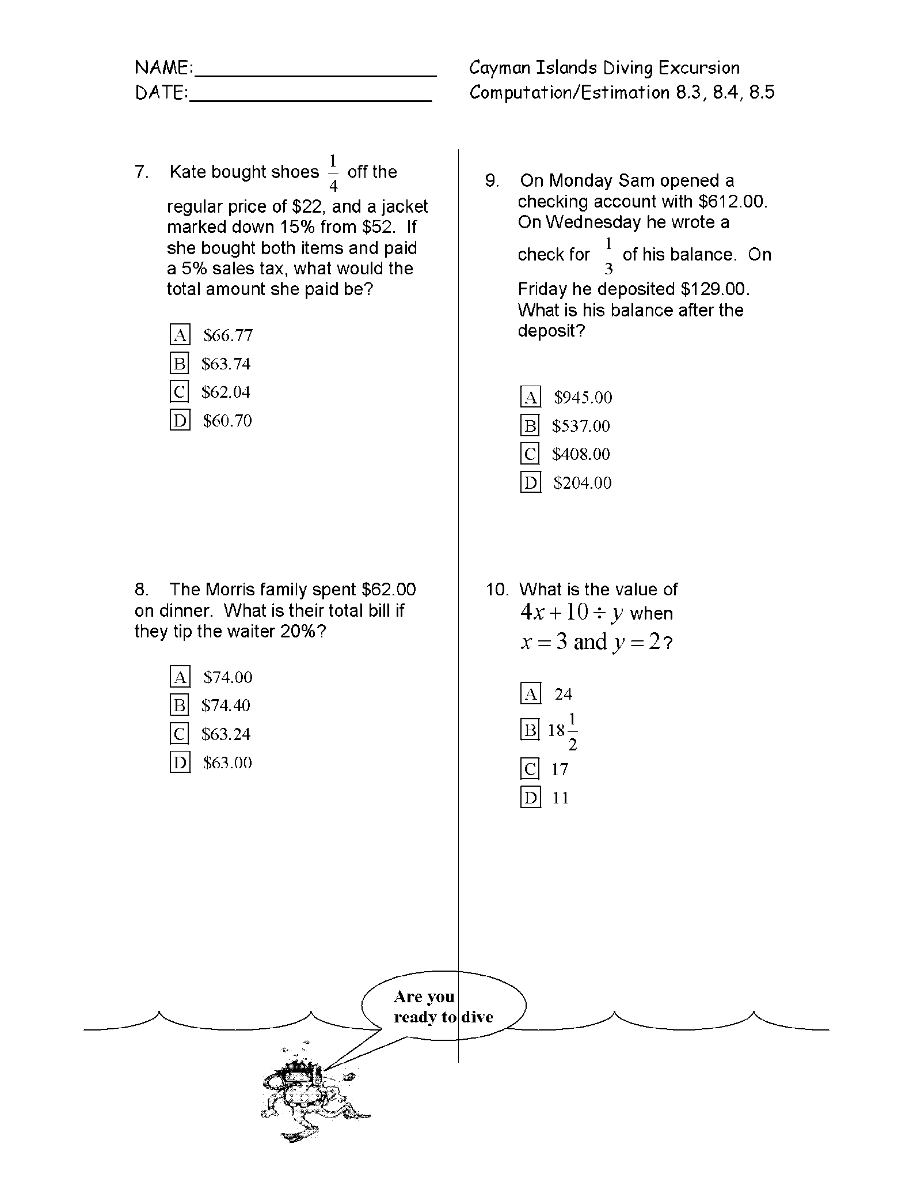



**Aruba Jeep Safari**

**Overcoming all obstacles with MATH!**

**Aruba’s Motto is “One Happy Island.”**

**The Aruba Jeep Safari is a student based activity designed to be used with review for measurement and geometry.**

**Copy and laminate the map of Aruba for the game board. You will need enough for groups of two students. Students will act as jeep drivers and navigators through the road map of Aruba. Tell students that they will switch positions at the ½ way mark.**

**Have students get into teams of two.**

**Hand out the 20 question worksheet regarding measurement and geometry.**

**Students can work in pairs on this assignment; however, each student must show all of their work for each problem, whether on another sheet or in their journal.**

**After the students have completed the problems for the activity, give each team a game piece. Again, centimeter cubes, small plastic jeeps, or whatever you have in your classroom can be used as game pieces. One game piece per team.**

**The game piece will be placed at the # 1 on the map.**

**Review each question and the navigator must show the team answer on a white board or with the ABCD letters.**

**If the answer is correct, the driver moves the jeep to #2 on the map. The game continues until all of the questions are answered through # 15. Now the game changes and with each correct answer, the team can drive “off road.”**

**After everyone has gone “off road” the activity winds down until all of the answers are given.**

**Students are given kudos for their excellent navigation and driving skills. For navigating the big boulders on the island, students may given a small token for navigating the bumps in the road to remember their adventure a.k.a., a “jolly rancher” candy.**

**Aruba Jeep Safari Map**

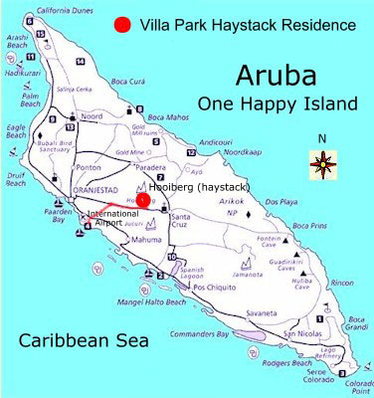

**j0233473**

**http://www.arubahaystack.com/layout/fotos/aruba-eiland.jpg**

**Jamaica Dining at the Captains Table**

**Cruises can be great fun and one of the things you get to do is eat, and the very important VIP’s have the opportunity to dine with the Captain at his table.**

**This invitation with the problem “questionnaire” is handed to each student as they enter the room.**

j0237192

Because of your incredible

efforts at deep sea fishing,

scuba diving and off road jeep driving, you are cordially invited to join the Captain at the table today. Please complete the following “questionnaire” to earn your seat at the table.

Regards, Your Captain

**Have students work in groups of 4 on the “tablecloth” to solve each problem. Students then check their answers together and put the team’s answers in the middle of the table cloth. These answers are checked by the teacher and if any are incorrect, the team must re-do the problems until all of them are correct. At that point the team is invited to the Captain’s table (area set up by the teacher, with a table cloth, basket of treats) to enjoy their “meal.” (We used sparkling cider and small bags of crackers or cookies).**

**Table cloth or math mats –**

**Use a piece of newsprint paper or large poster size paper.**

**Separate the paper into 5 workspace areas like the diagram below:**

**Workspace for student 1**

**Workspace for Team Workspace for**

**student 4 answers student 2**

**Workspace for student 3**

MCj02372020000[1]

**Mayan Treasure Hunt – Cancun – Patterns, Functions & Algebra**

**The students will engage in a “treasure hunt” activity based on the review for patterns, functions and algebra. Because this is the area where many test questions are derived, this activity should take place over several days.**

**Set up: Student are given a map of the ruins with a circle on the back for the “key” puzzle pieces which they will earn as they answer questions correctly each day.**

**Depending on your time frame you can cut the Mayan “key” picture into 3 – 5 pieces.**

**We copied the Mayan key, cut each into 5 pieces and put all of the day 1 key pieces in an envelope so that it would be easier to distribute each day. We had 5 envelopes; each had a class set of one piece per envelope.**

**Use the descriptions of each site as the opener for the day. Have the information and picture up on the board, screen or smartboard before the students start the work for that Mayan site.**

**The goal of the week is for the students to review all 5 objectives for the PFA SOL.**

**Give the students the work problems for the day. Have them complete the work and review the answers. When the students have answered the questions correctly, they get a piece of the key to glue onto the back of their map.**

**This activity runs for several days and students can work at their pace.**

**The object of the activity is to answer all of the review questions, receive all of the pieces of the key and then turn the completed Mayan key to open the treasure chest.**

**Before students arrive, set up the game activity problems strategically around your room.**

**Upon completing the hunt, students can choose a treasure from – you guessed it a dressed up shoe box or other treasure box that you have created. Inside – ring pops, candy, chips, stickers, pencils… whatever you choose.**

|  |  |
| --- | --- |
| Mayan Ruins fill  The world of the ancient Maya encompassed the Central American countries of Belize, El Salvador, Guatemala and Honduras as well as Mexico's southeastern states of Chiapas, Tabasco and the three states of the Yucatan Peninsula: Campeche, Quintana Roo and Yucatan.  This region, now known as the Mundo Maya (Maya World), contains more than 3,000 architectural sites of this ancient and powerful culture, whose incredible legacy and ritual secrets await almost daily discovery. |  |
| [www.cancuntoday.net/ruins/yucatan.gif](http://www.cancuntoday.net/ruins/yucatan.gif) used for maps, information on Mayan ruins |  |

**Mayan Treasure Hunt “Key” Picture**

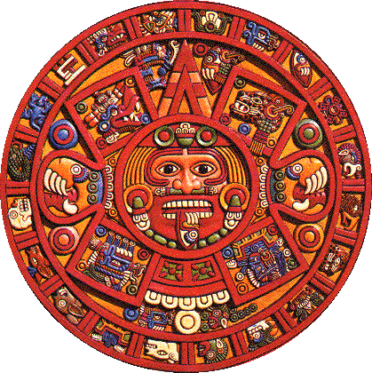

http://webexhibits.org/calendars/i/aztec2.gif

Treasure Hunt Team Period: \_\_\_\_\_\_\_\_\_ Cancun – Mayan

Patterns, Functions & Algebra

\_\_\_\_\_\_\_\_\_\_\_\_\_\_\_\_\_\_\_\_\_

\_\_\_\_\_\_\_\_\_\_\_\_\_\_\_\_\_\_\_\_\_ 8.14, 8.15, 8.16, 8.17, 8.18

\_\_\_\_\_\_\_\_\_\_\_\_\_\_\_\_\_\_\_\_\_

**Mayan Treasure Map Key – place the pieces on the circle to complete the key to the treasure!**

1

2

3

4

5

1. El Rey
2. Coba
3. Uxmal
4. Chichen Itza
5. Tulum

1) y = x – 3

x x – 3 y

0

-1

2

List the ordered pairs: ( , ), ( , ), ( , )

CONNECT THE POINTS WITH A LINE!



**List the domain: \_\_\_\_\_\_\_\_\_\_\_\_\_\_\_\_\_\_\_\_\_\_\_\_\_\_\_\_\_\_\_\_**

**List the range: \_\_\_\_\_\_\_\_\_\_\_\_\_\_\_\_\_\_\_\_\_\_\_\_\_\_\_\_\_\_\_\_\_\_**

2) y = 2x + 2

x x + 2 y

0

-1

1

List the ordered pairs: ( , ), ( , ), ( , )

CONNECT THE POINTS WITH A LINE!



**List the domain: \_\_\_\_\_\_\_\_\_\_\_\_\_\_\_\_\_\_\_\_\_\_\_\_\_\_\_\_\_\_\_\_**

**List the range: \_\_\_\_\_\_\_\_\_\_\_\_\_\_\_\_\_\_\_\_\_\_\_\_\_\_\_\_\_\_\_\_\_\_**

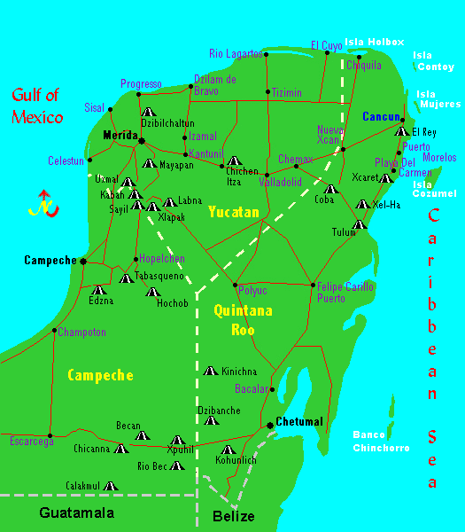

www.cancuntoday.net/ruins/yucatan.gif

**http://www.cancuntoday.net**

**El Rey Mayan Ruins**

|  |  |  |
| --- | --- | --- |
| The ruins, El Rey (The King), is a post-Classic Period archaeological site located right in Cancun's Hotel Zone near the southern end of the island, across from Playa Delfines.  Inhabited from the 10th century AD until the beginning of the 16th century AD, its structures include plazas surrounded by buildings and several platforms that are connected by a long pathway. The site takes its name from a skeleton uncovered there and thought possibly to be a former Mayan king. |  | elrey |
|  | | |
| Tulum Mayan Ruins fill  An important coastal trade city in the Mundo Maya, Tulum was a walled settlement inhabited from the 3rd century AD to the 10th century AD.  Here, the edifice, El Castillo (The Castle), is built on a high cliff overlooking the Caribbean Sea and creates a stunning vista, especially at sunrise. Other important structures are the Temple of the Frescoes, which is ornately painted on the interior and adorned with detailed carved masks at each corner, and the Temple of the Descending God with intricate bas-relief carvings. |  | tulum |

|  |  |  |
| --- | --- | --- |
| Chichen Itza Mayan Ruins fill  The Mundo Maya's most famous site, Chichen Itza was founded in 445 BC and inhabited until 1204 AD when, mysteriously, it was abandoned.  The site is centered around the largest structure, the pyramid El Castillo (The Castle), which has steps that end in huge serpents heads. During the Equinoxes, these steps cast shadows which give the appearance of a great snake descending the pyramid. Other important buildings include the Observatory, the temple of Chac Mool, and the Tzompantli, a representation of the underworld. |  | chichen |

|  |  |  |
| --- | --- | --- |
| Coba Mayan Ruins fill  The city of Coba was a huge settlement of the ancient Maya, occupying almost 60 square miles and dozens of roads leading in and out of the city. The site contains the Nahoch Mul pyramid, the tallest in the Mundo Maya, and is one of a central area made up of five groups of buildings.  This important settlement of the Maya has a history dating from around the 2nd century AD through the 11th century AD and has many interesting structures including another pyramid, La Iglesia (The Church), and a set of nine circular altars. |  | coba |

|  |  |  |
| --- | --- | --- |
| Uxmal Mayan Ruins fill  Considered one of the most striking of all the ancient cities of the Maya, Uxmal dates from the Classic Period and is seen rising magnificently from the hills of the Puuc Range. The buildings and structures here are in excellent condition and one, the Pirimide del Adivino (Pyramid of the Seer), offers the most breathtaking view in all the Yucatan.  The nightly Light and Sound Show will provide you with a different aspect of this mysterious and captivating archaeological site. |  | uxmal |

**Other informative site:**

**http://locogringo.com/research/ruins.html**

**Fun Review letters – Copy, laminate and put on a ring for students to use as you review for the test.**

A

**B**

C

D

**Cruise Planning Guide Notes**

**Cruise reference site sources:**

http://nctm.org

[www.doe.virginia.gov](http://www.doe.virginia.gov)

http://www.google.com/search?hl=en&q=google+maps+free+caribbean

<http://www.arubahaystack.com/layout/fotos/aruba-eiland.jpg>

[www.cancuntoday.net/ruins/yucatan.gif](http://www.cancuntoday.net/ruins/yucatan.gif)

http://webexhibits.org/calendars/i/aztec2.gif

<http://www.cancuntoday.net>

http://locogringo.com/research/ruins.html

ww.moneyinstructor.com

Math

MCSL00657_0000[1] Road Trip

Travel agents: 7th Grade Mathematics Teachers

Franklin Middle School

Chantilly, Virginia

Mathematics Road Trip

Preparing for High-Stakes Testing

As fourth quarter draws near every math teacher asks the same question, “What am I going to do to get these kids ready for the high stakes testing?” Last year that is exactly what happened to the 7th grade math teachers at Franklin Middle School.

Our 8th grade colleagues used a theme-based program to prepare Math 8 for their final test. They went on a cruise and were very successful. We loved the idea, but couldn’t use the same theme, so we brainstormed and came up with the idea for a Road Trip. We would travel across the country in an RV and visit roadside oddities. One of our rationales was that this would put all students on an even playing field. Unlike Disney World, which has been visited by many, but not all of the students, most students had never seen the places where we were going.

We organized our trip around the five strands of the Virginia Standard of Learning blueprint and focused on each strand for about three days. Each day the students entered the classroom to the song “On the Road Again”, by Willie Nelson as our Road Trip power point told of our day’s destination. The slide told the story of our location and posed one or two question for a warm up. After reviewing the warm up, we used a game to check homework. Each night the homework was to do several problems from released end-of-year tests. In the course of three weeks, the students practiced three entire tests. After the homework, we had a quick lesson and then the students practiced a particular skill with their team, so that most of the class time was used to practice.

To make the students accountable, we gave them each a “driver’s license”. Each completed homework assignment earned them a stamp. We gave three quizzes during the Road Trip, one each week. The students had to earn a 75% or better to receive another stamp on their driver’s license. An after school session was offered to those earning below 75%. A completed driver’s license was the student’s admission ticket to a party after the Standards of Learning test at the end of the year.

The students were also given a “suitcase”. This was a folder with each destination and workspace for them to work the problems of the day. Each child also received a Measuring Up book. It was from this book that we assigned our daily problems.

This review did involve some preparation time, just like any good lesson plan, but once the trip was in place, each day was another adventure for the students and teacher! Try a road trip, or cruise, or another theme to prepare your students for their very important high-stakes tests.

Linda Hall Gillen

Franklin Middle School

Chantilly, Virginia

[Linda.Gillen@fcps.edu](mailto:Linda.Gillen@fcps.edu)

MCj04160040000[1]MCj04160060000[1]

**Driver’s License**

|  |  |  |  |
| --- | --- | --- | --- |
| **Week:** | **Homework Completion** | **Classwork/Participation** | **SOL Quiz– 75% pass rate** |
| **Week One:**  **May 12-May 16** |  | Fraction Percent Stamp  Fraction Percent Stamp |  |
| **Week Two:**  **May 19 - 23** |  |  |  |
| **Week Three:**  **May 27 - 30** |  |  | Fraction Percent Stamp |

**Total Trip Points: \_\_\_\_\_\_\_/\_\_\_\_\_\_\_**

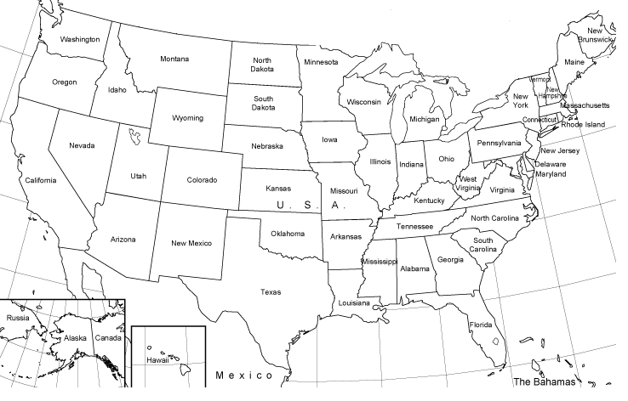The Mathematics Road Trip   
Map Itinerary

Longview, WA

Elmo, MT

Jackson Hole, WY

Custer, SD

Boys Town, NE

Burlington, IA

Dublin, OH

Fairfield, CA

Winchester, VA

Blackfoot, ID

Sumner, MO

Alliance, NE

Chantilly, VA

Roswell, NM

**Disclaimer: All itineraries are subject to change without notice. If we run into bad weather or car troubles we may have to stay in a location longer. Great driving weather and good music in the car may mean that we move to the next location at a faster clip. See your road trip directors daily for any additional announcements.**



MCSL00657_0000[1]**Trip Itinerary**

**Number & Number Sense**

* Convert fractions, decimals & percents
* Compare & order rational numbers
* Scientific notation
* Order of operations
* Properties of real numbers

**Computation & Estimation**

* Integers
* Word Problems with Integers
* Ratios & proportions
* Percent problems
* Word problems with proportions & percents

**Geometry & Measurement**

* Surface area of rectangular prisms & cylinders
* Volume of rectangular prisms & cylinders
* Compare & contrast quadrilaterals
* Similar figures
* Transformations

**Probability & Statistics**

* Theoretical versus experimental probability
* Simple and compound events
* Tree diagrams & the Fundamental Counting Principle
* Mean, median, mode, & range
* Frequency distribution & line plots
* Histograms
* Stem-and-leaf plots
* Box-and-whisker plots
* Scatter grams
* Circle graphs
* Analyze data

**Patterns, Functions & Algebra**

* Arithmetic & geometric sequences
* Functions
* Translate expressions & equations
* One-step & two-step equations
* One-step inequalities
* Word problems using one-step equations
* Represent relationships with tables, graphs, rules, and words

MCj03706900000[1]**Trip Journal**

**Date: Location:**

**Measuring Up Assignment: \_\_\_\_\_\_\_\_\_\_\_\_\_\_\_\_\_\_\_\_\_ Date:**

Corn Game Template

MCFD01247_0000[1]

Use centimeter cubes to fill the corn at each table as students get correct answers to HW.

**Road Trip Reference Site Sources:**

[www.city-data.com](http://www.city-data.com)

[www.dublin.oh.us](http://www.dublin.oh.us)

[www.mapquest.com](http://www.mapquest.com)

[www.puzzlechoice.com](http://www.puzzlechoice.com)

[www.roadsideamerica.com](http://www.roadsideamerica.com)

[www.theteacherscorner.net](http://www.theteacherscorner.net)

[www.united-states-map.com/usa7243](http://www.united-states-map.com/usa7243)