Adding a Student to a Parent Portal Account

- Log in to your Parent Portal account.

- Click on the Account Preferences icon on the left side of the page.
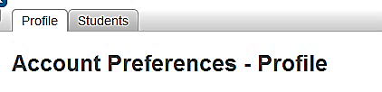
- Click on the “Students” tab at the top of the Account Preferences page.

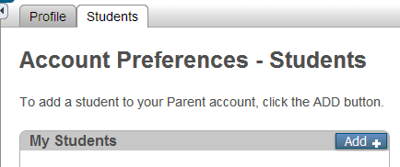
- When the “Account Preferences – Students” page opens, click the blue “Add+” button.

- An “Add Student” window will open showing the same information categories that were completed when you set up the original account. Complete the information and click Submit. **NOTE: You will need the student’s Birthdate and Student Number.
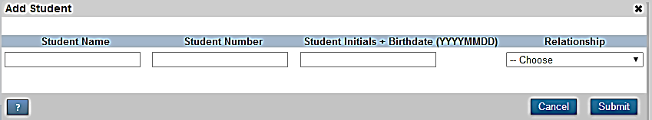

After completing the process, both student names will then appear on the Navigation bar at the top of the page. Choose the student whose information you wish to view by clicking the name.

