# C:\Users\abbaer\AppData\Local\Microsoft\Windows\Temporary Internet Files\Content.Outlook\ZSX3QREX\HCPS_PowerSchool_Black_280x41.jpg

# Student/Parent Portal Creating Connections Between Home and School

PowerSchool Parent Portal is a powerful, easy-to-use, secure communication tool connecting teachers, parents and students. Using Pearson’s PowerSchool student information system, the Parent Portal allows collaboration to improve student achievement. Online access to grades, attendance and assignments makes it easier for parents, teachers and students to accurately monitor, identify and accelerate student progress.

PowerSchool Parent Portal will allow parents/guardians with more than one child to access all of their children at one time with one login and password. This will also allow both parents/guardians to have separate accounts for their child(ren). Students will log in using their HCPS username and password.

***How to create a parent account***

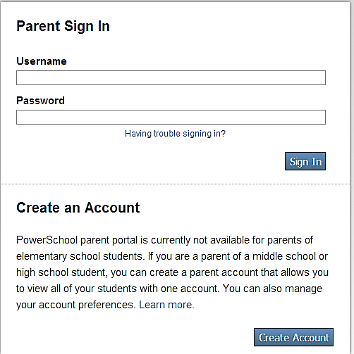1. Go to <https://sis.henrico.k12.va.us/public>

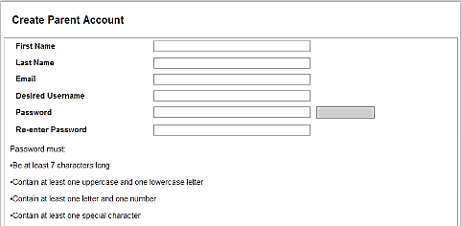2. Click on Create Account

3. Enter your first name

4. Enter your last name

5. Enter your e-mail address

6. Enter your desired user name. Your user name must be unique. If the name you choose already exists, you will be prompted to enter a different one.

7. Enter your desired password. Password must:

- Be at least 7 characters long

- Contain at least one uppercase letter

- Contain at least one lowercase letter

- Contain at least one number

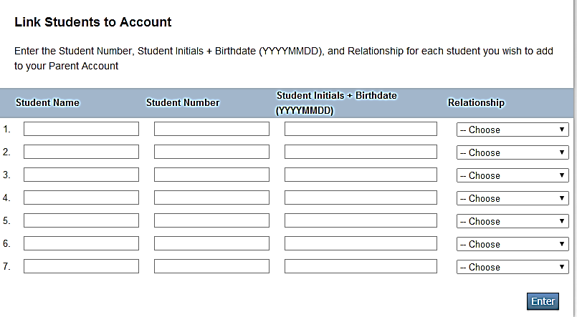- Contain at least one special character (Example: ! or #)

8. Re-enter your password

9. Enter your child’s first name, leave a blank space and enter your child’s last name

10. Enter your child’s student number. Your child’s student number can be found on multiple documents, such as report cards and student information records. Please contact your child’s school if you do not have this information.

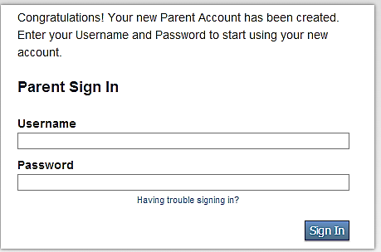11. Enter your child’s initials and birthdate. This is your child’s first initial (lower case), middle initial (lower case), last initial (lower case) and birthday (Example: John A. Doe with birthday of June 2, 2002 would be entered jad20020602)

12. Enter your relationship to the student

13. If you have multiple children, repeat steps 9-12

14. Click Enter

15. You have successfully completed your Portal Account setup when you receive this screen.

16. Log in to the PowerSchool Parent Portal using your new Username and Password.

***How to view your child’s information***

1. Go to <https://sis.henrico.k12.va.us/public>

2. Enter your user name

3. Enter your password

4. Information on your child(ren) will be available upon successful login

***From the start page, the following features are available under the Navigation menu:***

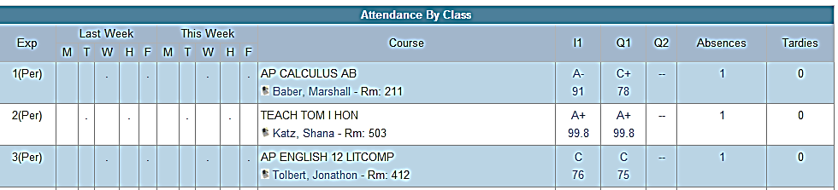

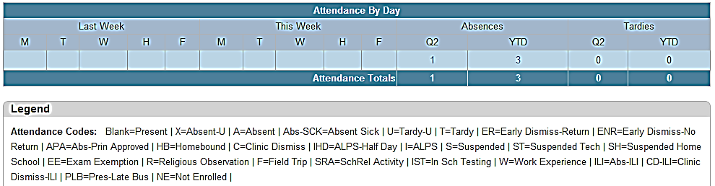This feature displays comprehensive information about student grades and attendance for the current term. The legend at the bottom of the page displays the attendance codes and their meanings.

- To view assignment details, click a grade in the term column. The Class Score Detail page appears. .

- To view total absences or tardies for the semester or for the year-to-date, click the number in the Absences or Tardies column in the Attendance by Day section. Use your browser’s Back button to return to the Grades and Attendance page.

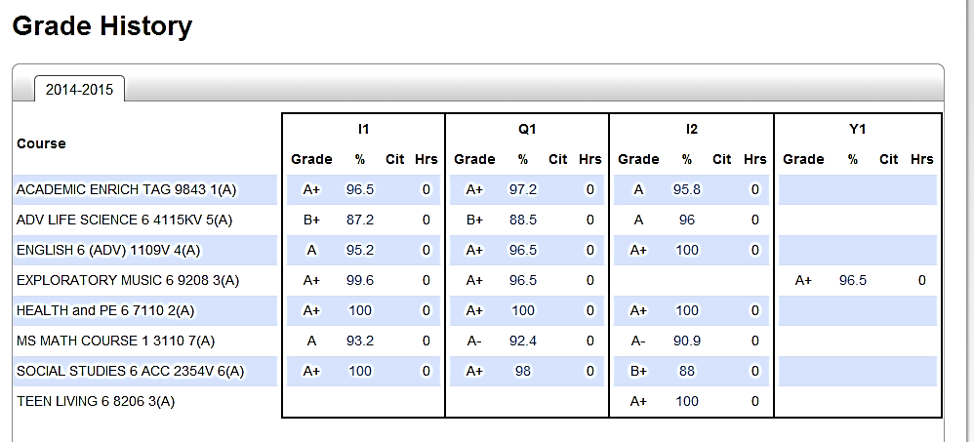



This feature displays student quarter and semester grades for the current term.

- Click a grade in the % column to see the Class Score Detail page. A caret (^) indicates score is exempt from the final grade. An asterisk (\*) indicates an assignment is not included in the final grade. The number one (1) indicates this final grade may include assignments that are not yet published by the teacher.



This feature displays morning and afternoon student bus route information.



This feature displays any comment(s) that a teacher has attached to a report card grade.



This feature displays the date, time and duration of each login to your account.



This feature displays student schedules. Click the Weekly Schedule tab to see your child’s schedule for each day of the week.



This feature displays school information such as school name, phone number and address.

This feature displays portal account preferences and provides the option of changing your Username and/or Password. Use the “Students” tab to add students to an existing account.



**Dr. Patrick C. Kinlaw, Superintendent of Schools**

**P.O. Box 23120**

**Henrico, Virginia 23223**

**Main: 804.652.3600**

**http://www.henrico.k12.va.us/**