Lee Naughton
Henrico High School
IB English 12
2018-2019
gbnaughton@henrico.k12.va.us

IB English 12 Supply List

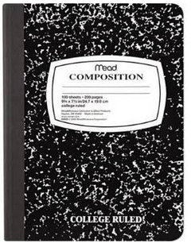
**REQUIRED:

- Composition notebook—color doesn’t matter, but must be a hardbound, regular composition notebook such as the traditional black and white marble type depicted here.
- Blue or black ink pens (NO PENCIL will be permitted)
- Stapler and staples
- College-lined loose-leaf paper
- Colored pencils
- Highlighters
- A binder for the exclusive use of IB English 12 (for the storage of English handouts).

NOTE: The following three required texts may be purchased in used editions or electronic editions; they do not have to be new. If an electronic edition is purchased for any book still in copyright, you will need to show me the receipt, as Internet versions can be downloaded to PDF and PDF versions can be read on a variety of readers, including Kindle, and therefore the mere possession of an electronic copy does not demonstrate that you acquired it legally.

- Your own copy of How to Read Literature Like a Professor by Thomas Foster (due by September 13 or 14 depending on your class period).
- Your own copy of The Great Gatsby by F. Scott Fitzgerald (purchased by the date of the How to Read Literature Like a Professor test).
- Your own copy of “Master Harold”…and the boys by Athol Fugard (purchased by the date of the How to Read Literature Like a Professor test).

NOTE: If purchase of any of the required supplies or texts poses a financial difficulty, please have your parents contact me, and I will make sure that you get the materials you need.

