Lee Naughton
Henrico High School
IB English 12
2018-2019
gbnaughton@henrico.k12.va.us

Suggested Summer Review Work

Preparing for Literary Analysis:
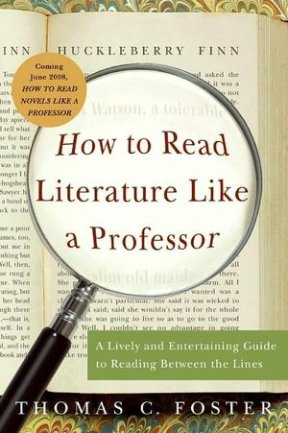
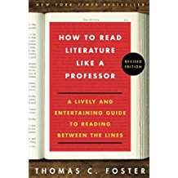

How to Read Literature Like a Professor by Thomas Foster. This is an outstanding resource for expanding your repertoire of ideas about what to look for in literary texts. There will be a test on this book during the first week in October. You will be given passages from a variety of texts and asked to identify elements from How to Read Literature Like a Professor. You will be allowed to use notes from the reading guide; if you want to get a head start and work on this assignment over the summer, the reading guide is available now; you can download it from Mrs. Biddle’s blog. The assignment and the reading guide were also provided to all juniors via Schoology at the end of the 2017-2018 school year. If you are NEW to Henrico High School’s IB program, or if you cannot find your original copy, and you are having trouble downloading the form, then please contact Dr. Naughton at the e-mail listed above, and she will be happy to help.

How to Read Literature Like a Professor is an extremely useful book for studying literature, and it will be an excellent resource for you to take to college. You are STRONGLY recommended to buy your own copy. Please note that the book has been revised in the past couple of years (the newly revised edition has the cover on the right), but the main information did not change significantly. New copies of the most recent edition run about $11.00 at both Amazon and Barnes and Noble. Used copies of the older edition are fine for our use and can be purchased at Amazon.com for (at the time of this writing) as little as $3.99 plus shipping. Former students have even found copies of this book at local Goodwill stores.

Note: copies of this work that you may find on the Internet are there in violation of copyright law, and you will NOT be allowed to use them for class. (You may use Kindle or other reading devices, if you wish). There will be a quiz grade in mid-September (specific dates will be announced on the first day of classes) for producing your personal copy of this book in class. If you bring an electronic copy, you must produce the receipt, as you can add any PDF to most reading devices. The presence of it on your device does not alone prove its legality!

Preparing for Literature Study:

IF you wish to get a head start on the reading, feel free to do so; this work is not required, however. The following pages detail the works of literature we will study next year.

A Preview of Next Year:

During your senior year, you will study two of the four parts of the required IB curriculum: Part 2 (Detailed Study) and Part 3 (Genres). There are specific assessments associated with each part, as described below:

Part 2: Detailed Study
(Assessments are Oral Commentary/Discussion and Exam Paper 1)

Part 2 requires you to read three works: poetry, and one work from each of two of the following genres: fiction (including the novel and short story), drama, or non-fiction (including letters, essays, biography, and autobiography.) Your teacher is required to choose the works from the IB list of Prescribed Authors. We will be reading sonnets by William Shakespeare, the novel The Great Gatsby, by F. Scott Fitzgerald, and the play “Master Harold”…and the boys, by Athol Fugard.
You will need to purchase your own copies of the novel and the play; I will provide you with copies of the poems. You can purchase used copies of the novel quite cheaply; for example, some are available on Amazon Marketplace starting at $2. You may use any edition of these two works, but you may not download illegally uploaded copies from the Internet.

I have no wish to direct you to any particular vendor—purchase your copy wherever you wish. I recommend getting the cheapest copy you can get, but I do recommend buying a hard copy so that you can annotate the text. The IB assessment will test you on your ability to interpret the details in detail, so you should be making many notes as we study the text in class.

Note: Any copies of these two works that you may find on the Internet are there in violation of copyright law, and you will NOT be allowed to use them for class. (You may use Kindle or other reading devices, if you wish). There will be a quiz grade on the day of the How to Read Literature Like a Professor test for producing your personal copies of The Great Gatsby and “Master Harold”…and the boys in class.

The oral assessment consists of two parts: the Oral Commentary and the Discussion. For the Oral Commentary, you will draw one of the sonnets we studied in class out of a hat; you will then have 20 minutes to review it and prepare an oral explication. Then, you will give a 10- minute presentation over the meaning and important strategies in the poem. Following that, you will discuss one of the other two Part 2 works (The Great Gatsby and “Master Harold”…and the boys) with the teacher for 10 minutes. You will not know in advance which one of those two works you will discuss, but you will have studied both works prior to undertaking the Oral Commentary.

For Exam Paper 1, you will write a commentary over a poem or a prose passage you have not studied before.

Part 3: Literary Genres
(Assessment is Exam Paper 2)

For this part of the syllabus, you are required to read four works of the same genre, either poetry, prose fiction (novels and short stories), non-fiction, or drama. We will be studying poetry by Emily Dickinson, Eavan Boland, Carol Ann Duffy, and Sylvia Plath. You do not have to purchase any texts for this part of the curriculum; you will be provided copies of all the poems.

For Exam Paper 2, you will be required to write a comparison-contrast essay in response to one of three questions, using two of the four poets you studied for part 3 as the basis for your argument.

Supply List:

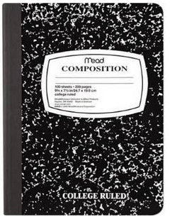
**REQUIRED:

- Composition notebook—color doesn’t matter, but must be a hardbound, regular composition notebook such as the traditional black and white marble type depicted here.
- Blue or black ink pens (NO PENCIL will be permitted)
- Stapler and staples
- College- lined loose-leaf paper
- Colored pencils
- Highlighters
- A binder to use exclusively for IB English (for the storage of English handouts).

NOTE: The following three required texts may be purchased in used editions or electronic editions; they do not have to be new. If an electronic edition is purchased for any book still in copyright, you will need to show me the receipt, as Internet versions can be downloaded to PDF and PDF versions can be read on a variety of readers, including Kindle, and therefore the mere possession of an electronic copy does not demonstrate that you acquired it legally.

- Your own copy of How to Read Literature Like a Professor by Thomas Foster (due by September 13 or 14 depending on your class period).
- Your own copy of The Great Gatsby by F. Scott Fitzgerald (purchased by the date of the How to Read Literature Like a Professor test).
- Your own copy of “Master Harold”…and the boys by Athol Fugard (purchased by the date of the How to Read Literature Like a Professor test).

NOTE: If purchase of any of the required supplies or texts poses a financial difficulty, please have your parents contact me, and I will make sure that you get the materials you need.

