Explanation of the International Baccalaureate Diploma Program Curriculum and Exams
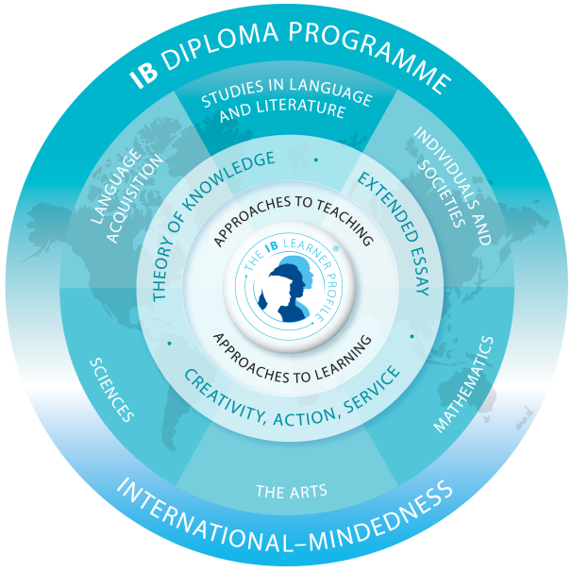

IB has created a curriculum model based on the European liberal arts model, creating a student who is well-rounded in all subject areas. The model contains six subject areas as well as the course Theory of Knowledge. In addition to the course work, students must complete the Extended Essay and CAS requirements for the IB Diploma.

Diploma courses are offered at the Standard level (SL) which may be one or two year courses and the Higher level (HL) which MUST be two year courses. Diploma students MUST have 3 HL’s and 3 SL’s. Two SL’s may be one year courses.

Students may elect to become “Course Students” in which they participate in the Diploma Program by taking courses and attending seminar. They are not required to take TOK or do CAS or the Extended Essay. As long as you examine in ONE IB subject, you are a part of HHS IB Program.

Language A1: Literature
English, Grades 11 and 12 (HL exam)
- This is a two year course of study and a mandatory HL course in our program.

Language B1: Language Acquisition
French, Chinese or Spanish IV or V, Grade 11
French, Chinese or Spanish V, Grades 11 or 12 (SL exam in senior year)
French, Chinese or Spanish VI Grade 12 (HL or SL exam in senior year)
- We require that students have at least 5 years of language study before they sit for the IB exam. Language B is a required two year course. Students in level 5 as seniors must take the SL exam. In year VI, students may sit for either the SL or the HL exam as needed to fulfill their Diploma requirements. Chinese will be offered through 2019 when the students in grade 7 in 2013-14 will graduate.

Individuals and Societies
History of the Americas, Grade 11
World Topics, Grade 12 (SL or HL exam)
- Like English and Language B, this is a required two year course of study in our program. It is offered at both the SL and HL levels.

Experimental Sciences
Biology, Grade 11 (SL exam)
Chemistry, Grade 11(SL exam)
Biology, Grade 12(SL or HL exam)
Chemistry, Grade 12 (SL or HL exam)
- Students must choose between Biology and Chemistry. Biology and Chemistry offer the option of being a one year course with the SL exam at the end of the junior year OR as a two year course with the option of either the SL or HL exam in the senior year, depending on what is needed to fulfill the students’ Diploma requirements. Students may also choose to take an additional science as their Group 6 elective. Students also may take Biology SL or Chemistry SL as seniors as an extra elective which does not count towards their IB diploma.

Mathematics
Extended Math, Grade 10 or 11
IB Mathematical Studies, Grade 11 or 12 (SL exam)
IB Mathematics, Grade 11 or 12 (SL exam)
- Students who take Mathematics or Math studies as juniors are required to take the SL exam at the end of their junior year. Our math courses are only offered at the SL level. Students who will take their math exam as seniors may only take one anticipated exam as juniors.

The Arts and IB Electives
Psychology, Grade 11(SL exam)
Psychology, Grade 12 (SL or HL exam)
Theatre Arts, Grades 11 and 12 (SL or HL exam in senior year)
Visual Arts, Grades 11 and 12 (HL exam in senior year)
- Although Psychology is technically in Group 3, it serves as an official IB elective in our program. Juniors enrolled in Psychology may opt to sit for the SL exam at the end of that year OR choose to take the second year. In that second year, students may opt for either the HL or SL exam, depending on their Diploma requirement needs. Seniors may also elect to take Psychology SL as an extra elective which does not count toward their IB Diploma. Theatre Arts is a mandatory two year course, but students may opt for either the SL or HL level at the end of their senior year, depending on their Diploma requirement needs. Visual Arts is a two year course and is only offered at the HL level.

Theory of Knowledge
- TOK is a mandatory two year course and required for the IB Diploma.

Planning Your Courses: The Diploma Program
Courses with an * indicate when an exam may or will be taken.

Course | Exam Level | Grade 11 | Grade 12
Group 1 | HL | DP English 11 | DP English 12*
Group 2 | SL or HL | MYP Sp/Fr/Ch 4 or DP Sp/Fr/Ch 5 | DP Sp/Fr/Ch 5 or 6*
Group 3 | SL or HL | History of the Americas | 20th Century Topics*
Group 4 | SL or HL | DP Bio or Chem SL* | DP Bio or Chem HL (or can still take SL exam)* OR AP or Honors Physics or AP Environmental Science if you examined as a junior
Group 5 | SL | MYP Extended Math or DP Mathematics* or DP Math Studies* | DP Mathematics* or DP Math Studies* OR AP Calc (AB or BC), AP Stats, OR AP Computer Science if you examined as a junior
Group 6 | Visual Arts HL  Theatre Arts SL or HL  Psychology SL or HL  Bio or Chem SL or HL | DP Visual Arts 11  DP Theatre Arts 11  DP Psych 11*  DP Bio or Chem* | DP Visual Arts 12*  DP Theatre Arts 12*  DP Psych 12*  DP Bio or Chem 12*
Core |  | Theory of Knowledge | Theory of Knowledge

Planning your Exams: Diploma Program

Think about the exams you plan to take and when. Remember, you can have 3 HL’s and 3 SL’s. Only two of the SL’s may be one year. If you take Math or Math Studies as a senior, you may only take ONE exam your junior year. If you take Math or Math studies as a junior, you may take it and another exam. You may want to circle those you are taking as a junior in this chart!

Subject | Level | Year Taken
English | HL | Senior
Language B | SL or HL | Senior
History | SL or HL | Senior
Science | SL or HL | SL – Junior, SL or HL -- Senior
Math | SL | Junior or Senior
Elective -- Psych | SL or HL | SL – Junior, SL or HL -- Senior
Drama | SL or HL | Senior
Visual Arts | HL | Senior

My Three HL’s Are
- English
- __________________
- __________________

My Three SL’s are
- Math or Math Studies
- __________________
- _______________

