Señora Rodríguez: IB MYP Spanish IV Honors

Extra credit and summer enrichment 2019-20

Create a folder on your desktop and name it Spanish enrichment 2018. If you don’t have access to a computer, you should go to any Henrico County Public Library or simply use your phone. Make sure you have a dumb drive so you can save your work. I will collect the work on the first week of school and your work will be extra credit.

Go to Study Spanish.com and click on the GRAMMAR tab at top of page. Look at the left side of the page and check out the Lesson Topics and scroll down to UNIT FIVE; read the lesson for activities 59 and 60; Reflexive Verbs I and II, take the Basic Quiz which will be on left hand side of the page and under the activity. You will need to take a screen shot of your results and put in your digital folder.
Make sure your screen shots show the following; Topic of activity and your score:
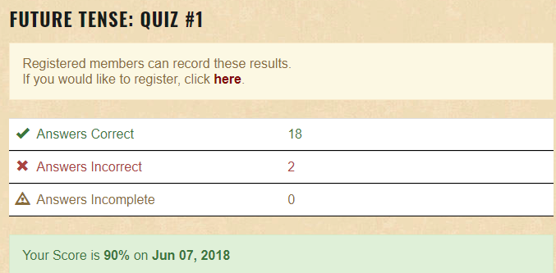
Luego, necesitan ir a UNIT SEVEN and and read the lessons on the Subjuntive I-VIII activities 77 through 84; complete the Basic Quiz for each activity and take a screen shot of the results; put in folder. You should have a total of 10 screen shots in your enrichment folder.
Después, scroll to UNIT 9 and complete all activities; 99 through 107, READ the lesson and complete the Basic Quiz for all activities, it is possible that some of these grammar concepts are new to you but you can take your time to read the lesson before taking the Basic Quiz. Also, you can take the quiz as many times as needed to get 100%.
Lastly, scroll through the Lesson Topics and PICK 6 activities in any UNIT that you are curious about, READ the lesson and complete the Basic Quiz and screen shot your results. Put in your folder. You should have a total of 25 screen shots of your results and in the folder. Extra credit work will be due on the first day of class in September 2019.

Scoring; 25/25 = 100%

