**MYP GEOMETRY Mrs. Melson**

Welcome to Tucker High School! I am so excited to meet all of you and look forward to seeing you in my Geometry class in September.

There are two areas of study that will help prepare you for a good start to the year— vocabulary and algebra. This work is completely optional as summer work and therefore will not be graded as such.

However, you need to bring this sheet with you on the first day of school. Keep it in the front of your Geometry notebook as we will refer to the vocabulary and algebra problems in the first couple of units. You will have less homework at the beginning of the school year if you work over the summer! This information will be assessed as part of our first few unit tests.

**PART 1**

**Communication is a key component** of our class and we will start the year off working with the vocabulary below. Most of these terms are ones you probably have seen before.

***These terms should be defined/described and sketched.***

**Terms**

|  |  |  |  |  |  |
| --- | --- | --- | --- | --- | --- |
| Acute angle | Adjacent angles | Angle | Angle bisector | Between | Collinear |
| Complementary angles | Concurrent lines | Congruent | Coplanar | Degree | Exterior of an angle |
| Interior of an angle | Intersection | Length of a segment | Line | Linear pair | Measure of an angle |
| Midpoint | Non-collinear | Non-coplanar | Oblique Lines | Obtuse angle | Opposite rays |
| Parallel lines | Perpendicular lines | Plane | Point | Postulate | Proof |
| Ray | Reflex angle | Right angle | Right Triangle | Segment | Segment bisector |
| Skew Lines | Straight angle | Supplementary angles | Theorem | Vertex of an angle | Vertical angles |

Some online resources that may be helpful in finding these definitions are:

|  |
| --- |
| <http://www.virtualnerd.com/geometry/all> |
| <http://www.mathopenref.com/planegeometry.html> |
| <http://www.mathsisfun.com/geometry/> |
| <http://www.classzone.com/cz/books/geometry_2011_na/get_chapter_group.htm?cin=1&ci=1&rg=games_and_activities&at=math_Vocabulary_flipcards&var=math_vocabulary_flipcards> |

**PART 2**

**Knowledge of algebra** is fundamental for this course. Besides knowing how to solve equations (systems included), you should be able to graph lines, simplify radicals, and factor. If you had any trouble with these topics, you will probably want to review them before school starts in September. Below are some problems that will help you to review.  **We will always review concepts and how they are used in our class before you are assessed.**

**Section 1: Solve the following Equations.**

1.  2.  3. 

4.  5.  6.  7. 

**Section 2: Write the following as algebraic equations – do not solve**

1. Angle A and Angle B are complementary.

2. Segment AB is 6 more than twice the length of Segment DC.

3. Twice the sum of a number and 7 is increased by 5. The result is 25.

4. Half a number, increased by 11 is twice the same number decreased by 5.

**Section 3: Rewrite each equation in slope-intercept form (*y* = m*x* + b). Identify the slope and y-intercept.**

1.  2.  3. 

4.  5.  6. 

**Section 4: Factor each expression completely.**

1.  2.  3.  4.  5.  6.  7.  8. 

**Section 5: Solve for x**

1.  2.  3. 

4.  5.  6. 

**Section 6: Find the solutions to the systems of equations by graphing.**

1.  2.  3. 

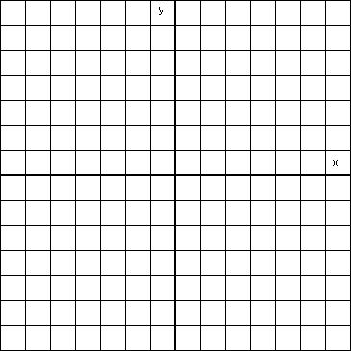  

**Section 7: Find the solutions to the systems of equations by Substitution or Elimination.**

1.  2.  3.  4. 

**Section 8: Simplify the radical expressions.**

1.  2.  3.  4.  5.  6.  7. 

**Section 9: Linear equations.**

1. What is the equation of the line through the points (2,1) and (-2,-7)?

2. What is the equation of the line if y = -3x – 2 is shifted up 6 units?

3. What is the equation of the line with slope 1/3 and passes through (6,2)?

4. What is the equation of the line that passes through (2,2) and (-3,6)?

5. What is the equation of the line that is parallel to and passes through (6,5)?

6. Find the slope of the line that passes through (-1,2) and (-11, 5).

7. What is the slope of a horizontal line?

8. What is the slope of a vertical line?

9. What is the equation of the line perpendicular to  and passes through the point (6,3)?

10. What is the equation of the line with slope 1/3 and y – intercept 6?