DP 11th grade History- History of the Americas
Presumed knowledge
(Course-specific skills which are needed for success)
- Reading for knowledge- Like most history courses, HOTA will cover a large amount of material. We will cover information stipulated by the SOL curriculum as well as by the IB curriculum. Some assignments will require that you read from a text or website in order to learn and understand some of the major concepts in history. For example, look at the following link from a homework assignment. You should be able to read this information and better understand the evolution of the slave trade in Africa. http://www.bbc.co.uk/history/british/abolition/africa_article_01.shtml
- Summarizing- This skill is applicable to many aspects of your studies. For example, summarizing may involve taking notes during a lecture or discussion and then recalling and describing the main points. Summarizing may also refer to recalling and describing a unit of study. Additionally, summarizing may also refer to the skill of providing a narrative of an event in writing. For example, use the website below to summarize how the policies of the American System, once meant to unite the country, began to divide the United States. https://www.constitution.org/hwdebate/hwdebate.htm
- Analysis- This skill refers to the ability of the student to draw conclusions based upon available information. This skill is present when looking at historical documents in OPCVL activities (Origin, Purpose, Content, Value, and Limitations). A student should be able to look at a document and discuss the above listed aspects. Analysis also refers to creating your own understanding of the information which is presented in the class as well as in the assignments.
- Creating an argument- Most of the essay writing that is done in HOTA revolves around creating an argument. Many students are able to provide a narrative of information in an essay. However, the best essays contain an argument. For example, the two websites below can assist a student in answering the prompt: “Discuss the role of foreign powers during the American Civil War.” A narrative describes the role of foreign powers. An argument goes beyond the description and presents an account of why foreign powers took the actions which were taken. http://millercenter.org/president/lincoln/essays/biography/5 http://www.newyorker.com/magazine/2011/08/01/over-there-3
- Essay writing- One of the objectives for this class is to help students develop the ability to write essays which will assist them in earning higher marks on the History exam. Students should be able to format and organize an essay with an introduction/thesis, body, and conclusion. We will develop the skills of addressing the command terms (see below) and scoring on the rubric (below) throughout the year.
Command Terms for IB History
Analyze Break down in order to bring out the essential elements or structure.
Compare and contrast Give an account of similarities and differences between two (or more) items or situations, referring to both (all) of them throughout.
Discuss Offer a considered and balanced review that includes a range of arguments, factors or hypotheses. Opinions or conclusions should be presented clearly and supported by appropriate evidence.
Evaluate Make an appraisal by weighing up the strengths and limitations.
Examine Consider an argument or concept in a way that uncovers the assumptions and interrelationships of the issue.
To what extent Consider the merits or otherwise of an argument or concept. Opinions and conclusions should be presented

Rubric for IB History Essays
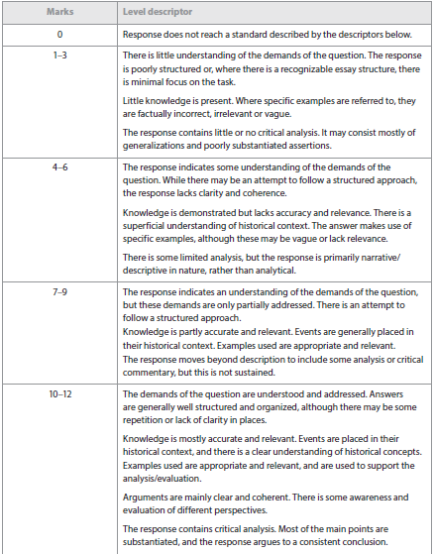
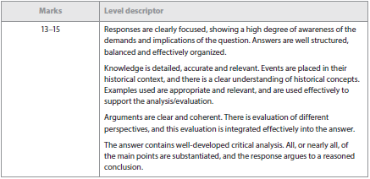

Overview
In this class we will cover the Virginia and United States SOL Curriculum and will also cover three IB Units of study (Slavery in the Americas, The American Civil War, and the Cold War in the Americas). The IB Units will be detailed and focused upon writing essays. The SOL units will cover the required curriculum.
Assessments consist of homework and classwork assignments, quizzes (written responses as well as multiple choice) and tests (IB Unit tests are essay tests and SOL Unit tests are a combination of written and multiple choice questions).

If you have any questions then please email me at jmdorton@henrico.k12.va.us

This is the IB Curriculum for the Slavery Unit. The dark bullet points represent the required topics. The white bullet points are examples of essay prompts from past IB Tests:

- Reasons for, and origins of, slavery
  - “Slavery was introduced for economic rather than political reasons. Discuss.”
- Role of the colonial powers in the establishment and expansion of slavery; asiento system
  - “Compare and contrast the role of two colonial powers in the expansion of slavery in the Americas.”
  - Evaluate the importance of the asiento system in the establishment and expansion of slavery.
- Economic and social impact of slavery
  - “Discuss the social impact of slavery on the New World.”
- Middle Passage: living and working conditions in the New World; social structures on plantations in the West Indies, Brazil and the southern colonies of British America
- Slave resistance and slave rebellions in British America, including a case study of a specific rebellion
- Opposition to the slave trade and slavery: Quakers and other early abolitionists.
  - “Evaluate the effectiveness of early opposition to slavery and the slave trade in the New World.”
  - Discuss the reasons why the Quakers and other early abolitionists opposed slavery.

