DP HL Chemistry, Year 2

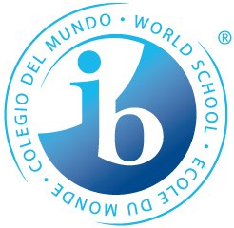

Instructor: Matt Togna
Email: mjtogna@henrico.k12.va.us
Period: 3
Location: 62

Course Outline
Unit 1 – Year 1 Review, MP1

Unit 2 – Acid/Base Chemistry, MP1

Unit 3 – Oxidation-Reduction, MP1

Unit 4 – Organic Part 1, MP2

Unit 5 – Organic Part 2, MP2

Unit 6 – Measurement and Data Processing, MP3

Unit 7 – Biochemistry, MP3

Other Major Assessments
- Internal Assessment (December – February, MP2)
- Full Length IB Mock Exam (late March, MP3)
- End of Year Project (after IB exams, MP4)

