DP-11 Chemistry Summer Review Packet
Dr. Brock – kabrock@henrico.k12.va.us

Completion of this packet is OPTIONAL but strongly recommended. There may be parts that are more challenging than others – that’s where the value of this work comes in: If we identify the challenges early, we can address them early, and then move on smoothly! There will probably be areas in which you feel a bit lost, especially if it was content from the Extended Learning time. Don’t worry! It will be remedied as we move through the year.

Packet Contents:
- REFERENCE: Things you should know

- REVIEW
  - Vocabulary
  - Basic Review Problems (these are examples of things you should know how to do)
    - Lab Safety
    - Topic 1: Stoichiometric Relationships
    - Concept Review
  - Challenge Problems

- REFERENCE

Some Common Polyatomic Ions: You need to know the names and formula/charge of the following polyatomic ions:

C₂H₃O₂ ⁻¹ | Acetate |  | ClO ⁻¹ | Hypochlorite |  | CrO₄ ⁻² | Chromate
HCO₃ ⁻¹ | bicarbonate |  | ClO₂ ⁻¹ | Chlorite |  | Cr₂O₇ ⁻² | Dichromate
 | (hydrogen carbonate) |  | ClO₃ ⁻¹ | Chlorate |  | SiO₃ ⁻² | Silicate
NO₂ ⁻¹ | Nitrite |  | ClO₄ ⁻¹ | Perchlorate |  | S₂O₃ ⁻² | Thiosulfate
NO₃ ⁻¹ | Nitrate |  | C₂O₄ ⁻² | Oxalate
OH ⁻¹ | Hydroxide |  | SO₃ ⁻² | Sulfite |  | PO₄ ⁻³ | Phosphate
MnO₄ ⁻¹ | Permanganate |  | SO₄ ⁻² | Sulfate
 |  |  | CO₃ ⁻² | Carbonate |  | NH₄ ⁺¹ | Ammonium

*Acids and Bases

Names & Formulas
Nomenclature: Based on what H is combined with
a) negative ion: hydro-stem of the negative ion-ic acid
b) polyatomic ending in –ite: stem of the polyatomic-ous acid
c) polyatomic ending in –ate: stem of the polyatomic-ic acid

Formulas: Reverse the process for nomenclature; begins with H
a) hydro-stem-ic acid: Hydrogen and stem ion; crisscross charges
b) stem-ous acid: Hydrogen and stem (-ite) polyatomic; crisscross
c) stem-ic acid: Hydrogen and stem (-ate) polyatomic; crisscross

You need to know the names and formulas of the following strong acids and bases.

Strong Acids |  | Strong Bases
Hydrochloric acid, HCl |  | Alkali metal hydroxides
Nitric acid, HNO₃ |  | (LiOH, NaOH, KOH, etc)
Sulfuric Acid, H₂SO₄ |  | Alkaline earth metal hydroxides
Hydrobromic acid, HBr |  | (Ca(OH)₂, Ba(OH)₂)
Hydroiodic acid, HI
Perchloric acid, HClO₄

SI Units and Conversions
You need to know all of the SI units below

Property | Unit | Symbol
Mass | kilogram | kg
Time | second | s
Temperature | Kelvin | K
Volume | cubic meter | m³
 | Liter | L
Pressure | Pascal | Pa
Energy | joule | j

and how to convert between orders of magnitude

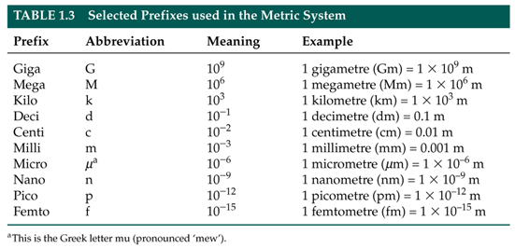

- REVIEW
- Vocabulary – be sure you can accurately identify and use this content!

Stoichiometry | Transition elements | Conductivity
Mole ratio | Alkali metals | Sublimation
Avogadro’s constant (number) | Alkaline earth metals | Reactants
Molecular formula | Halogen | Products
Empirical formula | Noble gases | Solute
Element | Ionization energy | Solvent
Atom | Atomic radius | Solution
Compound | Physical change | Precipitate
Proton | Chemical property | Molarity
Neutron | Electronegativity | Aqueous
Electron | Physical property | Saturated
Isotope | Chemical change | Unsaturated
Ion/cation/anion | Melting point | STP
Relative atomic mass | Boiling point | Kinetic Molecular Theory
Period (on the Periodic Table) | Ionic bond | Catalyst
Group (on the Periodic Table) | Covalent bond | Chemical reaction

- Basic Review

  - Lab Safety
Lab Safety Assignment: Complete the activities listed below.

- Watch at least 3 chemistry lab safety videos on YouTube and compile one page of notes that summarize everything you should know about lab safety.

- Choose two accident scenarios from the list below and demonstrate (with a paragraph, comic, flow chart, etc …) that you know how to respond to the situation.

  - A stock bottle of a chemical tips over and breaks.
  - A Bunsen burner catches some papers on fire at your lab station
  - A student’s sleeve catches fire
  - Some chemical splashes onto your face and clothes
  - You knock over your beaker full of boiling water and it breaks

- On a separate sheet of paper, identify the following lab equipment and give an example of what it might be used for.

a. | b. | c. | d. | e. | f. | g. | h.
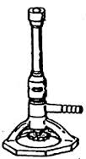 |  | 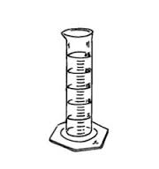 | 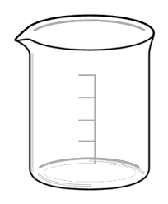 | 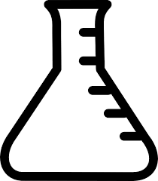 | 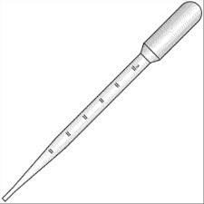 |  | 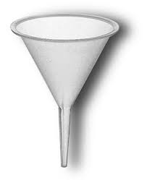
  - Topic 1: Stoichiometric Relationships

Topic 1 Assignment: On a separate sheet of paper, solve the following problems, showing all of your work and units, with correct significant figures in your answers. If you are struggling, use your notes from your MYP chemistry class.
1) Convert 4,672,000,000 into scientific notation.
2) Convert 0.000005210 into scientific notation.
3) Convert 50.0 g to milligrams.
4) Convert 150. dm³ to liters.
5) How many significant figures are in the number 4.0070 x 1012?
6) An object has a mass of 40.1g and occupies a volume of 8.20 cm³. What is the density of the object?
7*) Calculate the percent yield if 28.0g of MgCl₂ is produced, but 32.0g of MgCl2 should have been produced.
8) How many atoms are in 52.4g of nickel?
9) 6.00g of water contains how many moles of water?
10) What is the molar mass of methane?
11) How many hydrogen atoms are in 3.0 moles of ethanol, C₂H₅OH?
12) What is the empirical formula of glucose, C₆H₁₂O₆?
13) A compound with an empirical formula of CH₂ has a molecular mass of 42.09. What is its molecular formula?
14) A compound of nickel has a mass composition of 37.9% nickel, 20.7% sulfur, and 41.4% oxygen. What is its empirical formula?
15) Aluminum and iron(III) oxide react to form iron and aluminum oxide. What mass of iron is produced from the reaction of 21.4g of aluminum and 91.3g of iron(III) oxide? *What is the limiting reactant? *What is the excess reactant?
16) What volume of nitrogen forms when 100. g of ammonia, NH₃, decomposes completely into its elements at STP?
17*) A helium party balloon has a volume of 12.0L. At room temperature (25°C) the internal pressure is 1.05atm. Calculate the number of moles of helium in the balloon.
18*) The gas left in a used aerosol can is at a pressure of 1.00atm at 27.0°C. If the can is thrown into a fire, what is the pressure of the gas when its temperature reaches 927 °C?
19*) The volume of a gas is 20.0L at 275K and 92.1kPa. Find its volume at STP.
20*) What volume of 18.0M sulfuric acid is required to prepare 16.5dm³ of 0.126M sulfuric acid?

  - Concept Review

Concept Review Assignment: On a separate sheet of paper, answer the conceptual questions below. If you don’t remember a topic, use the Internet sources provided above to review.
1) Determine the number of protons, neutrons, and electrons for each: a. Sulfur
b. Chloride
c. Calcium ion
d. ¹²⁷I
2) Which is larger? Ca or Ca⁺² Why?
3) Which is larger? F or F⁻ Why?
4) Why is sodium larger than chlorine?
5) Why is fluorine smaller than iodine?
6) Why does it take less energy to remove an electron from Potassium than from Bromine?
7) List the following elements in order from smallest to largest electronegativity: Magnesium, Sulfur, Francium
8) Write full electron configurations for Na, Al, and Cl⁻¹
9) Draw Lewis dot diagrams for Nitrogen and Fluorine.
10) Draw the Lewis structures for NH₃ and CO₂.
11*) Discuss how intermolecular forces determine the physical properties of a substance.
12) Write and balance chemical equations for:
a. The combustion of methane
b. The single replacement reaction of zinc and hydrochloric acid
c. The double replacement reaction of sodium hydroxide and barium nitrate.
d. The decomposition of dinitrogen pentoxide.

13*) Compare and contrast endothermic and exothermic reactions
14*) Why are aqueous solutions of ionic compounds considered electrolytes?
15*) Define collision theory and identify the factors that affect the rate of a reaction.
16*) Consider the following reaction: N_{2(g)} + 3H_{2(g)} ⇄ 2NH_{3(g)} ∆H = -93 kJ/mol
a. How would increasing the volume of the container affect the equilibrium?
b. How would increasing the temperature affect the equilibrium?
c. How would removing NH₃ affect the equilibrium?

- Challenge Problems

Challenge Problem Assignment: On a separate sheet of paper, solve the following problems. These “challenge” problems are designed to make you use all of your chemistry knowledge to solve an integrated problem. Explanations and all work/units/sig figs are required!

1. The white limestone cliffs of Dover, England contain a large percentage of calcium carbonate. A sample of limestone with a mass of 84.4g reacts with an excess of hydrochloric acid to form calcium chloride water and carbon dioxide gas. If the mass of calcium chloride formed from this reaction is 81.8g, what is the percentage by mass of calcium carbonate in the limestone?

2. Two elements are to be combined to form a compound. The first element, M (fictitious), has two valence electrons. The second (fictitious) element, X, has five valence electrons. Predict and explain how many M’s and how many X’s will come together to form a neutral ionic compound.

3. The following information concerns six consecutive elements in the periodic table. Study the information carefully and then identify each element.

Element A is a diatomic gas at room temperature. It combines with element B to form a compound B₂A.

Element B reacts with water to produce heat and a strongly basic solution. Element B reacts with element F to form the compound BF.

Element C is a diatomic gas at room temperature. 22.4 liters of the gas at 0°C and a pressure of 1.0 atm weighs 28.0g.

Element D is a gas that does not form compounds with anything.

Element E is a non-metal solid that in some forms can conduct electricity moderately. It combines with element A to form common compounds EA and EA₂.

Element F is the most reactive nonmetal of all the elements in this question.

**4. A fundamental feature of stoichiometric calculations and using dimensional analysis is the canceling of units. Using the following equation and constant prove that the units do in fact cancel.

R = 8.31 J K⁻¹ mol⁻¹ $R=8.31\frac{j}{mol ∙K}$

pressure unit = Pa temperature units = K volume units = m³ n = moles

The ideal gas law states that PV=nRT. Solve for R and clearly show that the units are equal on both sides of the equation. (Some research into units will be needed here – don’t hesitate to use the Internet for help.)

