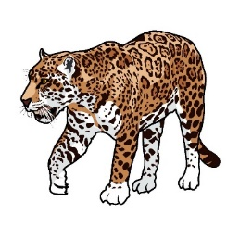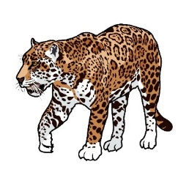
In Class Animal Research/Diorama Project
Dear Parents,
We have started a new unit on animals. Students will be completing a project in class over the next 2 weeks. They are very excited about researching and learning more about an animal of their choice. The project research and diorama will be completed at school. Every student will need a sturdy shoebox. If you are interested in contributing additional supplies we need for our animal project, please see the list below.
*tissue paper *model magic/clay
*toothpicks *pipe cleaners
*felt *sequins
*feathers *popsicle sticks
In class, our study of animals will include: body covering, appendages, needs and habitat. In addition to researching and writing a report, your student will be creating a diorama of the animal’s habitat to include the animal and what it needs to survive.
This is an excellent opportunity for the students to create and use their language, writing and research skills. We appreciate any supplies you are able to donate for our class to make the dioramas. Thank you for your support!
***Shoebox is due by Monday, October 21st***
Please contact your teacher if you have any questions.
