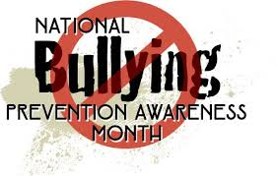
National Bullying
Prevention Month
October 2018

POSTER CONTEST – “A World Without Bullying”
Official Rules:
- Use the official entry form to design your poster.
- You may use any materials.
- Your entry must stay within the box.
- Entries are due to Ms. Bushey by October 22nd.
- Have fun! Winners get to attend an ice cream party on October 29th.

MIX IT UP DAY – Make friends with someone you don’t know on October 10th! Take action and don’t let anyone feel lonely at school.

UNITY DAY – Join us in our effort to end bullying by wearing orange on October 24th.

Plus, special announcements and classroom lessons from Ms. Bushey and The Bully Blockers about what bullying is, how to stop it, and what to do if bullying happens to you!



